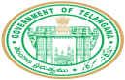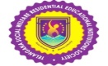

**TELANGANA SOCIAL WELFARE RESIDENTIAL DEGREE COLLEGE FOR WOMEN WANAPARTHY**

**Wanaparthy – 509103**

**Affiliated to Palamuru university-3252**

**An ISO 14001: 2015 Certified institution**

**E-mail: prl-rdcw-wnprt-swrs@telangana.gov.in**

**2.6.2 Semester Wise, year wise and Faculty Wise result analysis**

**<https://rdcwwanaparthy.tswreis.ac.in/Docs/2.6.2%20Attainment%20of%20COs%20and%20POs%20are%20evaluated.pdf>**