2022
FEB-21-2022 TELUGU BASHA DINOSTAVAM

FEB-28-2022 NATIONAL SCIENCE DAY
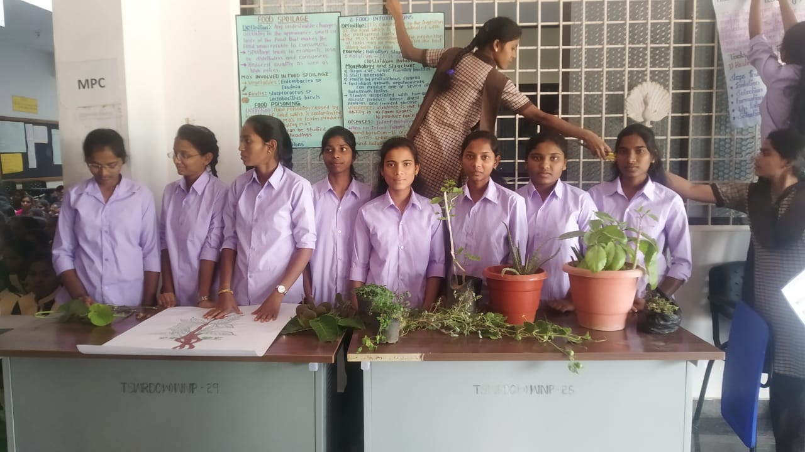

APRIL -14-2022 POSTER PRESENTATION ON DR.B.R. AMBEDKAR

APRIL-26-2022 WORLD INTELLECTUAL PROPERTY DAY

AUGUST-2022 “AZADI KA AMRUTH MAHOSTAV”
VAJROSTAVALU-75th INDEPENDENCE DAY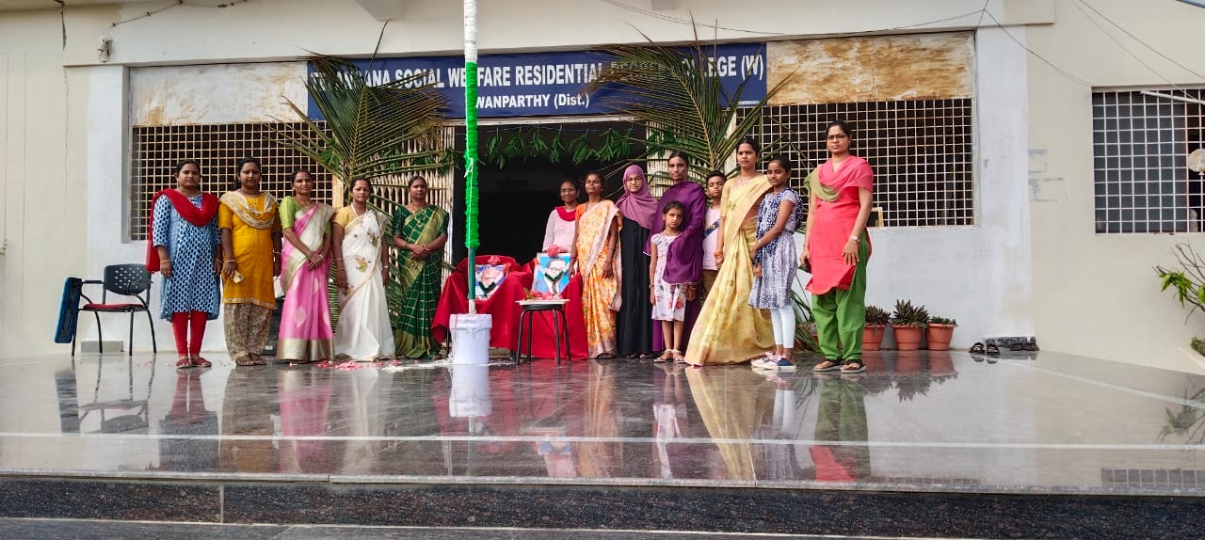

AUGUST -26-2022 SEMINAR ON “BUILDING COMPETINEY:EMPLOYABILITY SKILLS” BY CGC

AUGUST -29-2022 TELUGU BASHA DINOSTAVAM

SEPTEMBER-8-2022 WORLD LITERACY DAY

SEPTEMBER-9-2022 TELANGANA BASHA DINOSTAVAM

SEPTEMBER -2022 SWACHCHA GURUKULA DRIVE
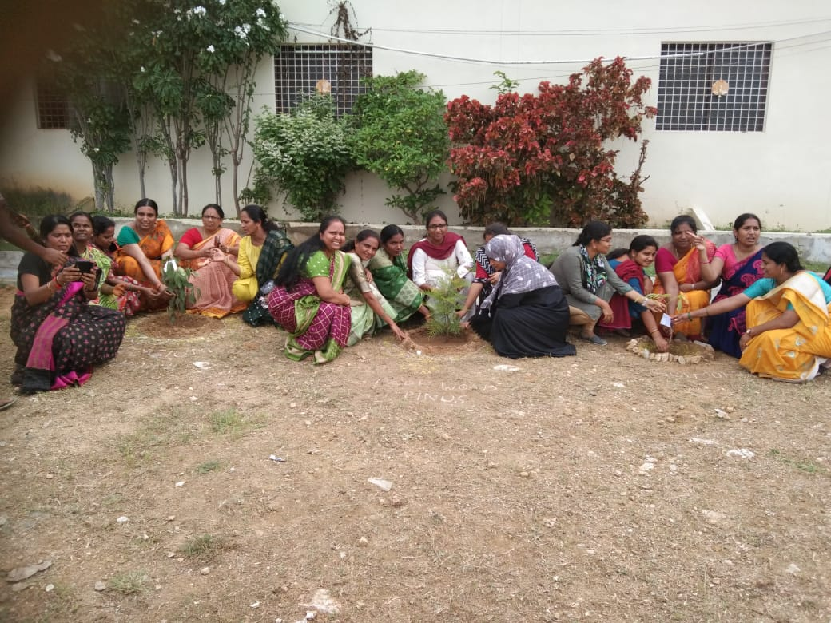

NOVEMBER-16-2022 NATIONAL LIBRARY WEEK
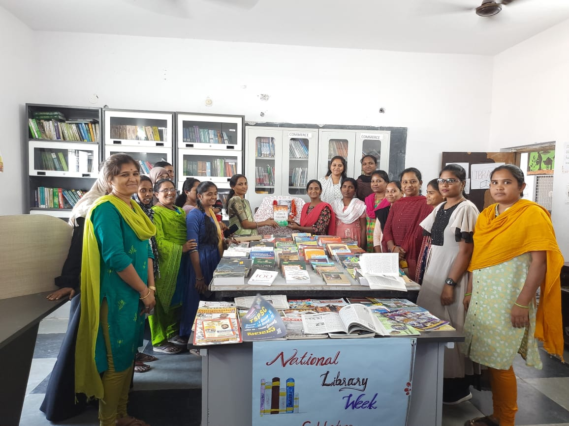

2023

JAN-3-2023 SAVITHRI BAI PULE BIRTHDAY CELEBRATIONS
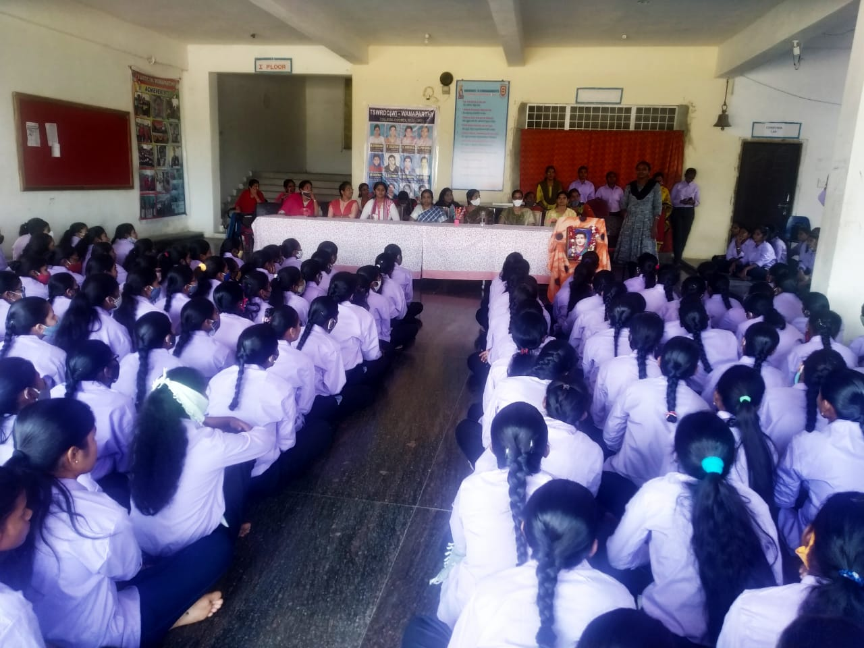

FEB-21-2023 TELUGU BASHA DINOSTAVAM
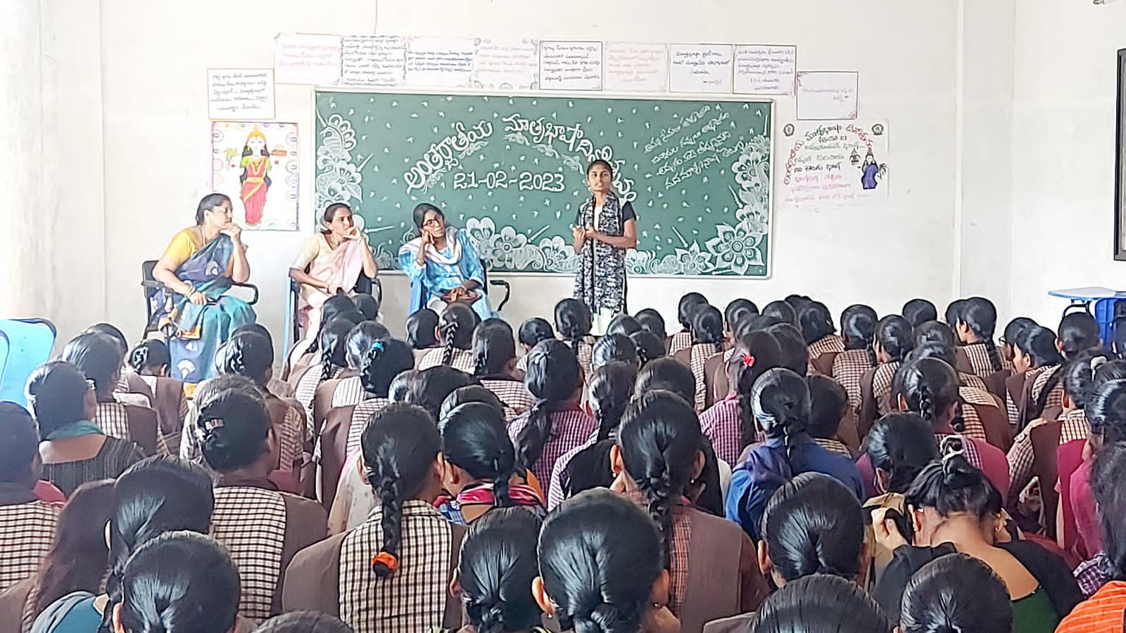

FEB-28-2023 NATIONAL SCIENCE DAY SCIENCEFAIR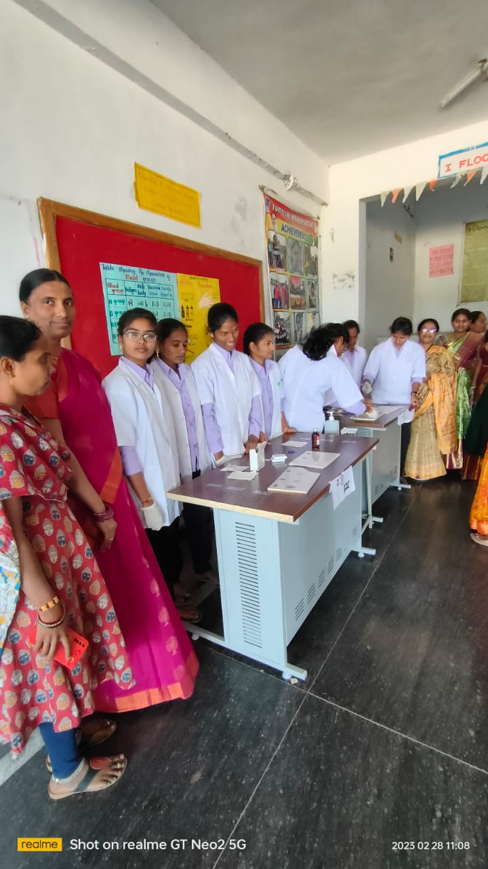

FEB-04-2023 AWARENESS ON CANCER BY COLLECTOR
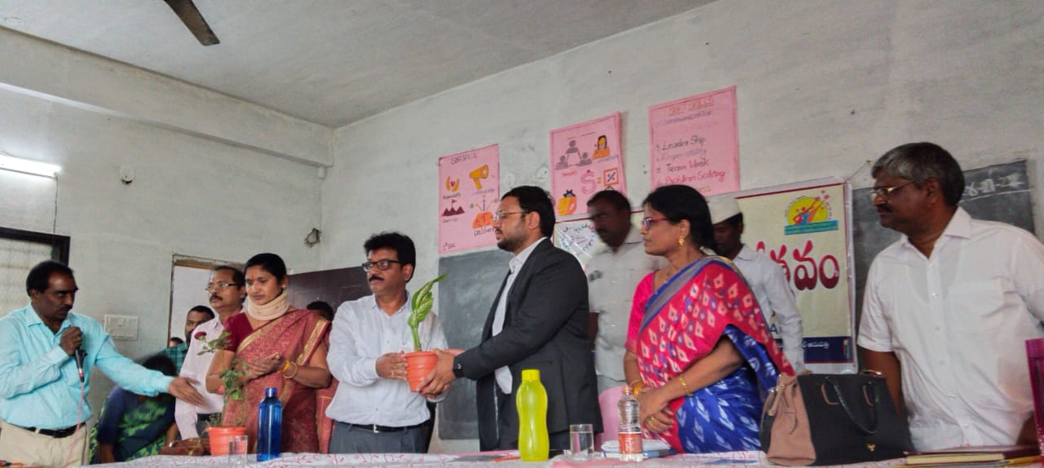

FEB-25-2023 SEMINOR ON SCIENCE
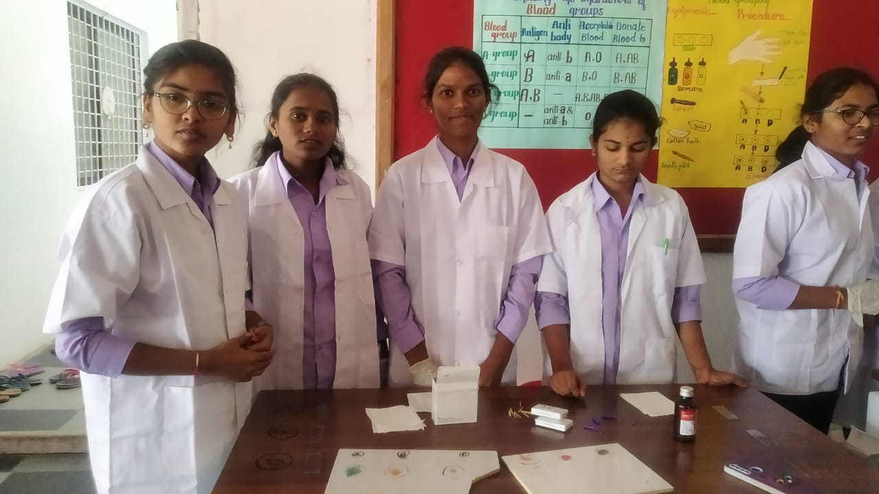

APRIL-14-2023 AMBEDKAR JAYANTHI
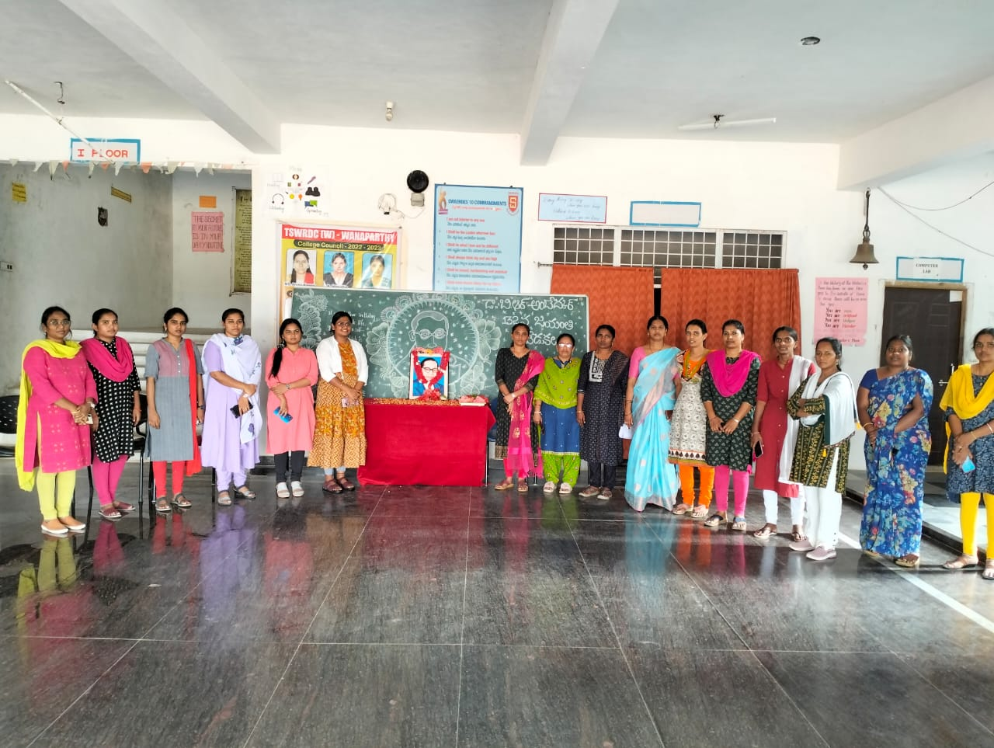

JUNE-12-2023 TELANGANA DASHABDI USTAVALU
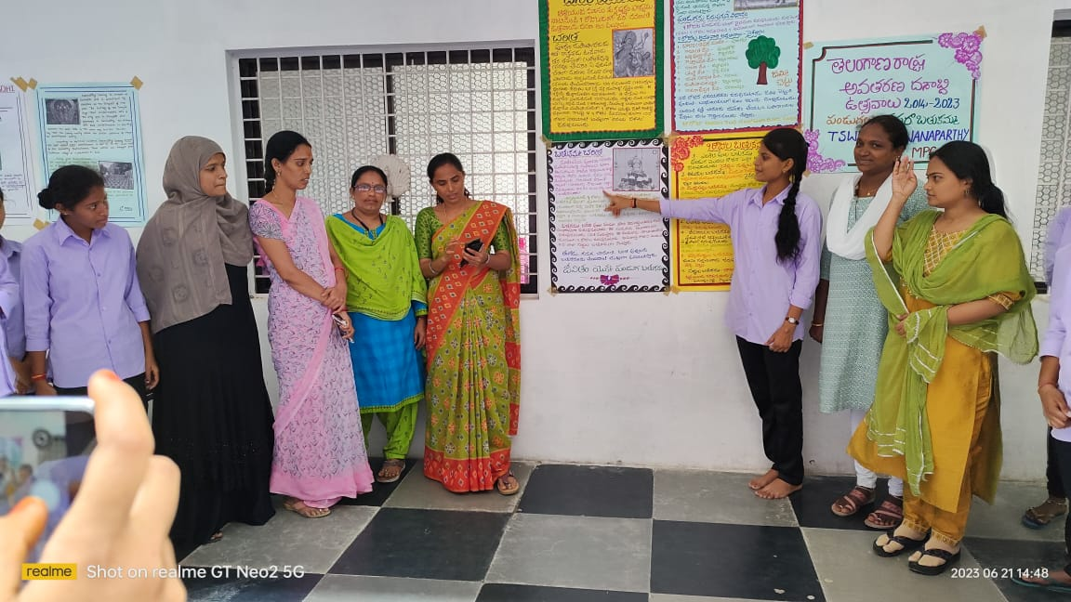

AUGUST-29-2023 TELUGU BHASHA DINOSTAVAM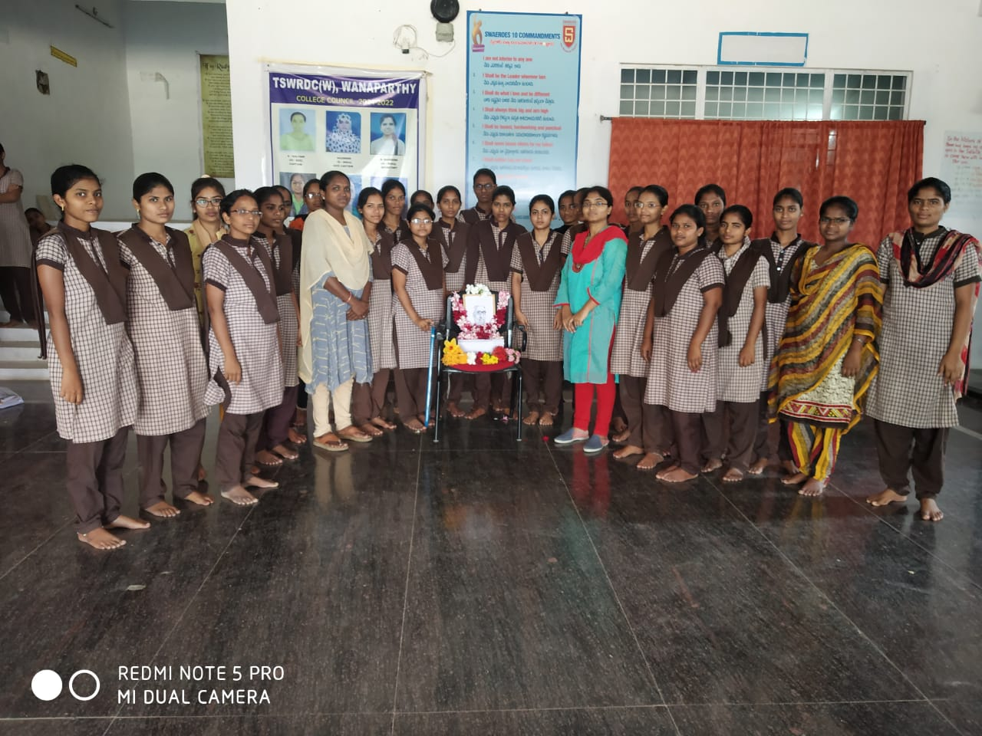

SEPTEMBER-9-2023 TELANGANA BHASHA DINOSTAVAM
