**College activities 2024**

**03.01.2024: SAVITHRI BAI PHULE BIRTHDAY CELEBRATIONS**

Celebrations of Savithri Bai Phule “194th” Birthday.

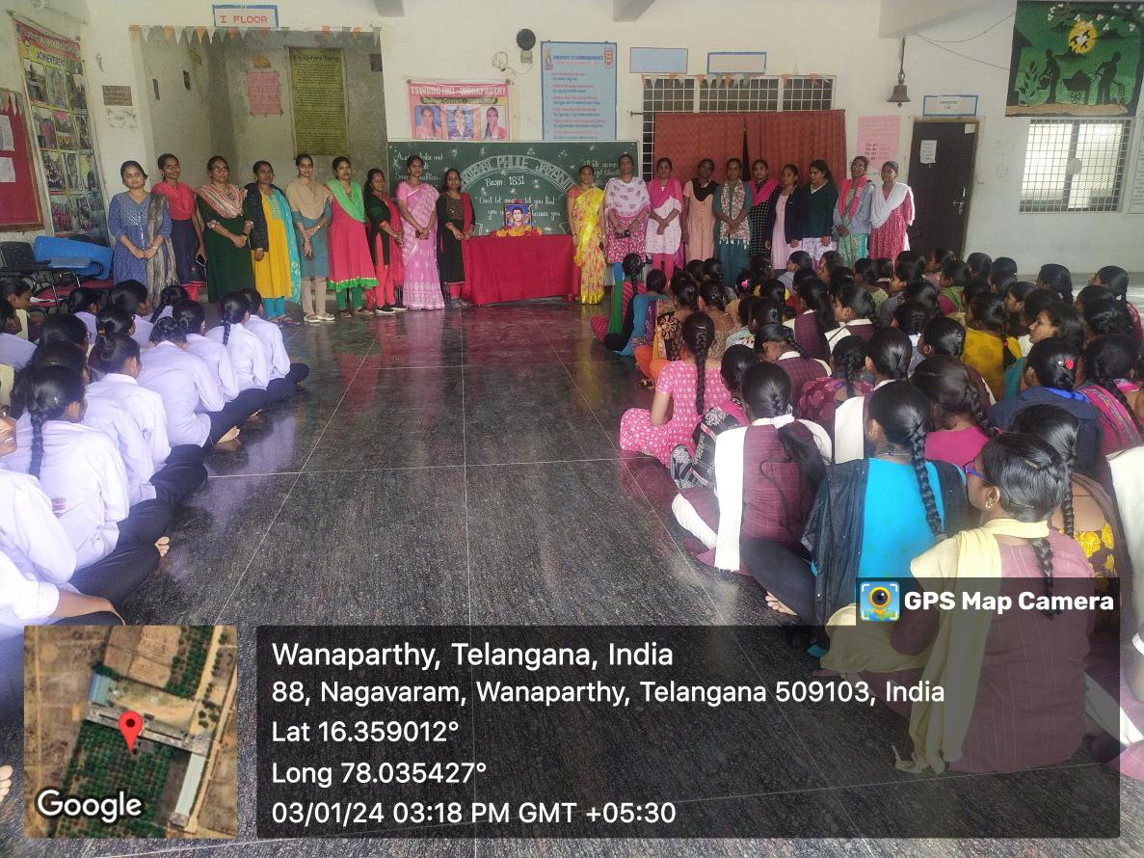

**04.01.2024: PLANTATION B.Com II YEAR STUDENTS**

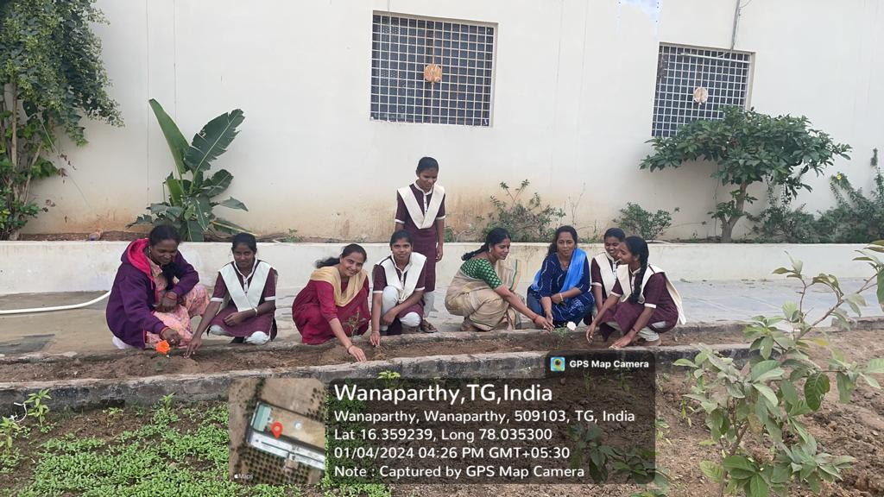

**10.01.2024: 5E ORIENTATION PROGRAMME**

5E aims at nurturing the all-round development and performance excellence of students right from the school level as well as working professionals.

The ultimate goal of 5E is to empower all individuals to create impactful value additions to the world.



**10.01.2024: HYM INTERNATIONAL CERTIFICATES**

RECEIVED ISO CERTIFICATES FOR

1. EDUCATIONAL QUALITY MANAGEMENT SYSTEM
2. ENVIRONMENTAL MANAGEMENT SYSTEM
3. ENERGY MANAGEMENT SYSTEM

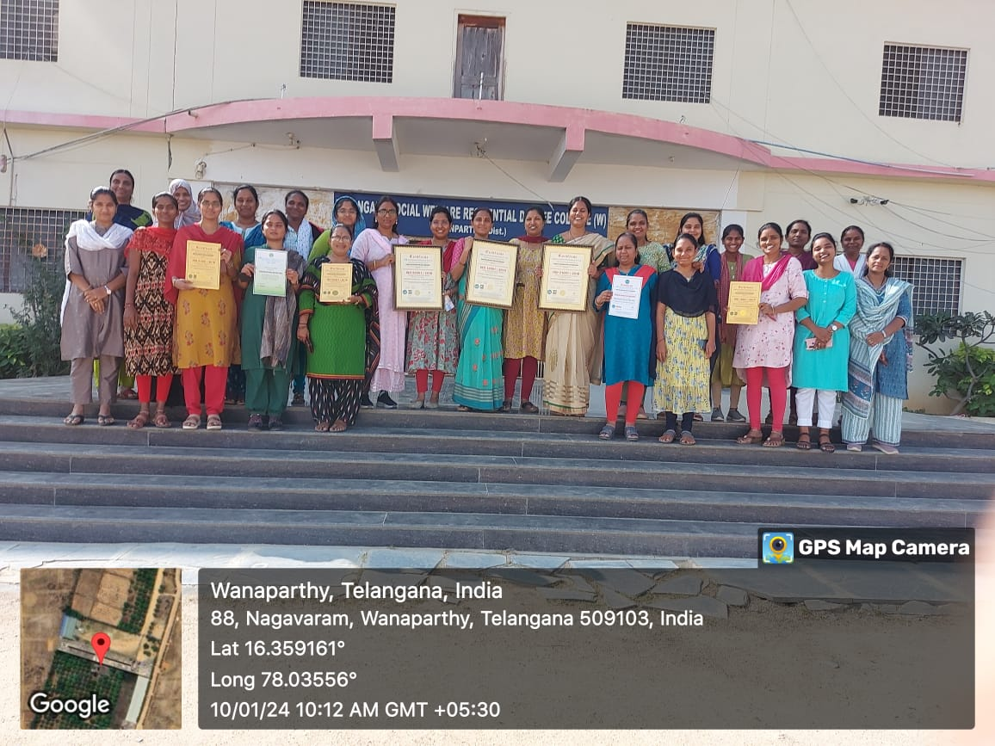

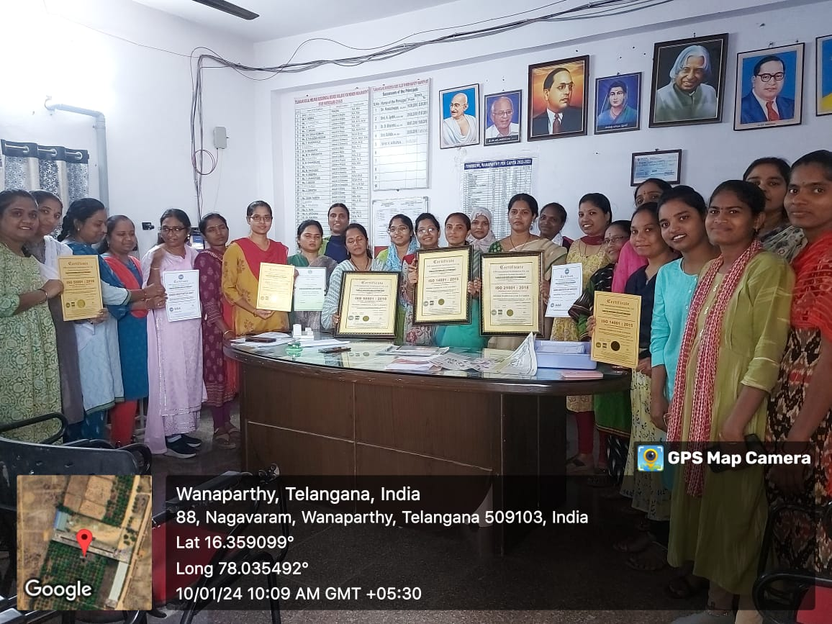

**10.01.2024: Orientation on STEM Programme**

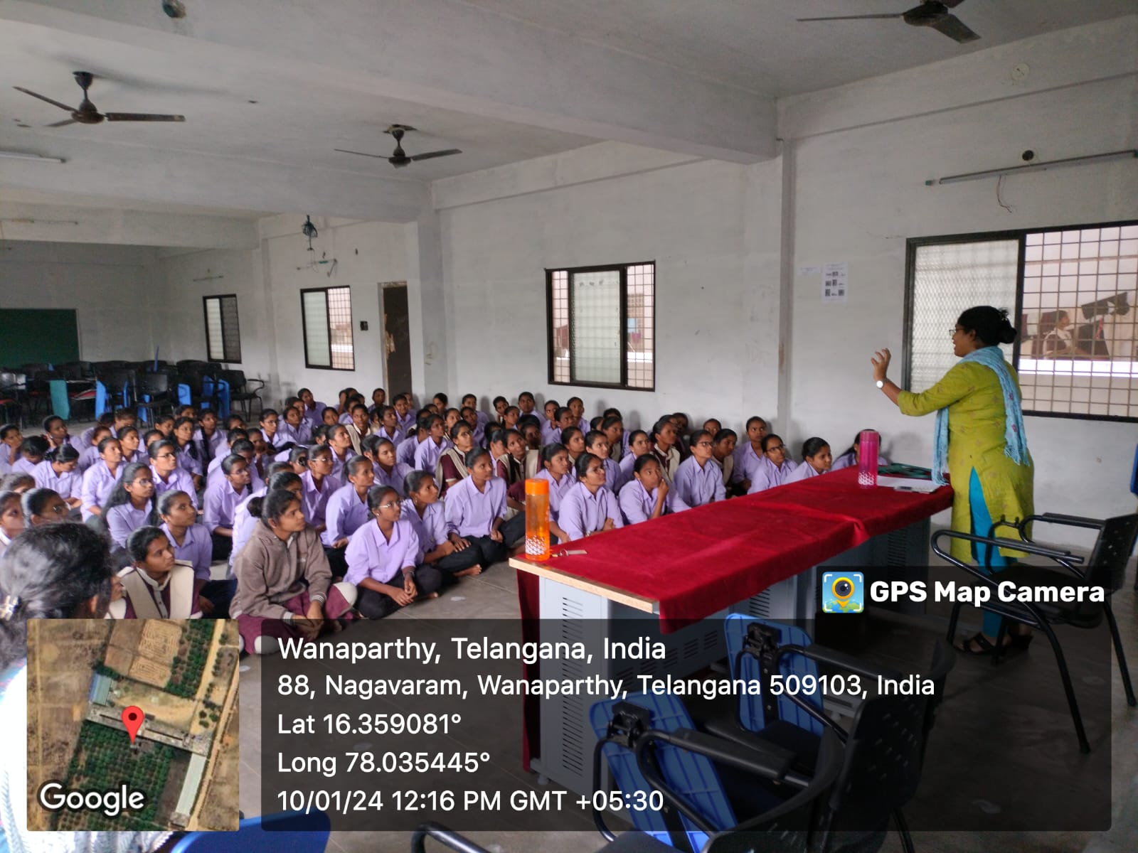

**26.01.2024: REPUBLIC DAY**

**CELEBRATIONS OF 75TH REPUBLIC DAY CELEBRATIONS**

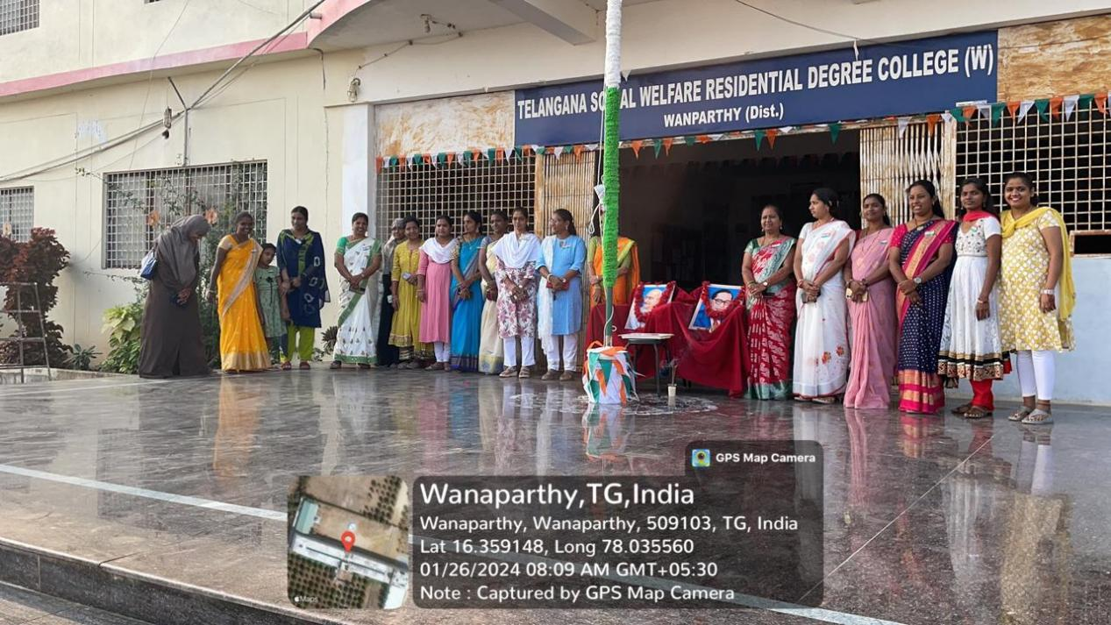

**26.01.2024: ZONAL SPORTS MEET**

Students leaving the college to attend the Zonal Sports meet at TSWRDC(W), Ghatkesar from 26.01.2024 to 30.01.2024

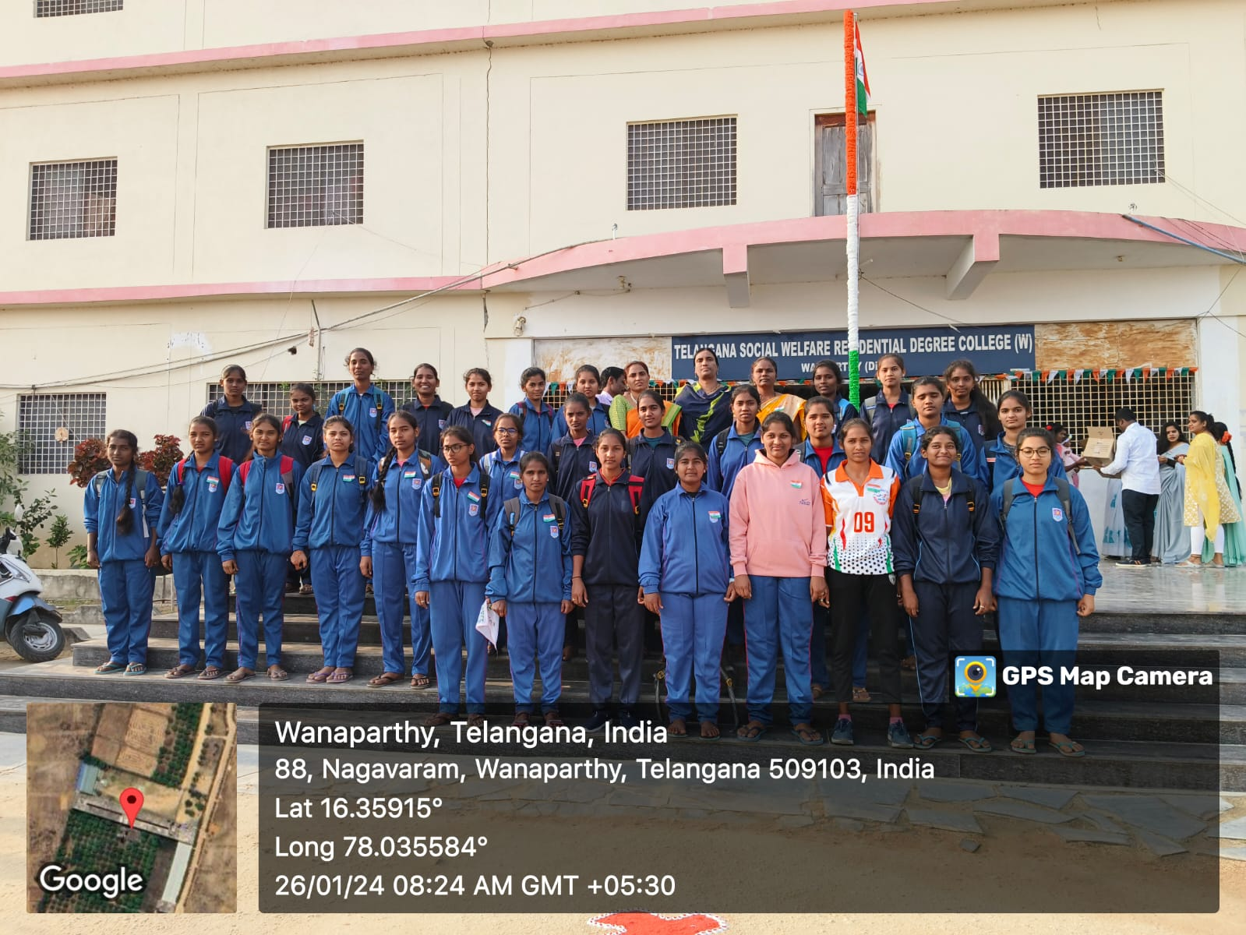

**27.01.2024: NYAYA VIGNANA AVAGAHANA SADASSU**

Awareness on the Child Marriages, Dowry Acts and Property Rights of Women by The Senior Civil Court Judge Smt. V. Rajani and team on the day of “National family literacy day”.

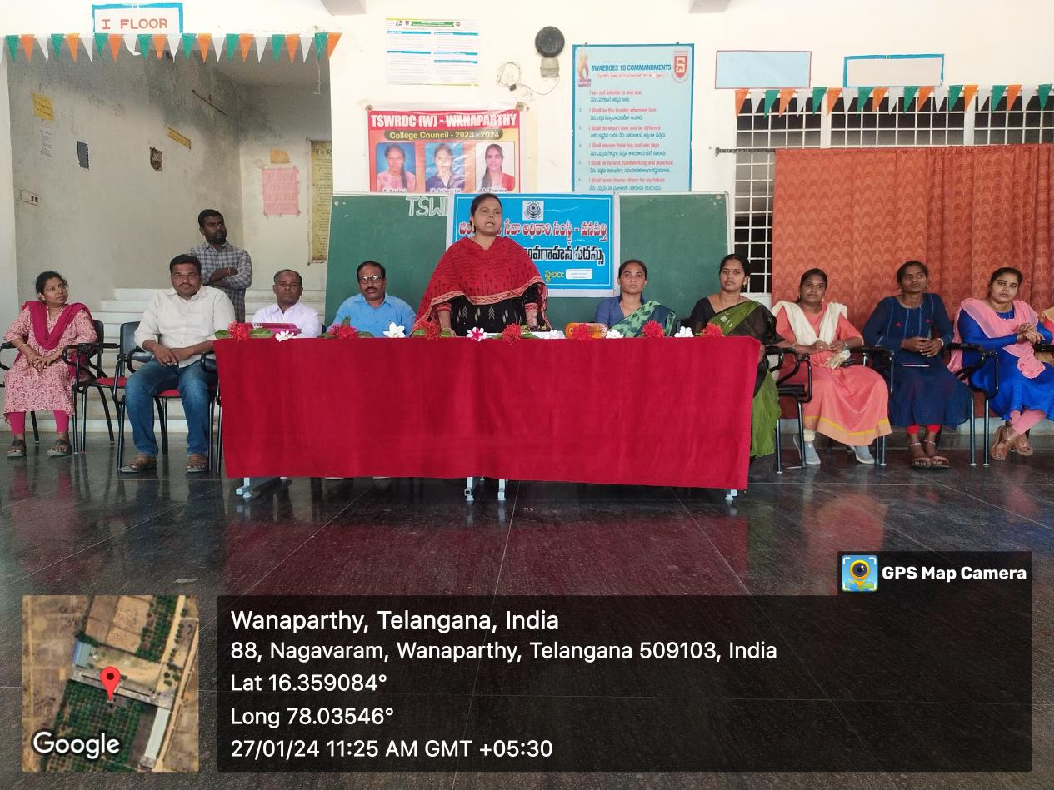

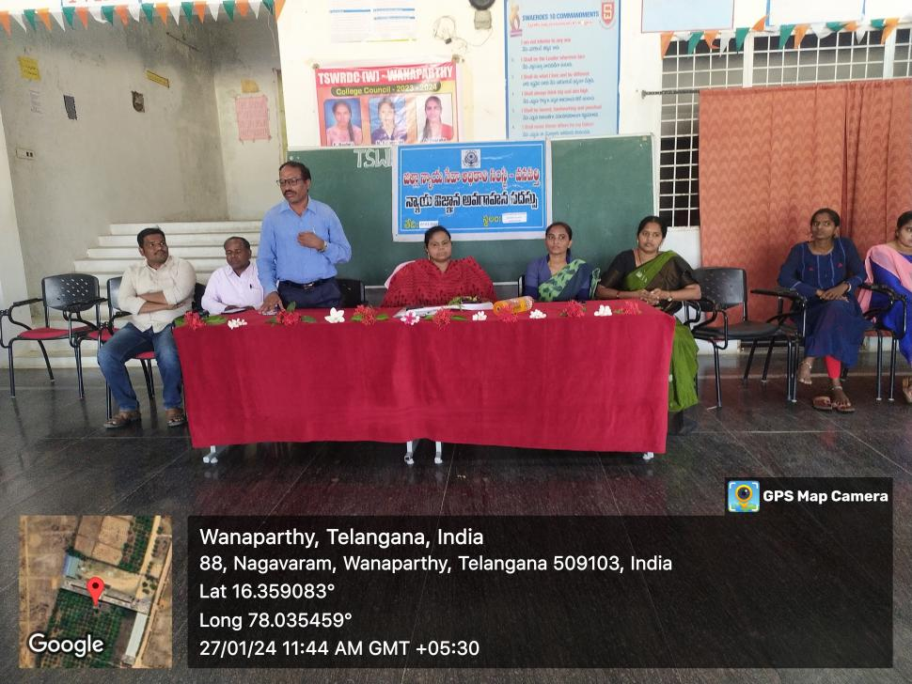

**Feb-04-2024: VIBRATIONS ( STATE LEVEL CULTURAL AND ACADEMIC MEET)- 2024**

Students leaving the campus to attend the “VIBRATIONS ( STATE LEVEL CULTURAL AND ACADEMIC MEET)- 2024” at TSWRDC(W), Kamareddy from 05.02.2024 to 06.02.2024.

