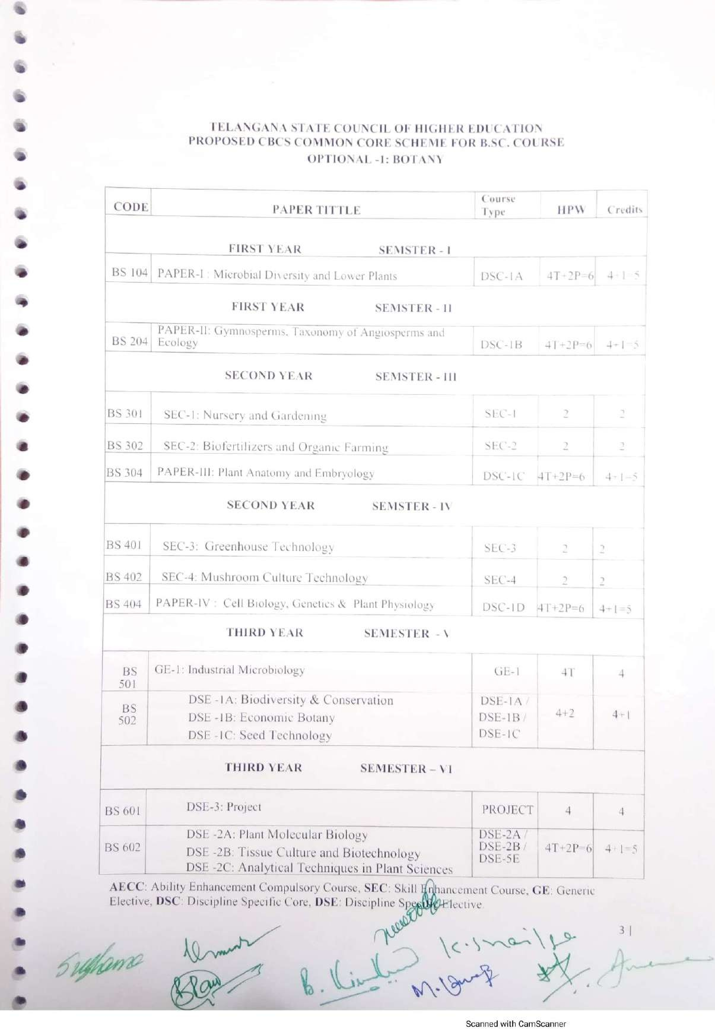

Palamuru University-UG syllabus Botany

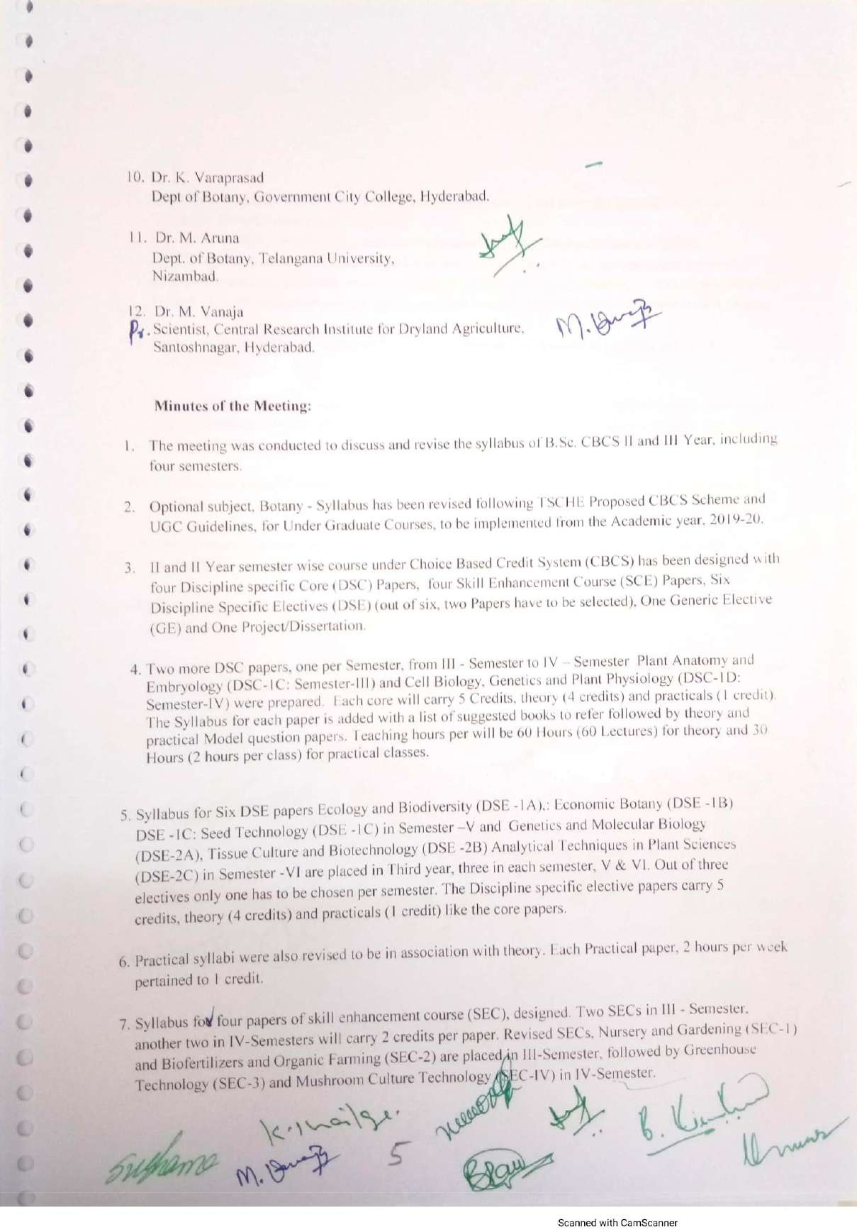

Palamuru University-UG syllabus Botany

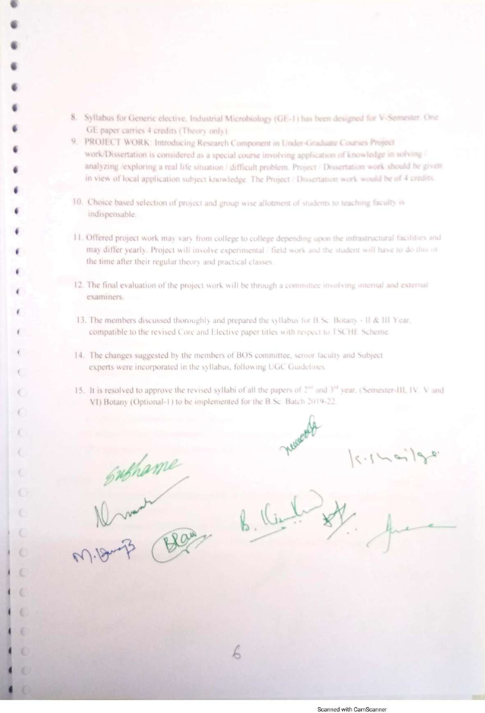

Palamuru University-UG syllabus Botany

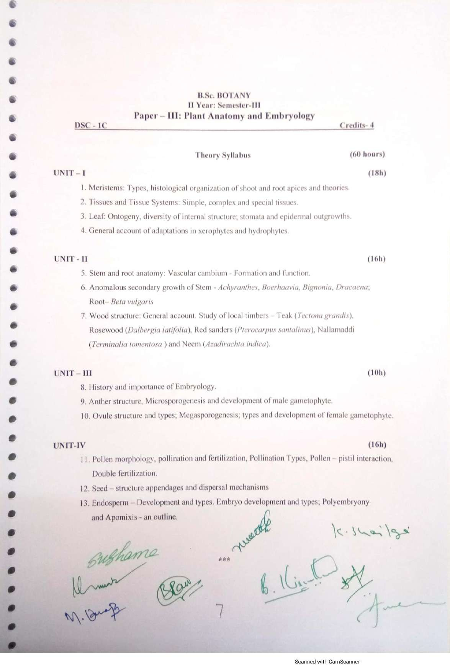

Palamuru University-UG syllabus Botany

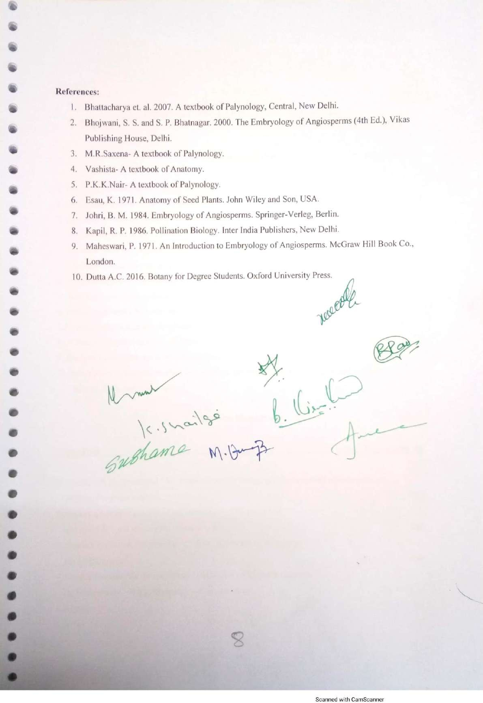

Palamuru University-UG syllabus Botany

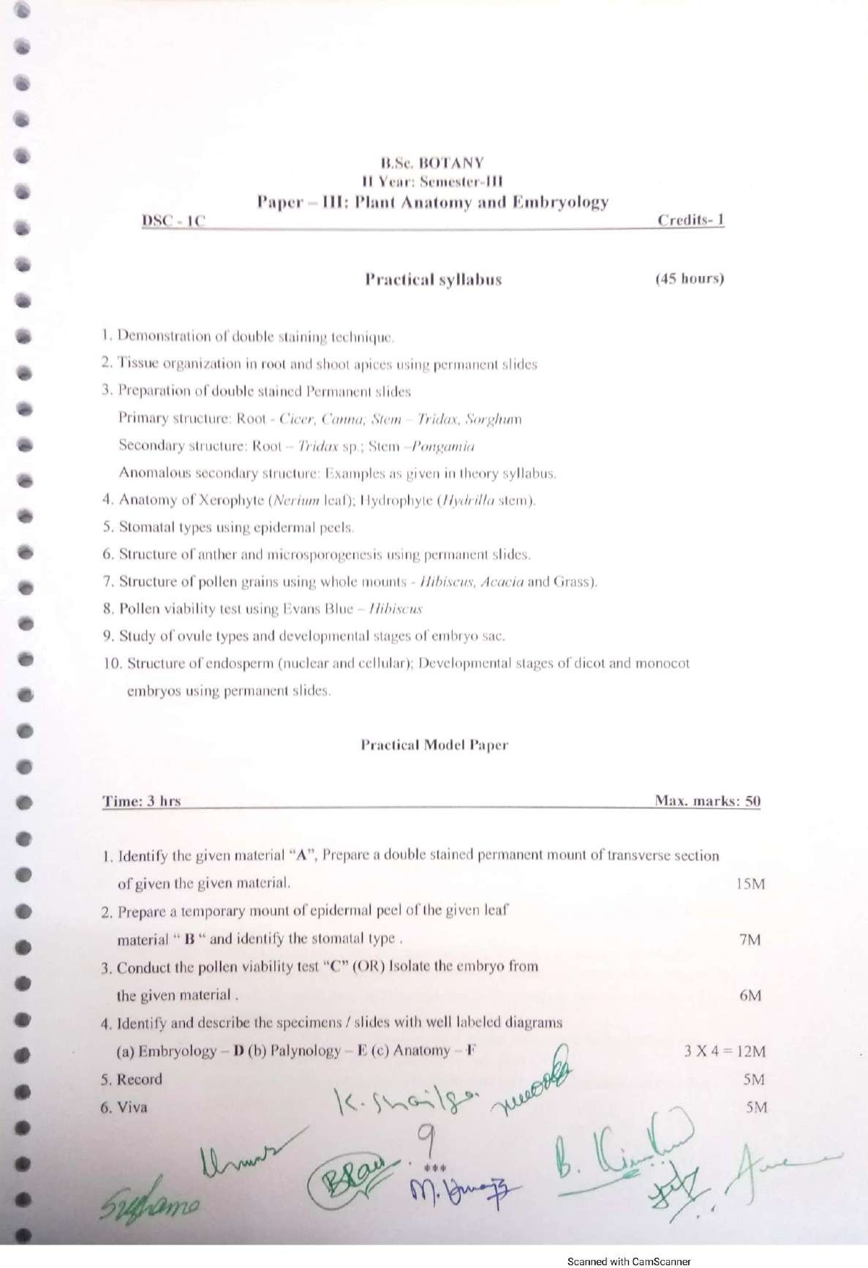

Palamuru University-UG syllabus Botany

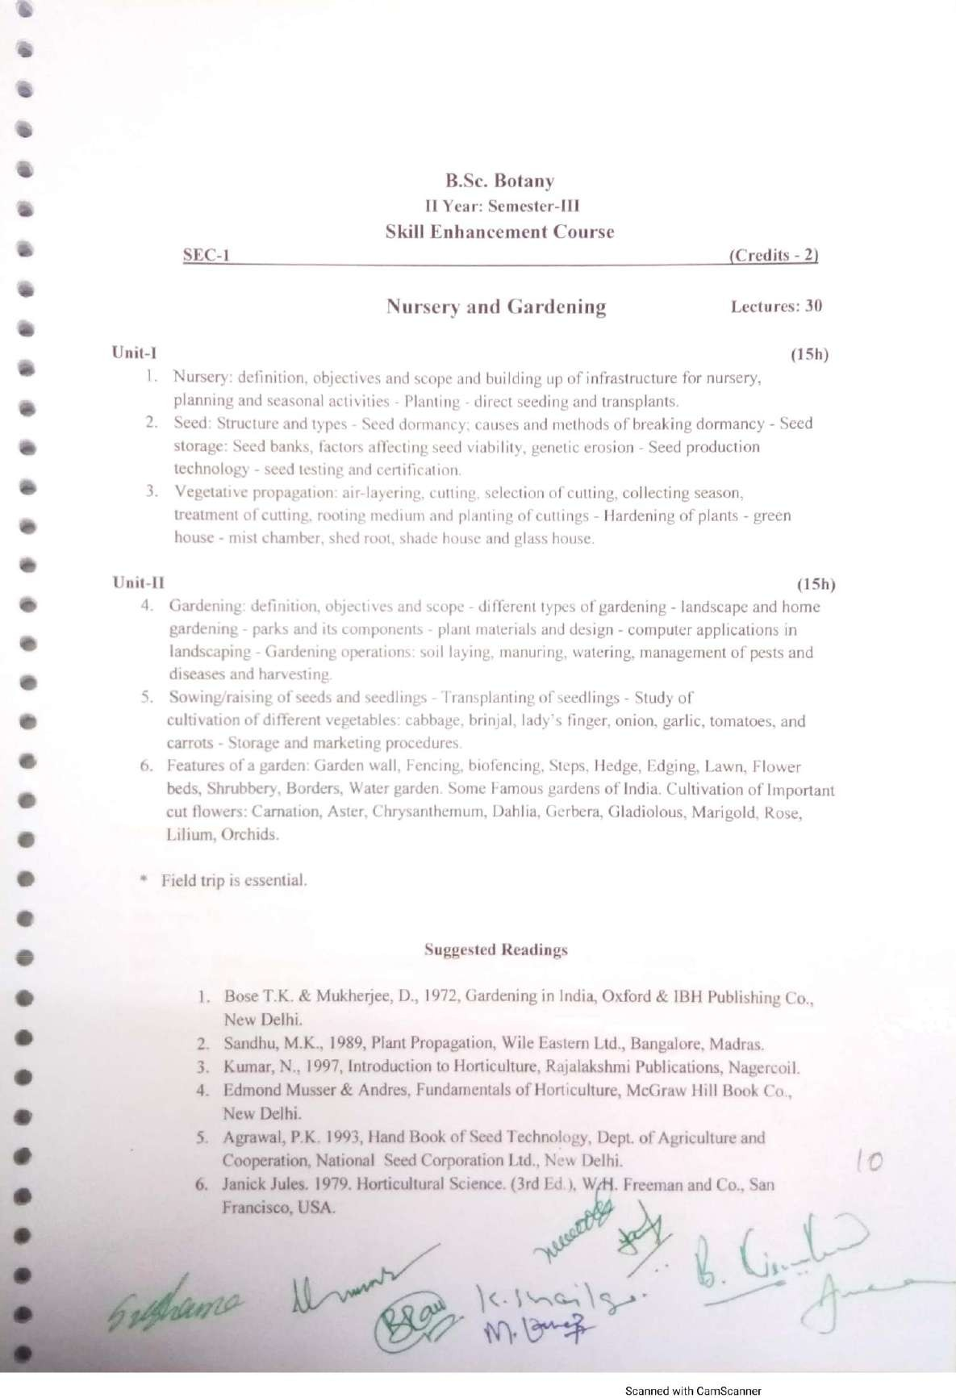

Palamuru University-UG syllabus Botany

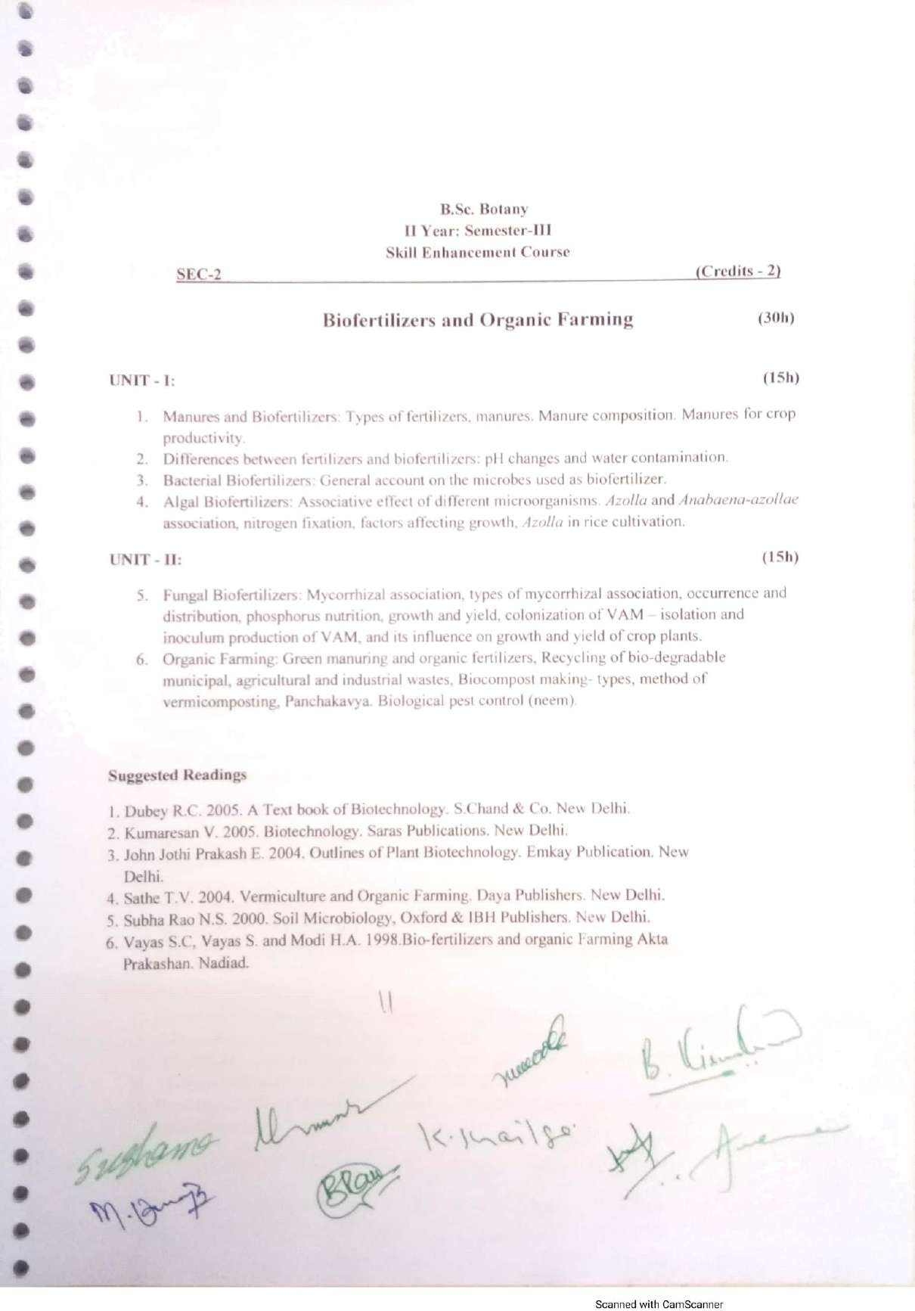

Palamuru University-UG syllabus Botany

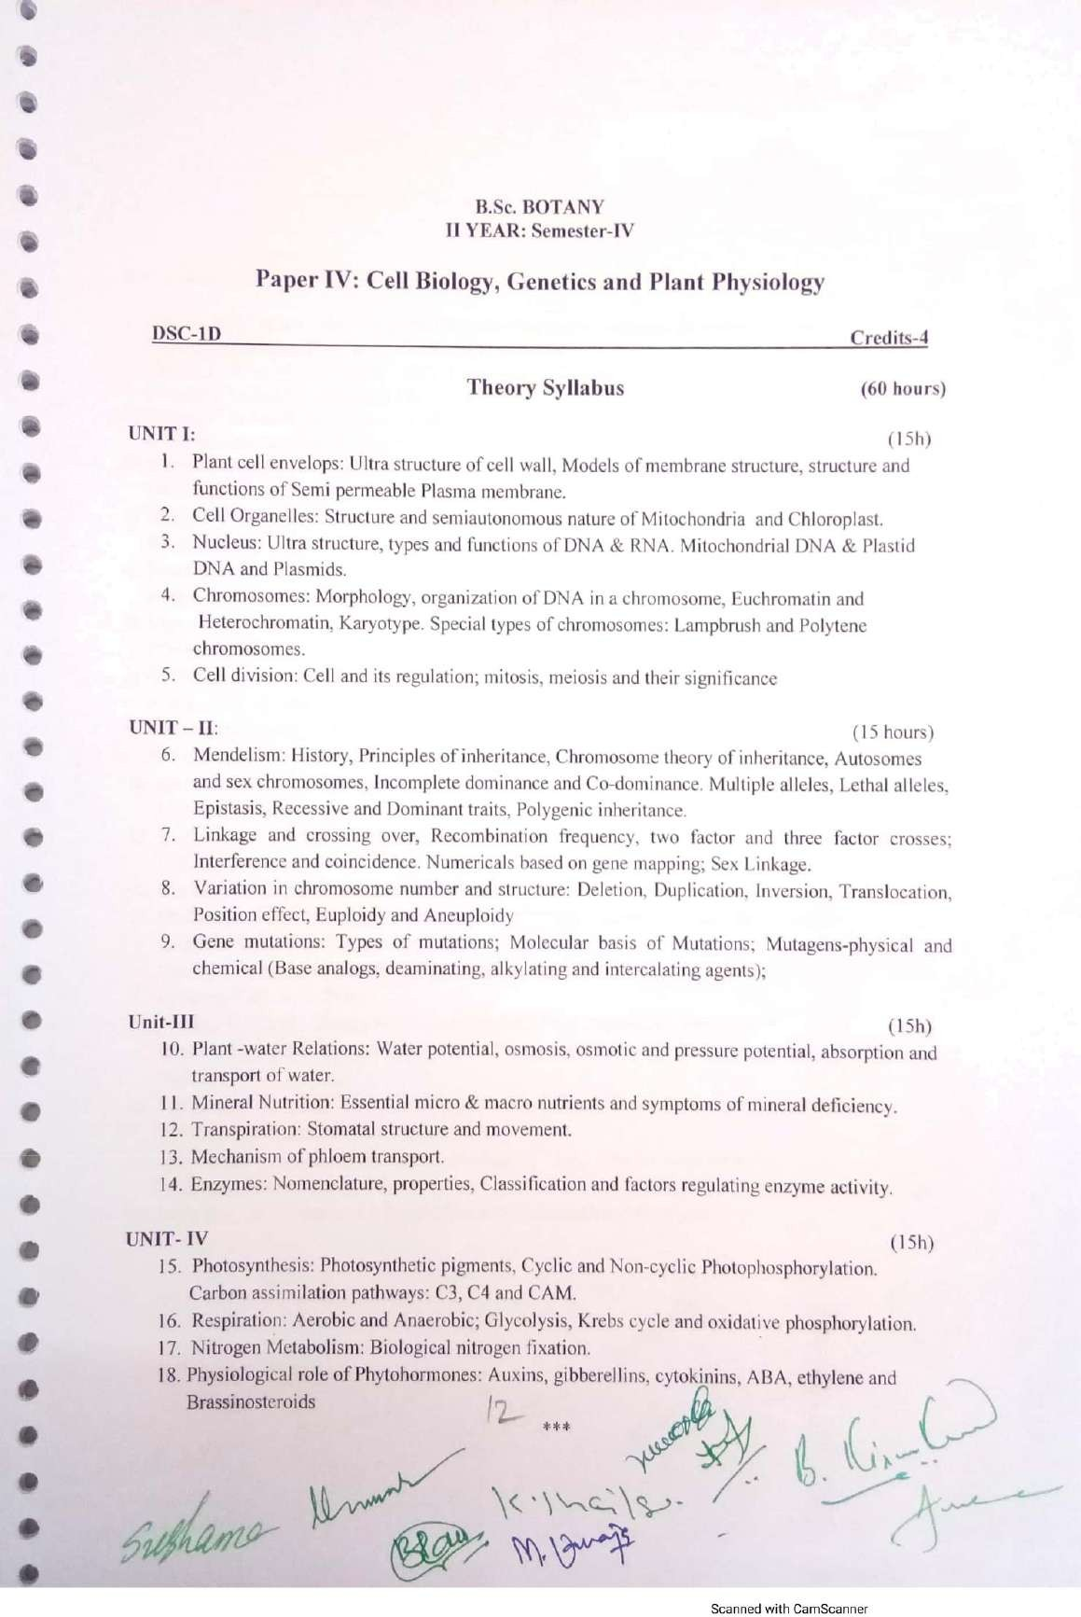

Palamuru University-UG syllabus Botany

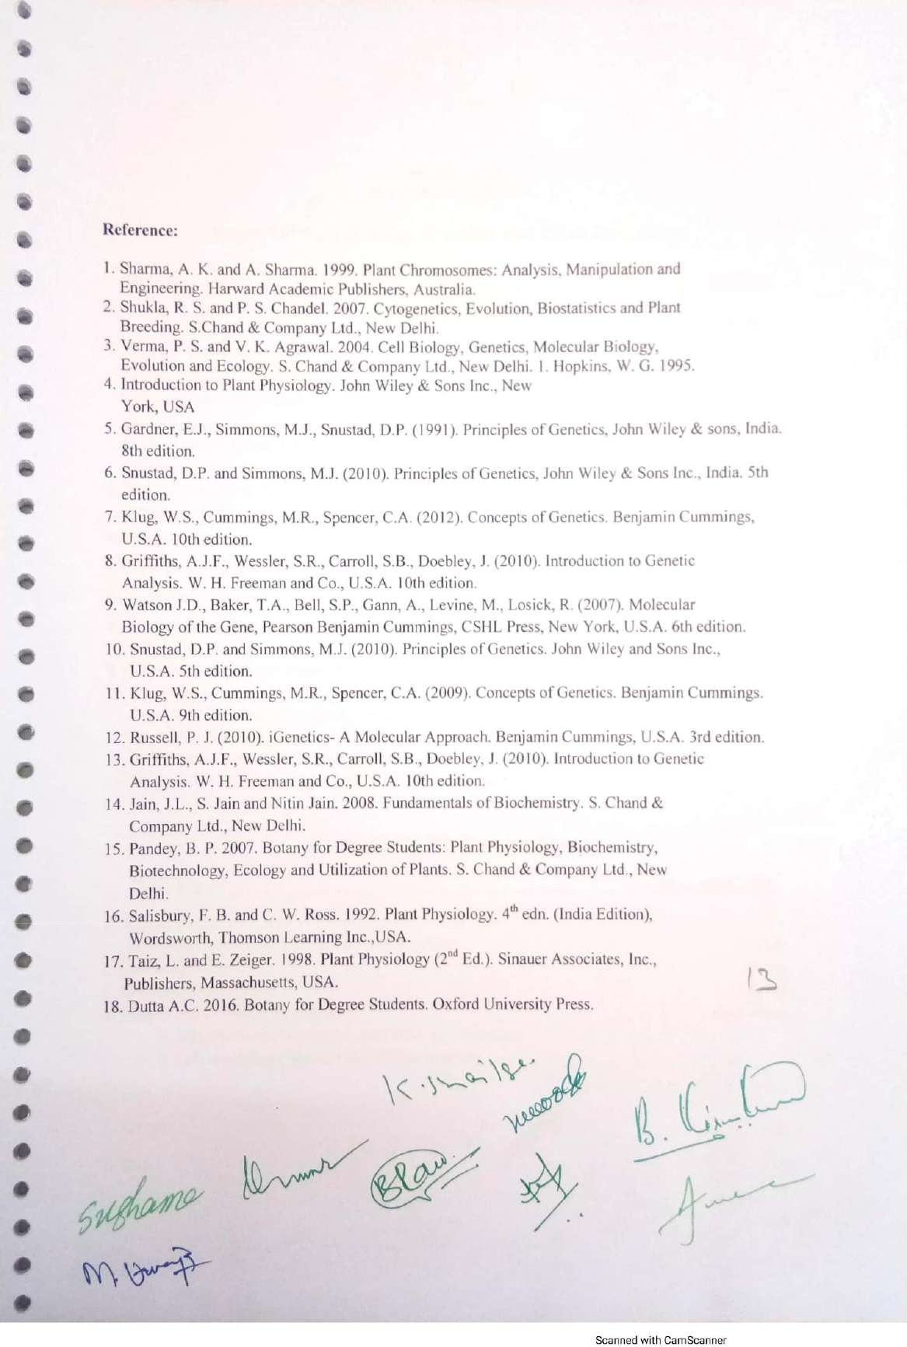

Palamuru University-UG syllabus Botany

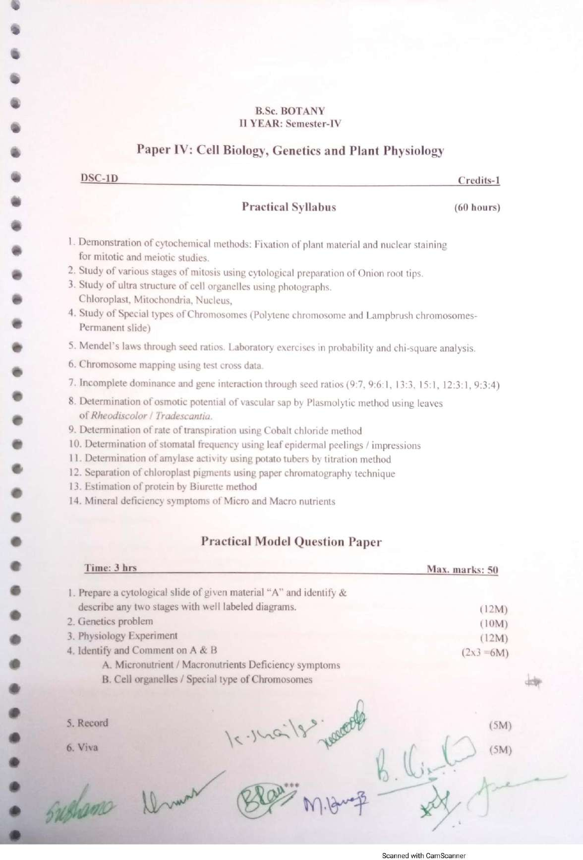

Palamuru University-UG syllabus Botany

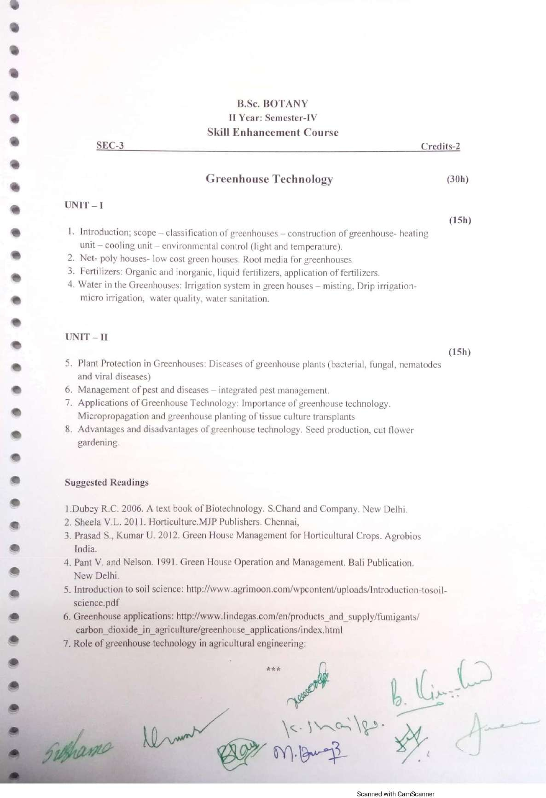

Palamuru University-UG syllabus Botany

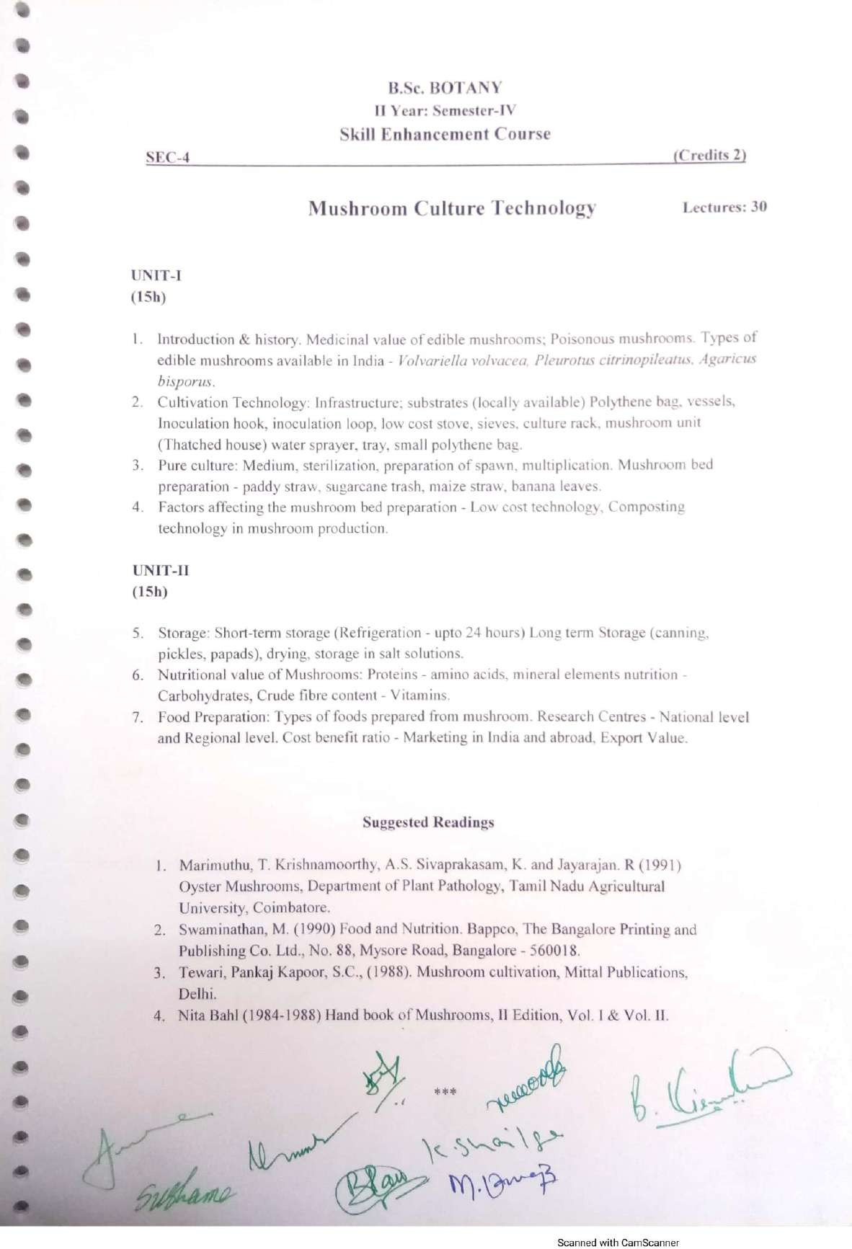

Palamuru University-UG syllabus Botany

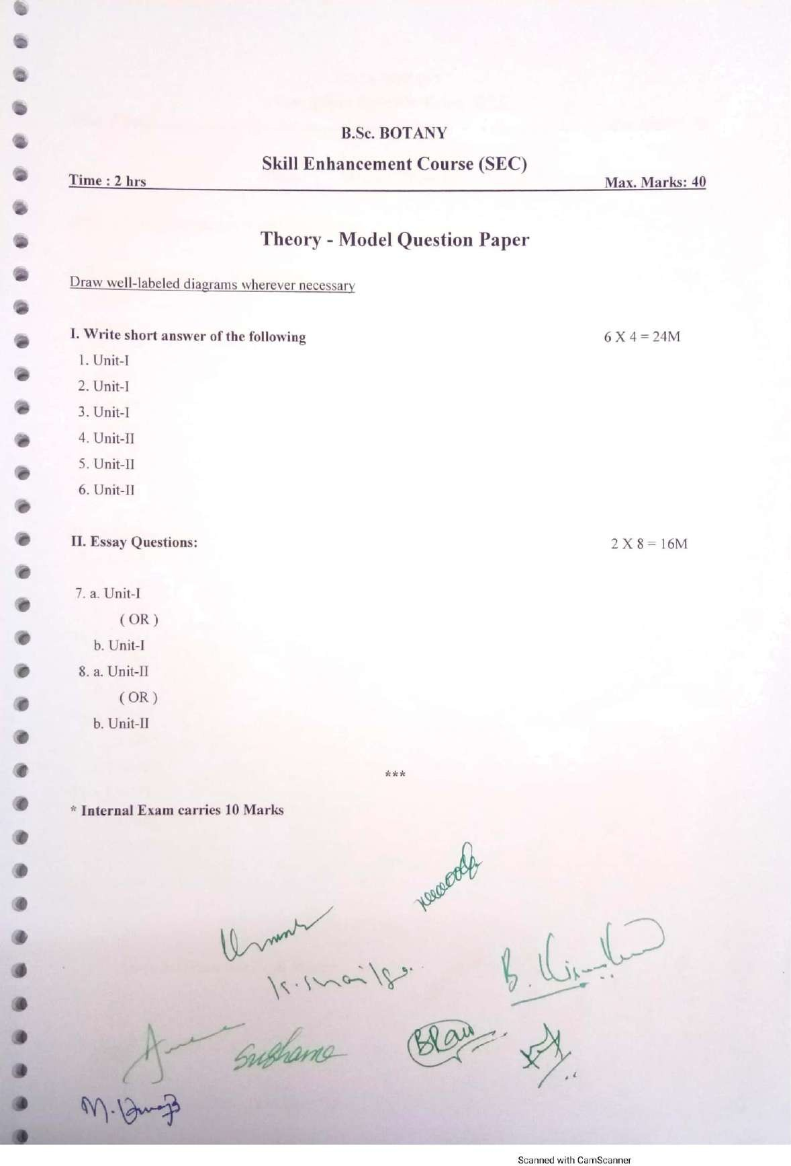

Palamuru University-UG syllabus Botany

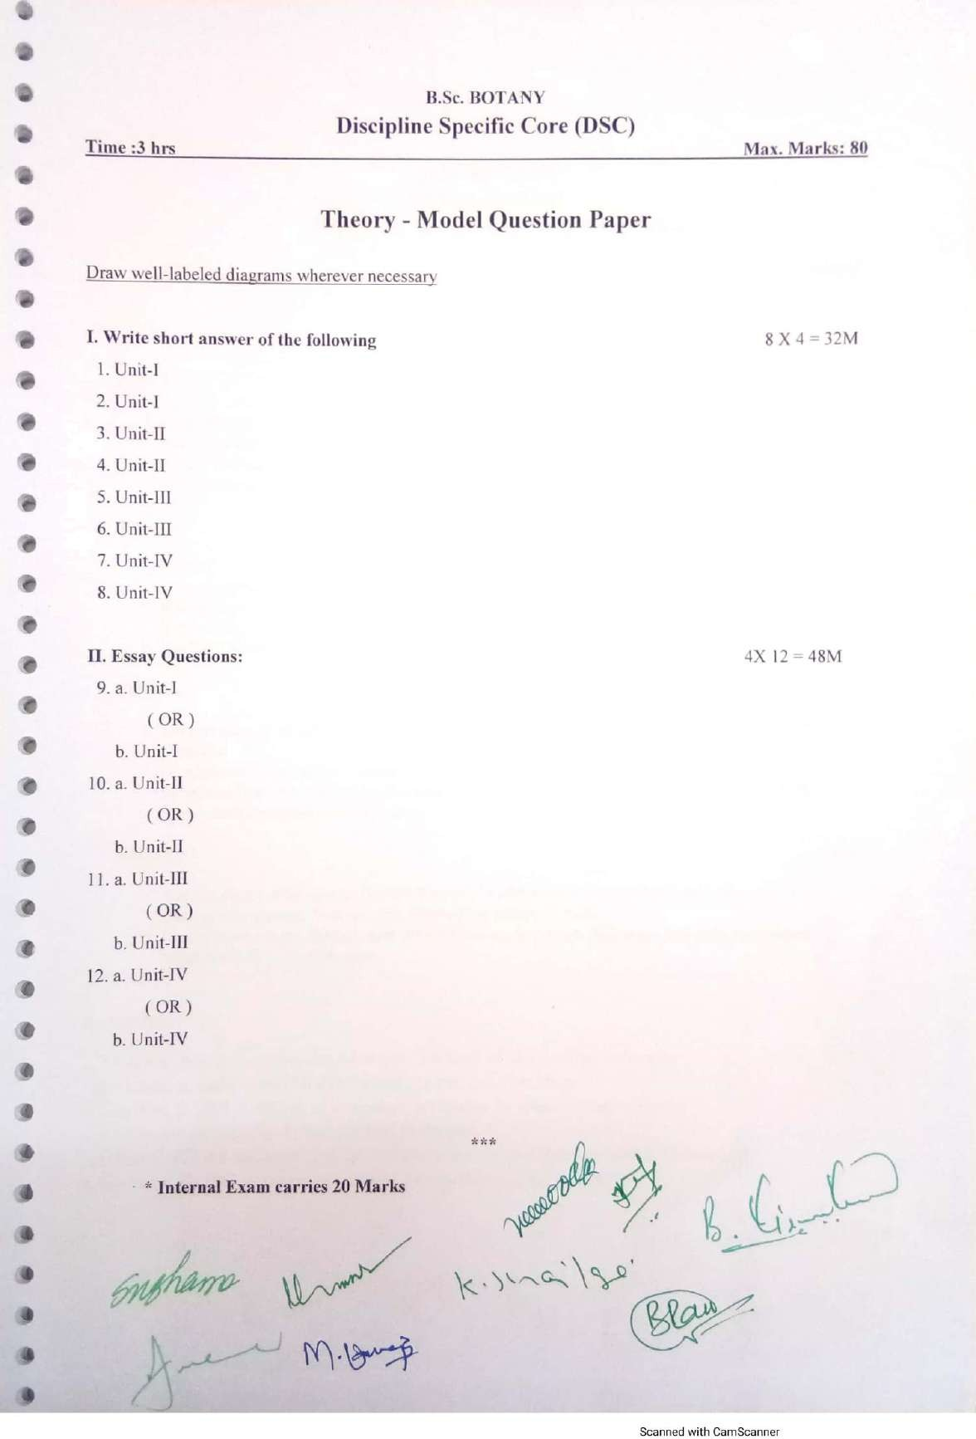

Palamuru University-UG syllabus Botany

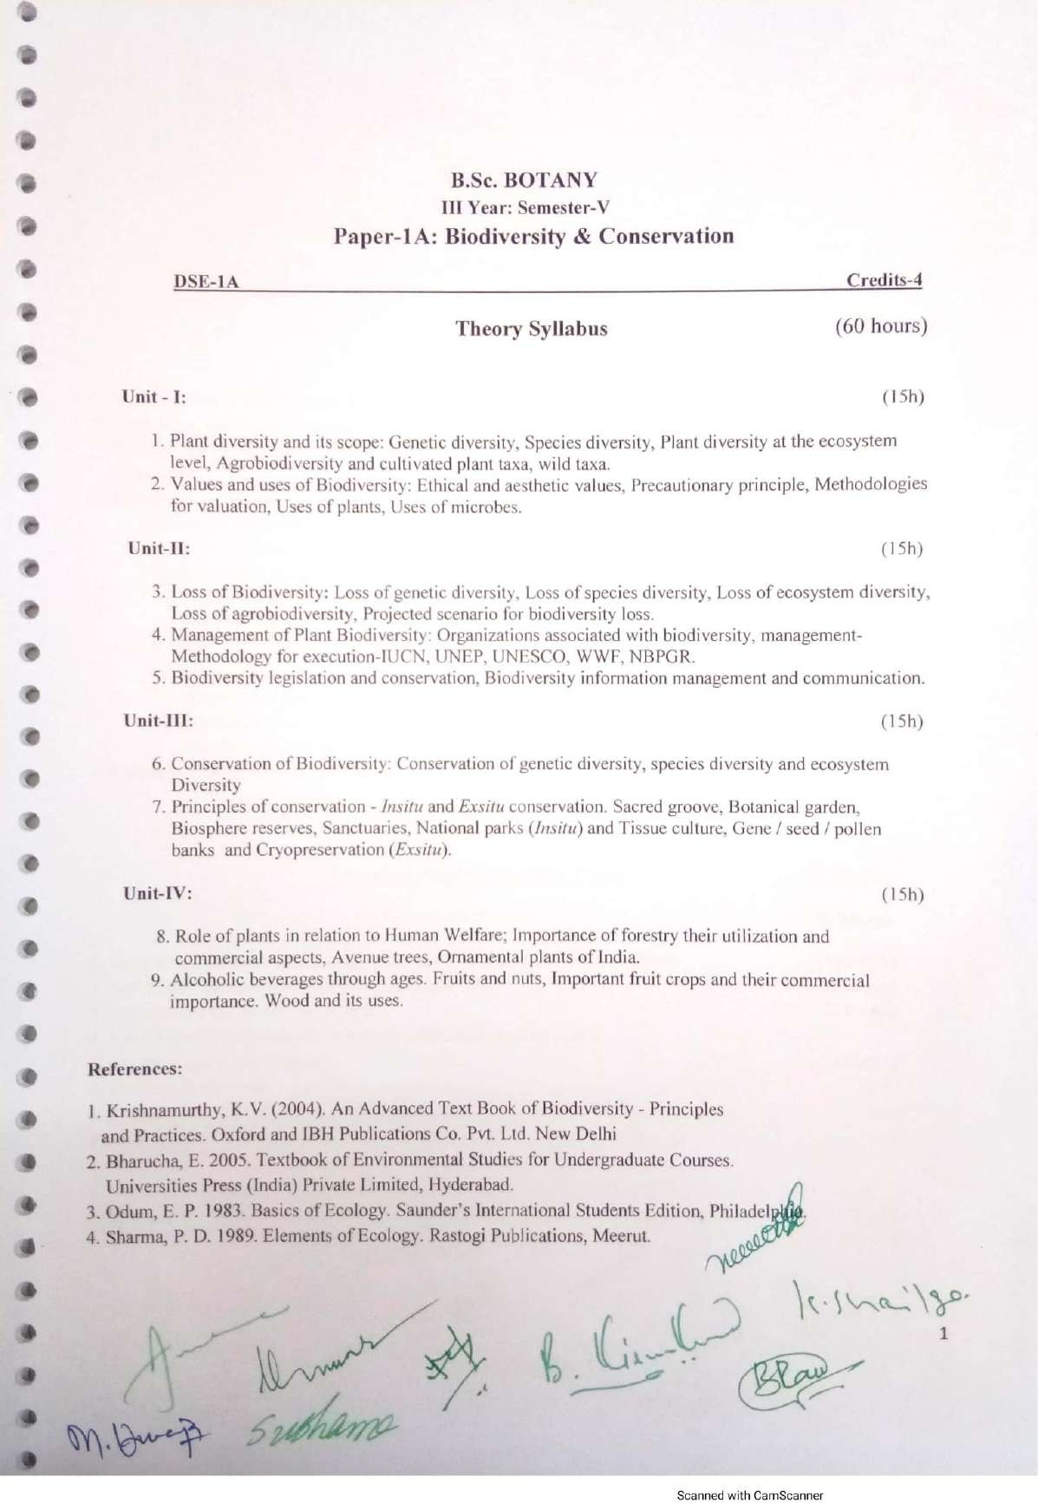

Palamuru University-UG syllabus Botany

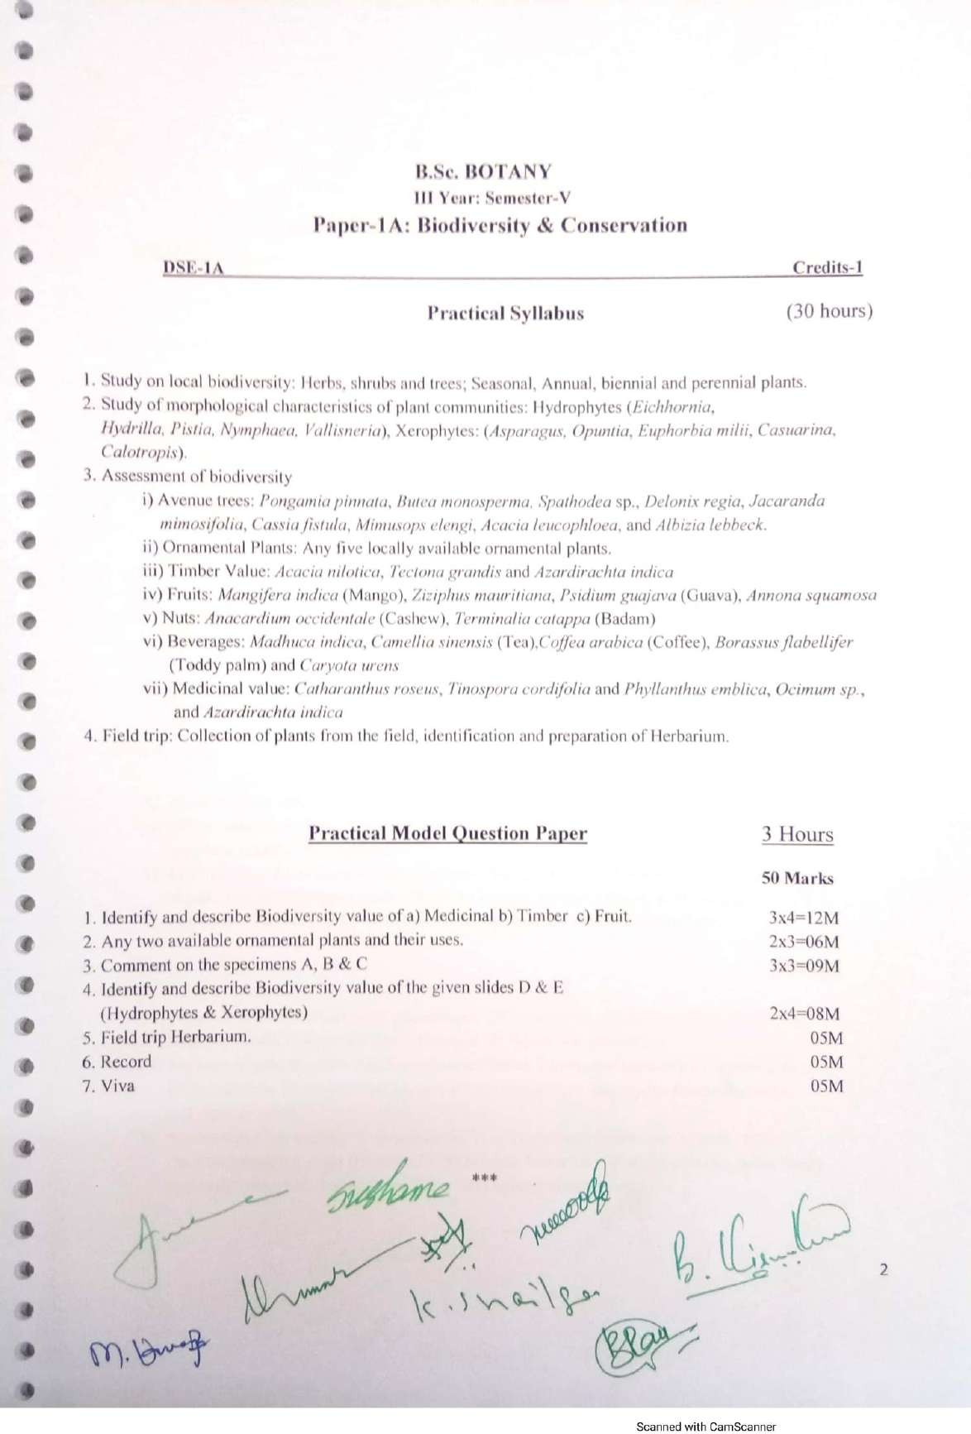

Palamuru University-UG syllabus Botany

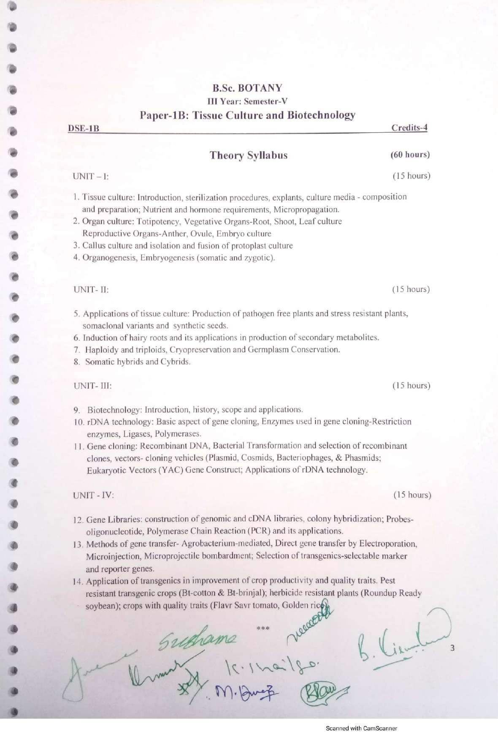

Palamuru University-UG syllabus Botany

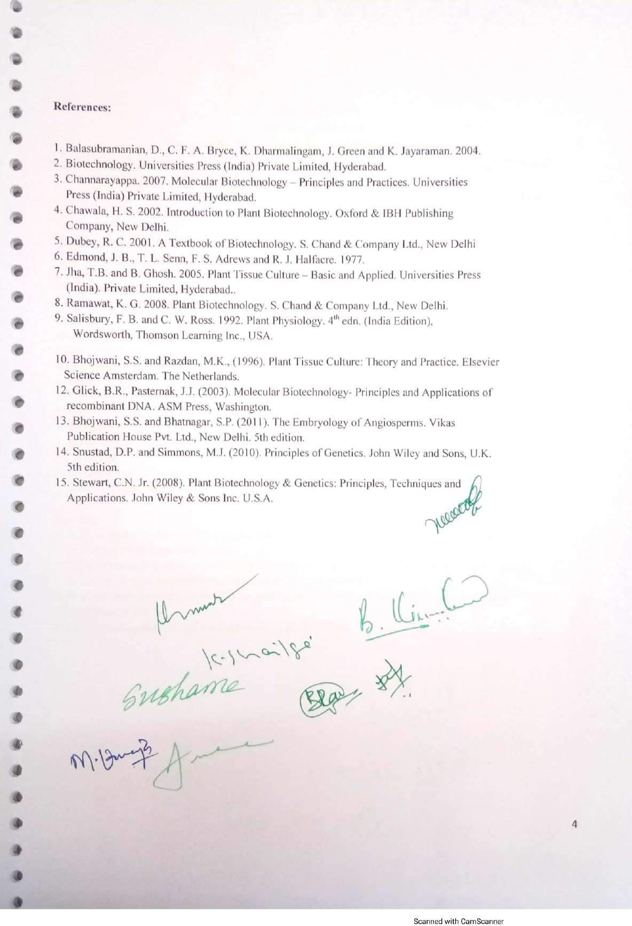

Palamuru University-UG syllabus Botany

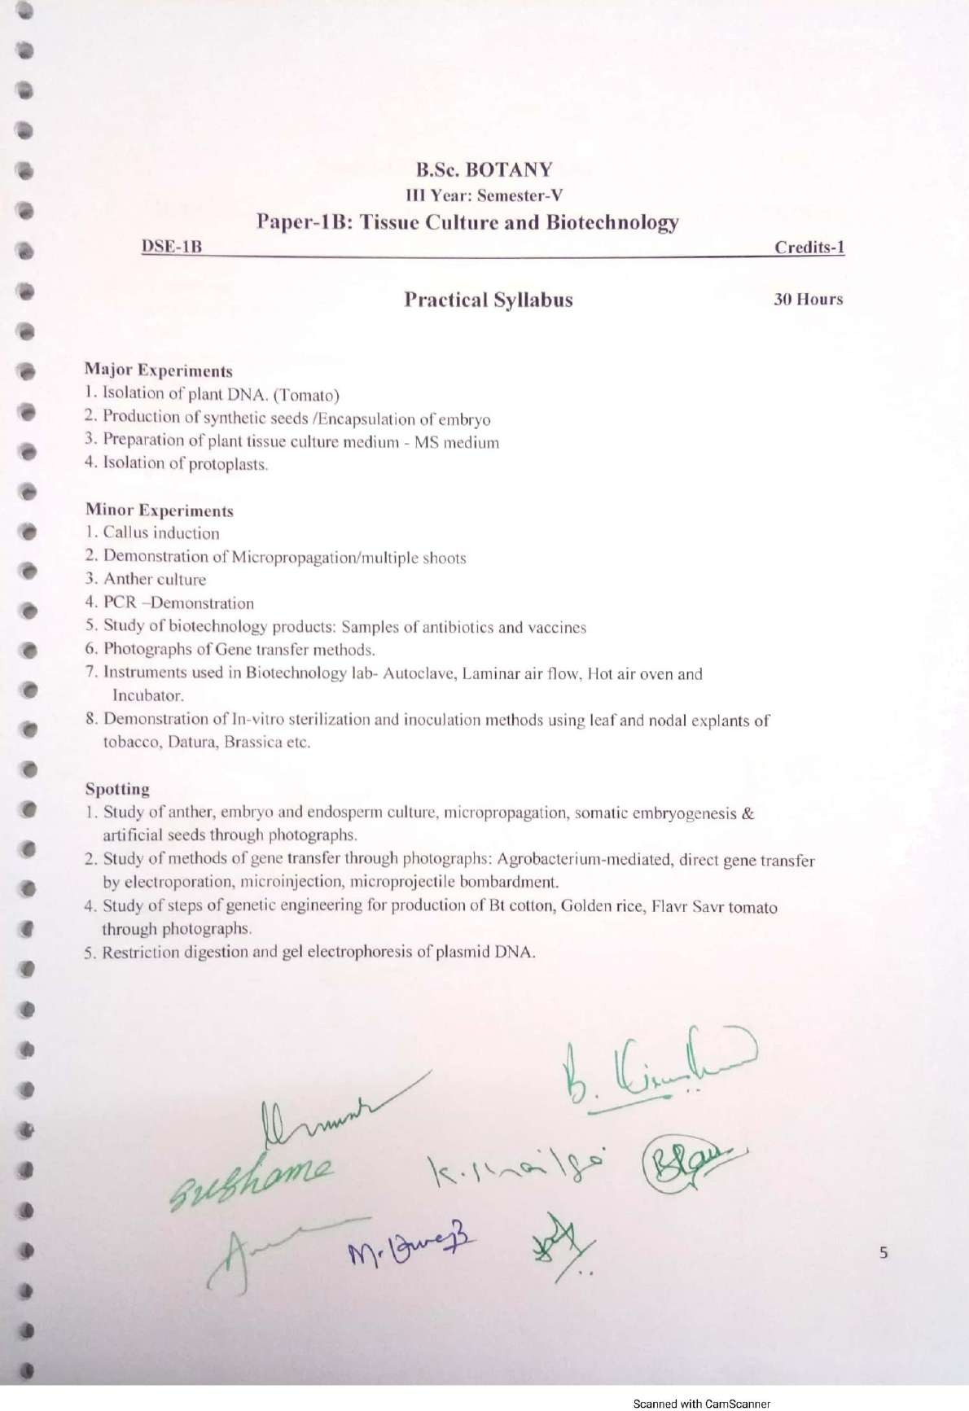

Palamuru University-UG syllabus Botany

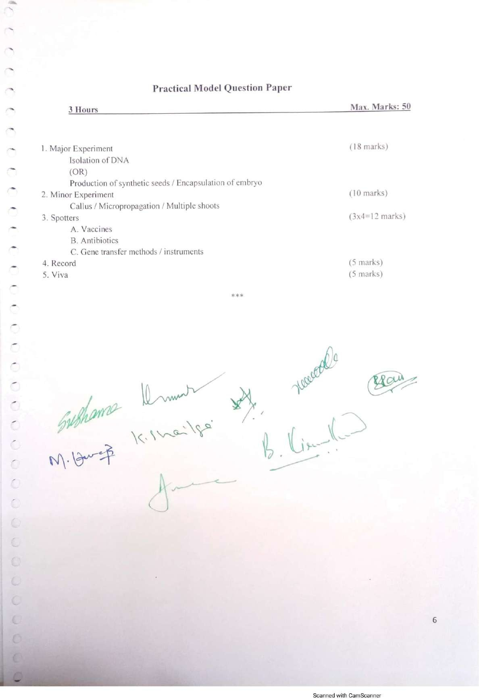

Palamuru University-UG syllabus Botany

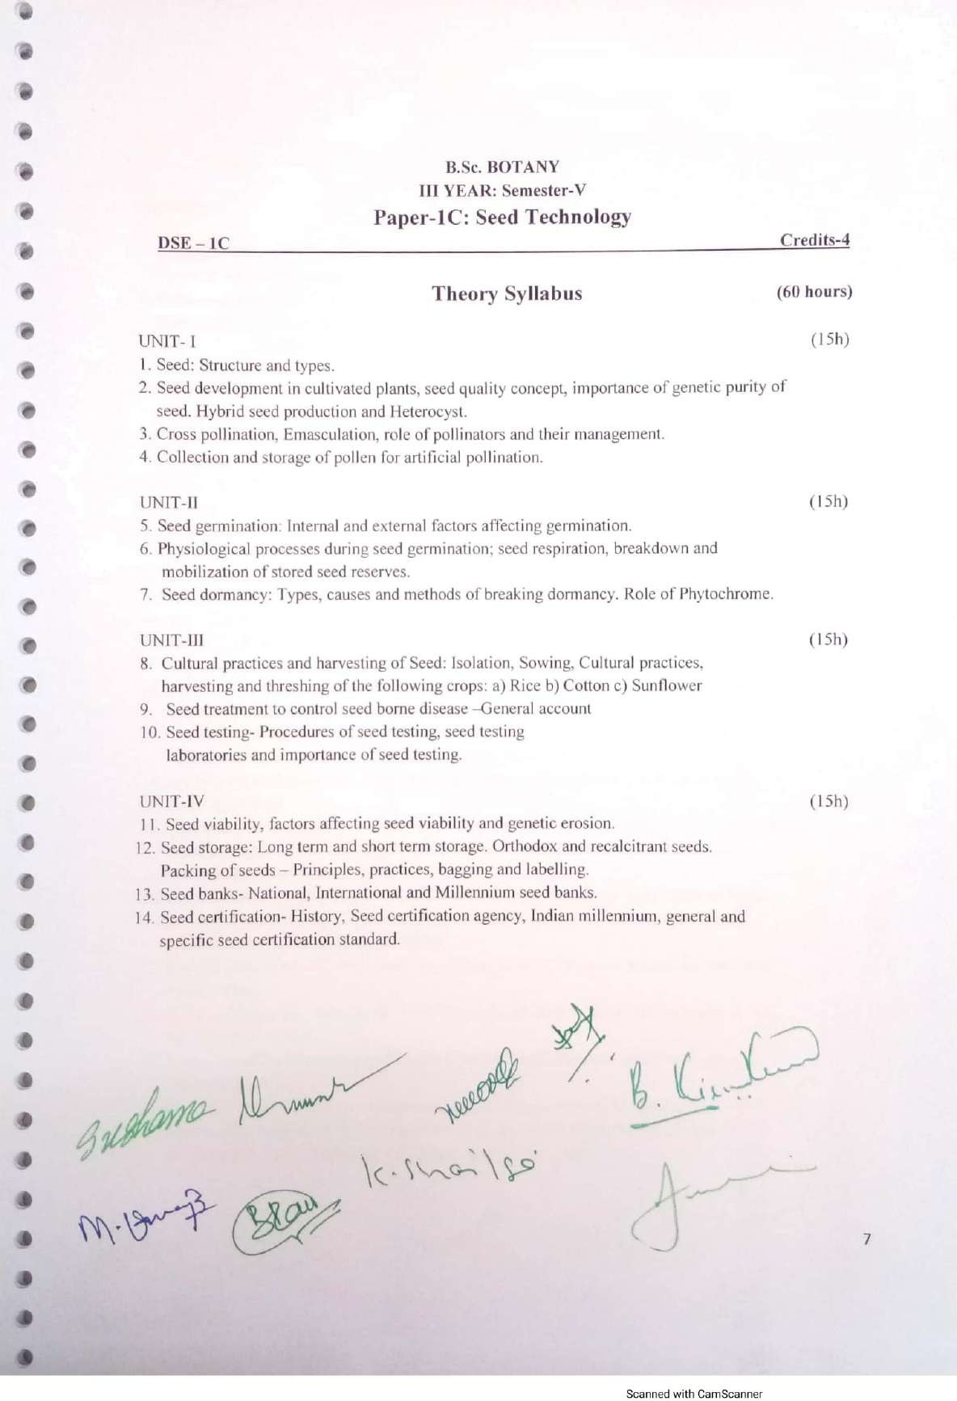

Palamuru University-UG syllabus Botany

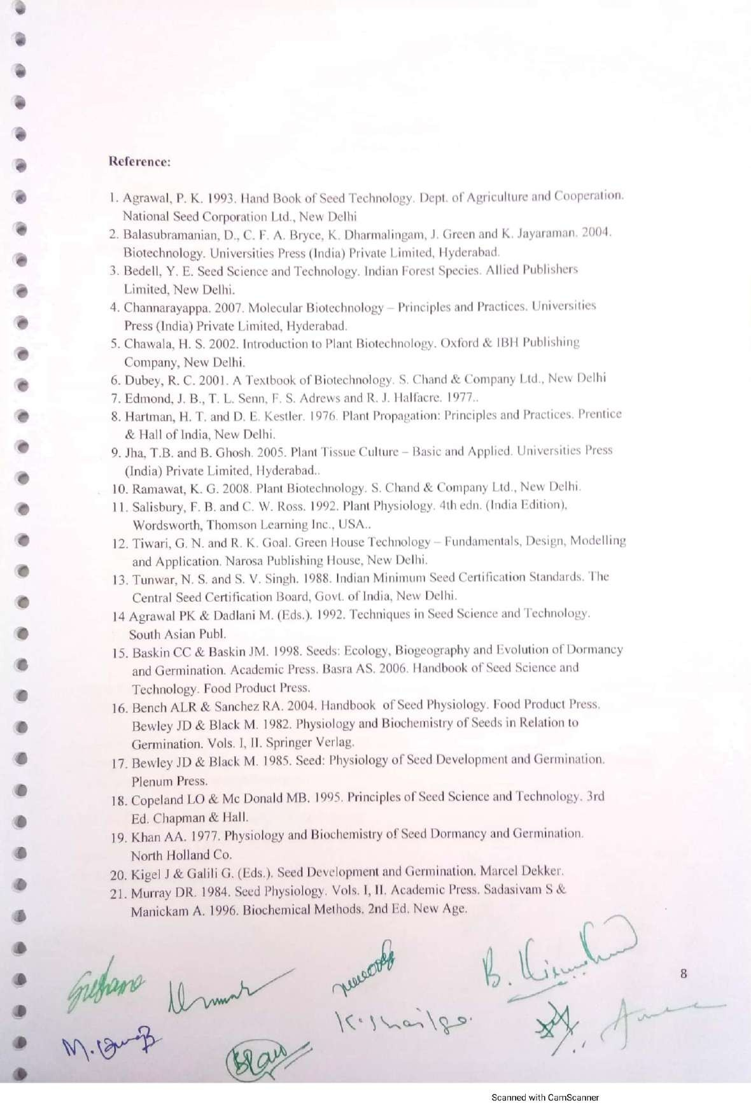

Palamuru University-UG syllabus Botany

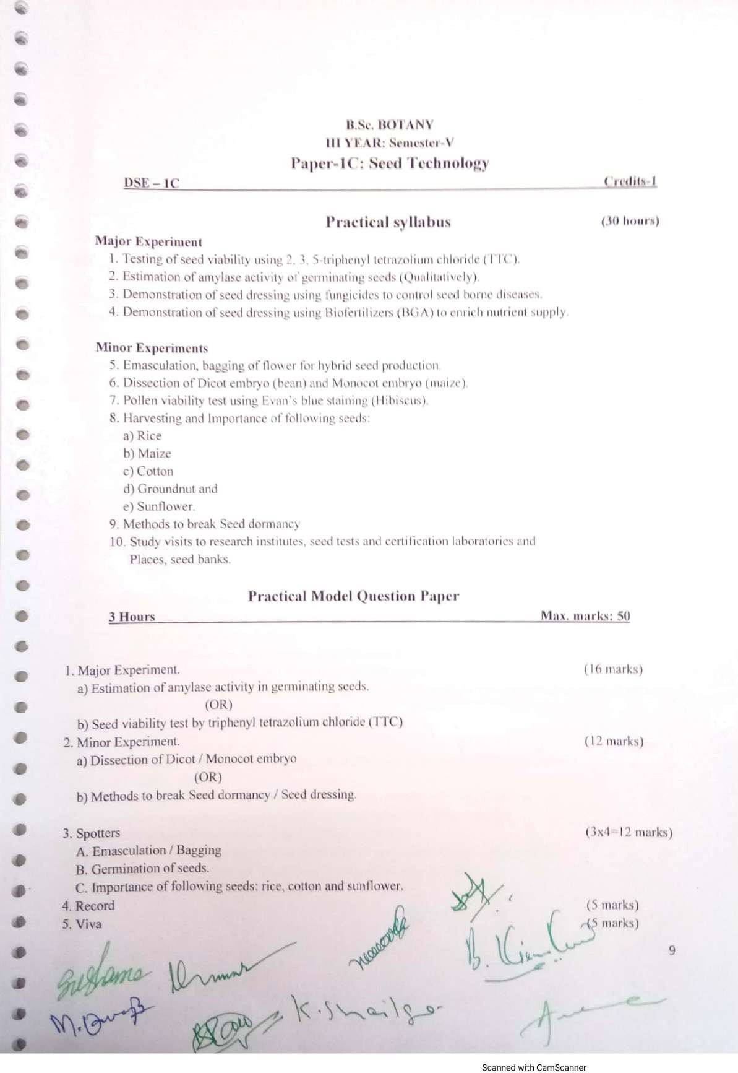

Palamuru University-UG syllabus Botany

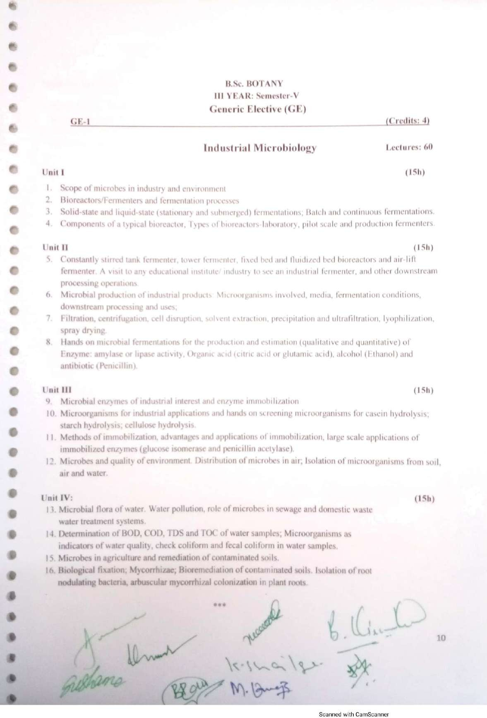

Palamuru University-UG syllabus Botany

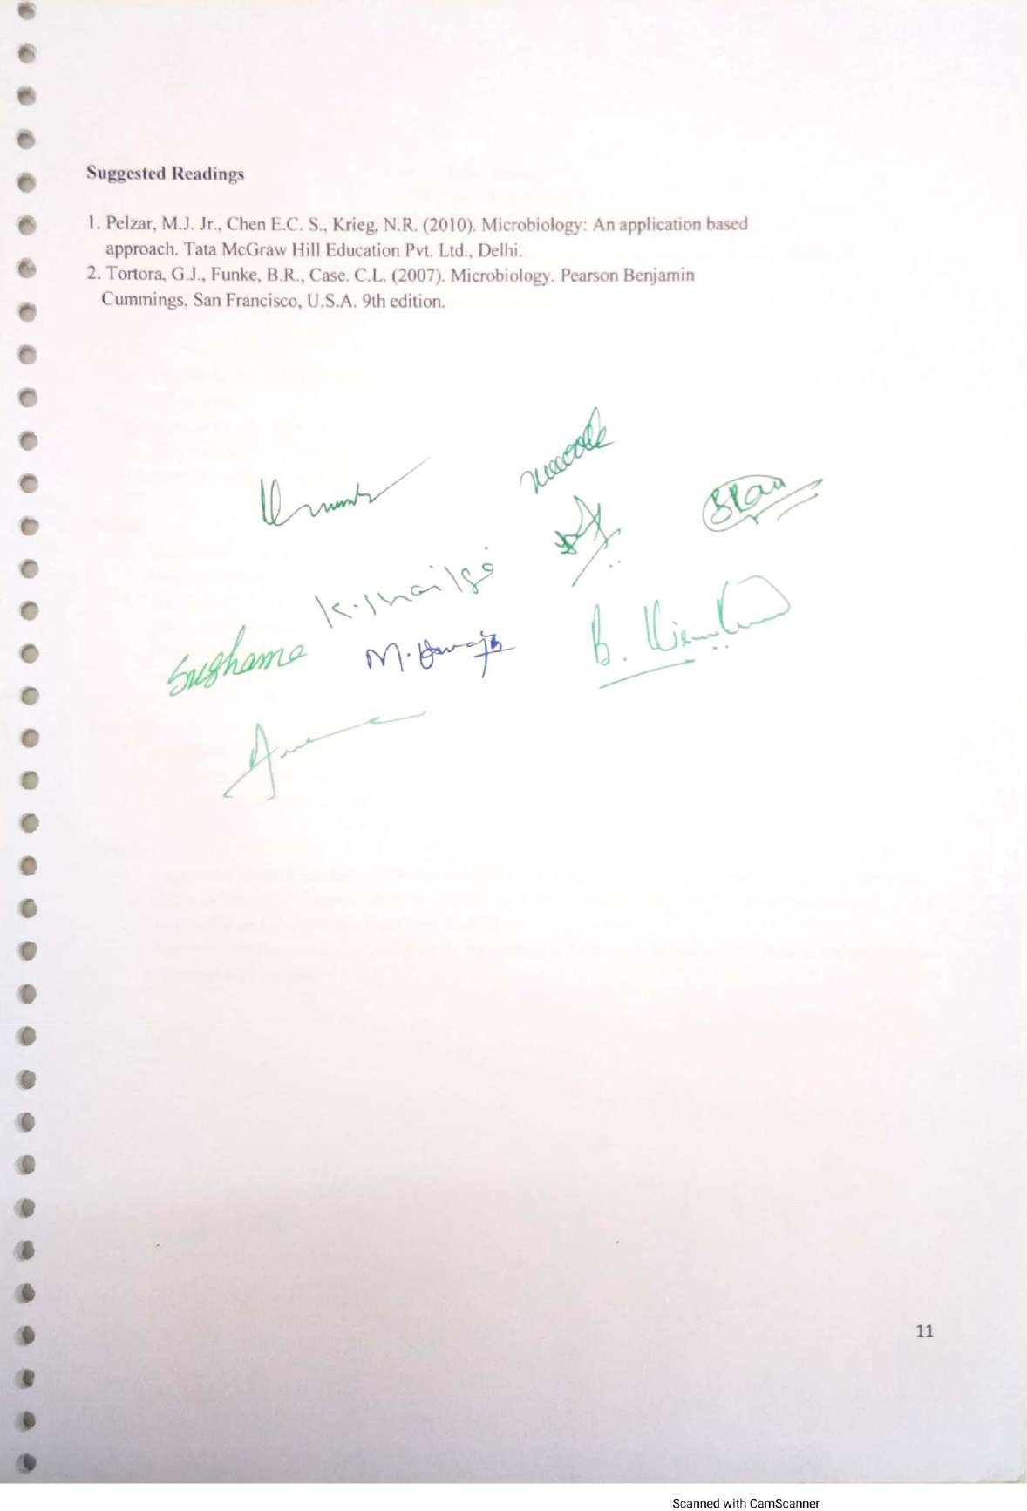

Palamuru University-UG syllabus Botany

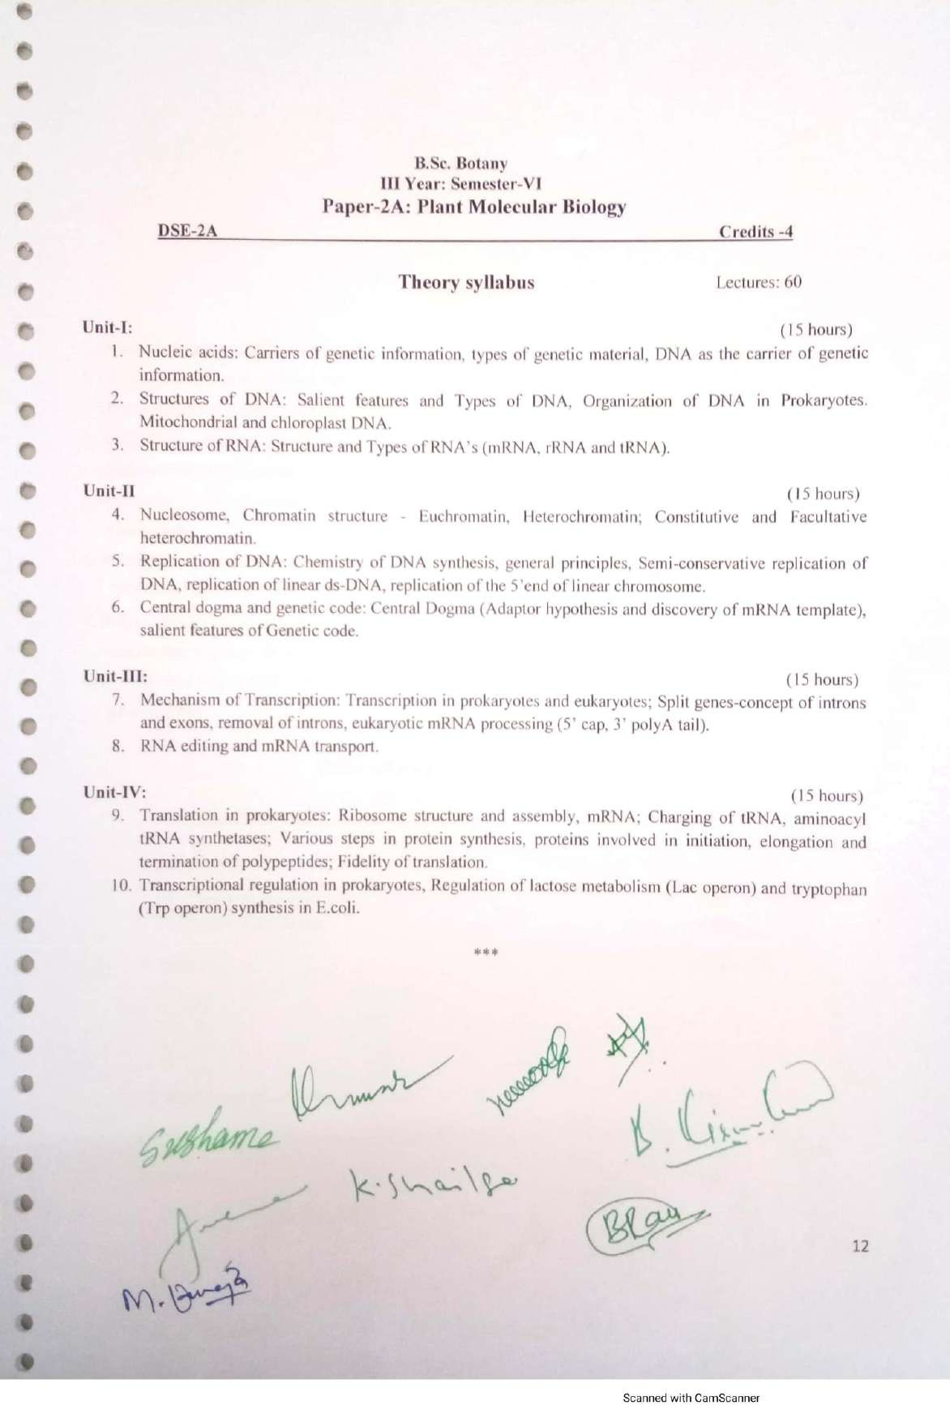

Palamuru University-UG syllabus Botany

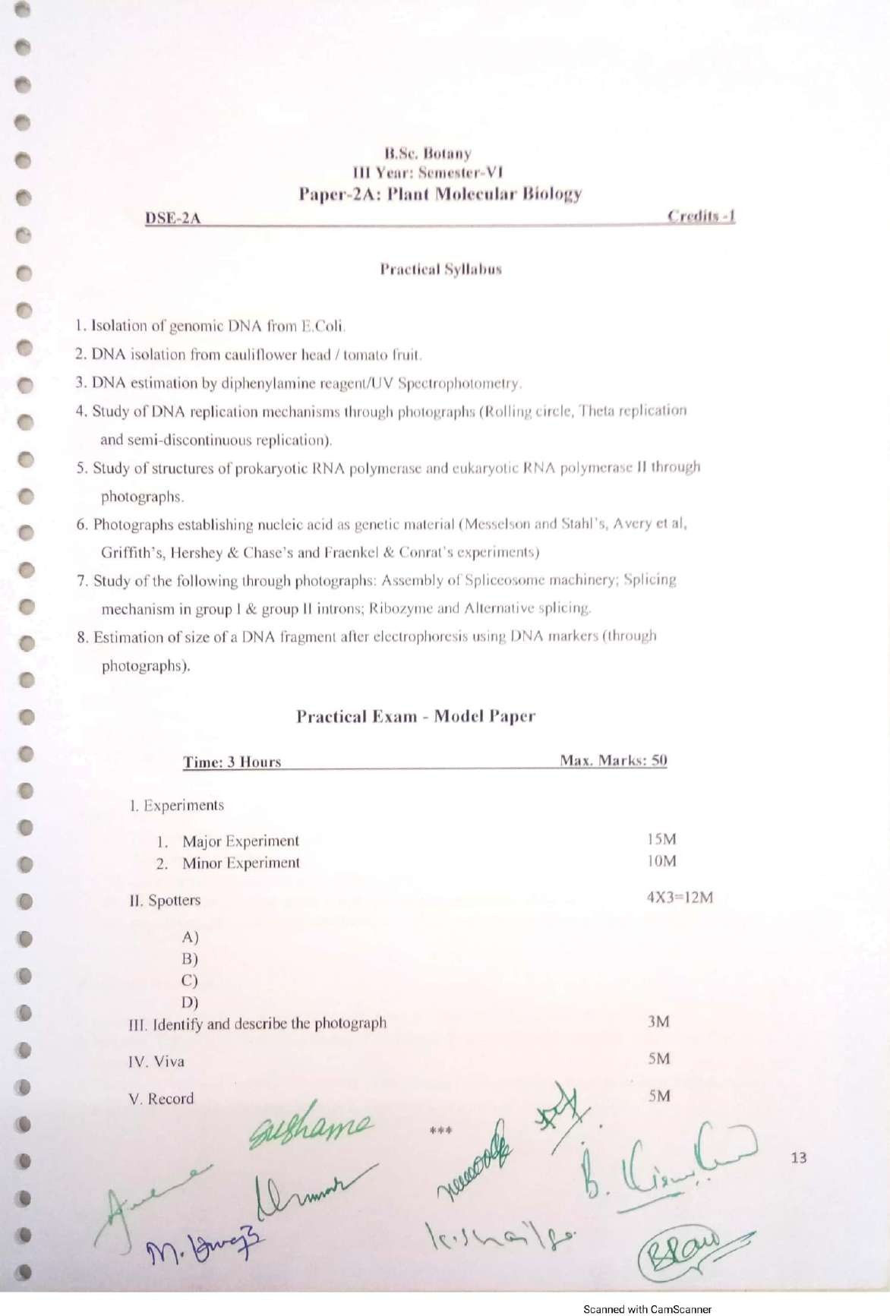

Palamuru University-UG syllabus Botany

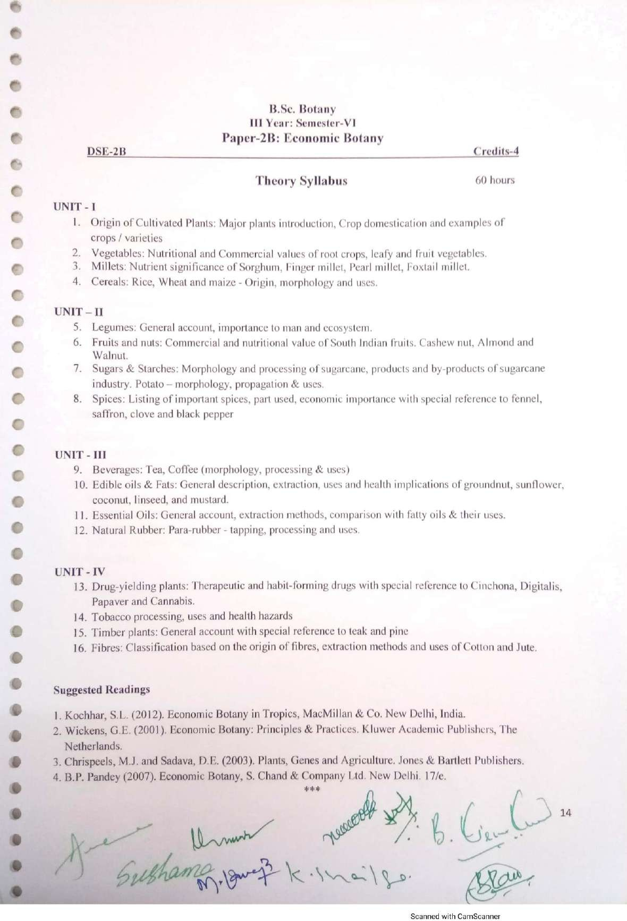

Palamuru University-UG syllabus Botany

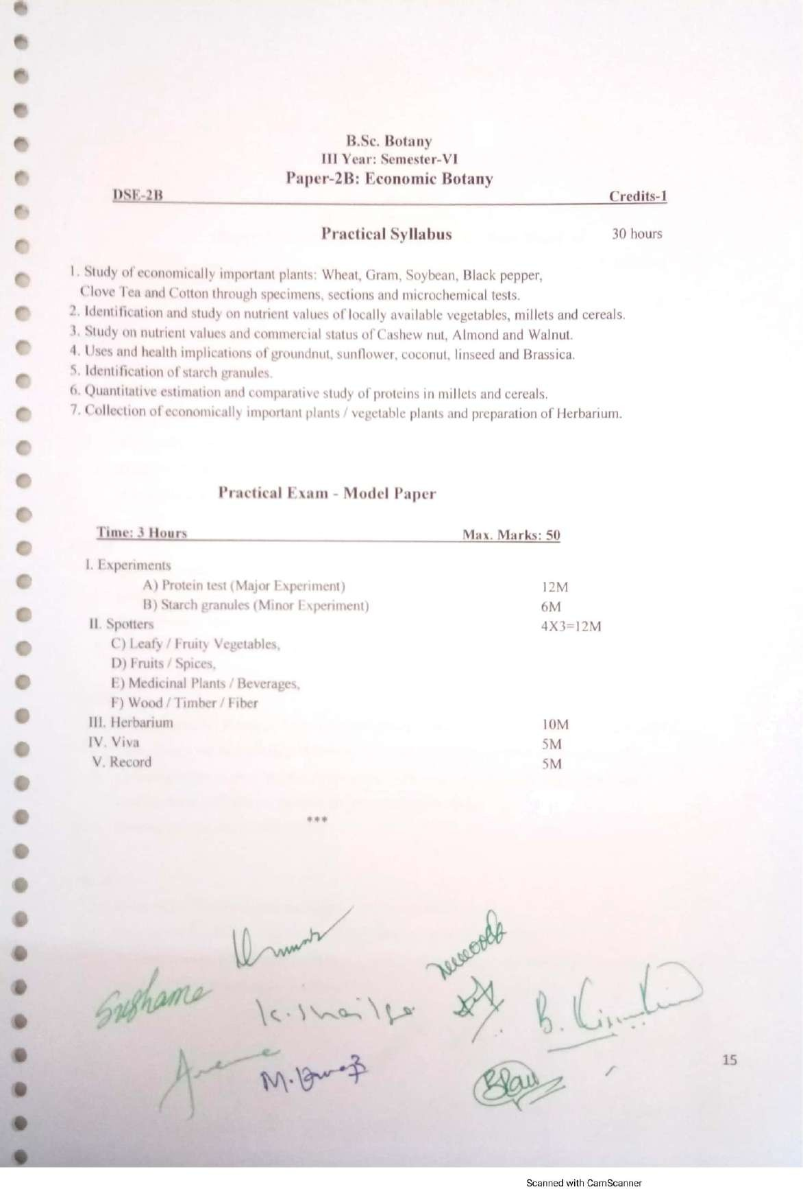

Palamuru University-UG syllabus Botany

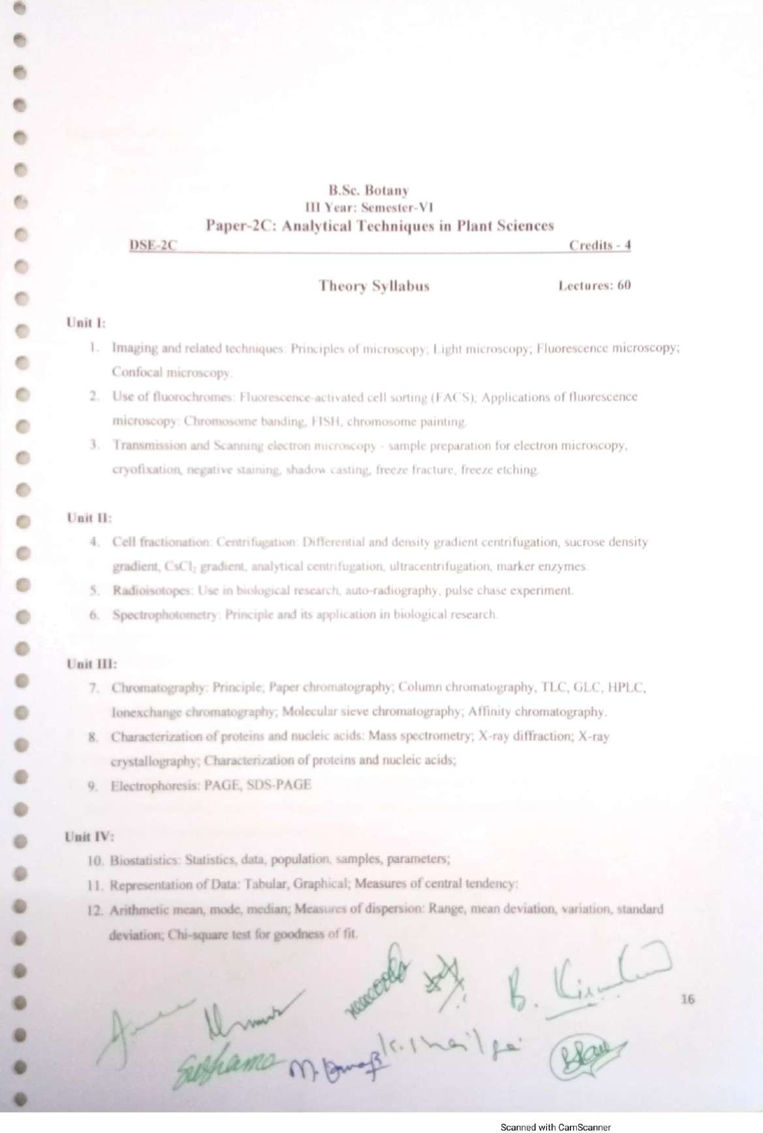

Palamuru University-UG syllabus Botany

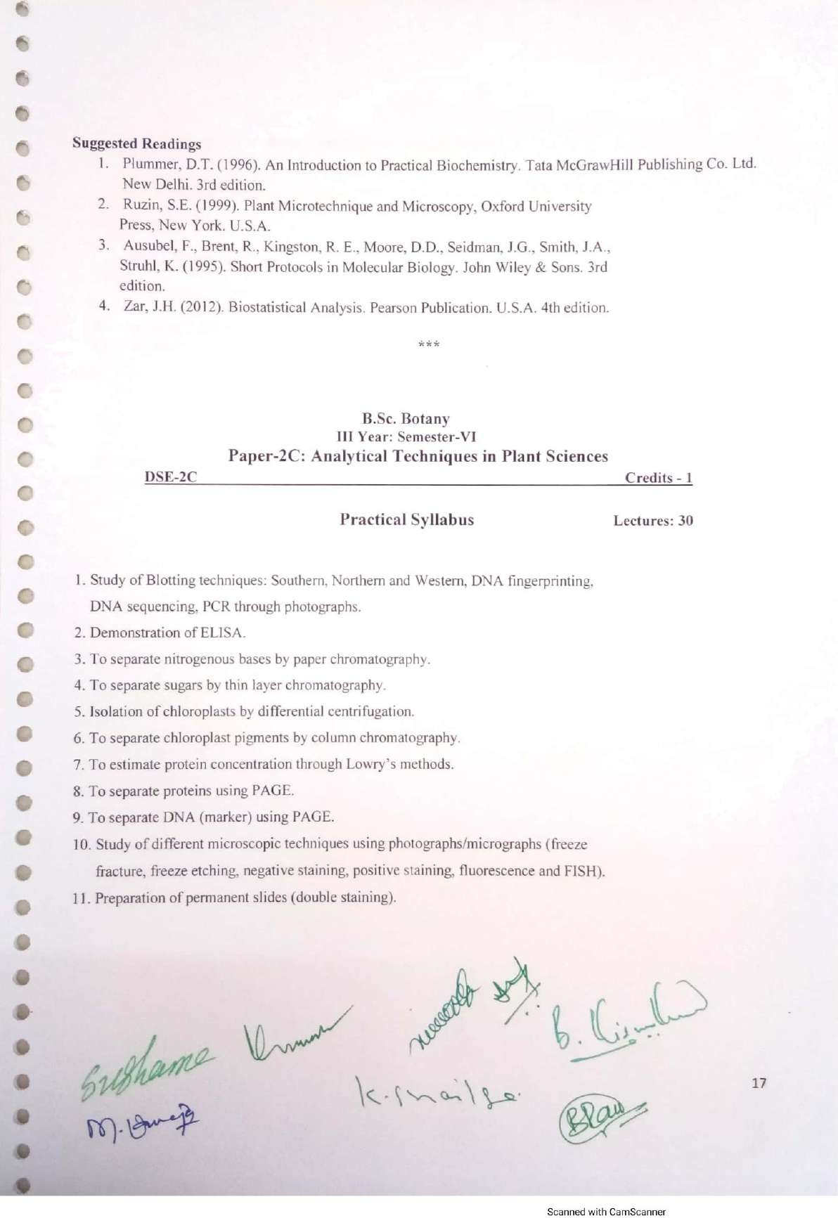

Palamuru University-UG syllabus Botany

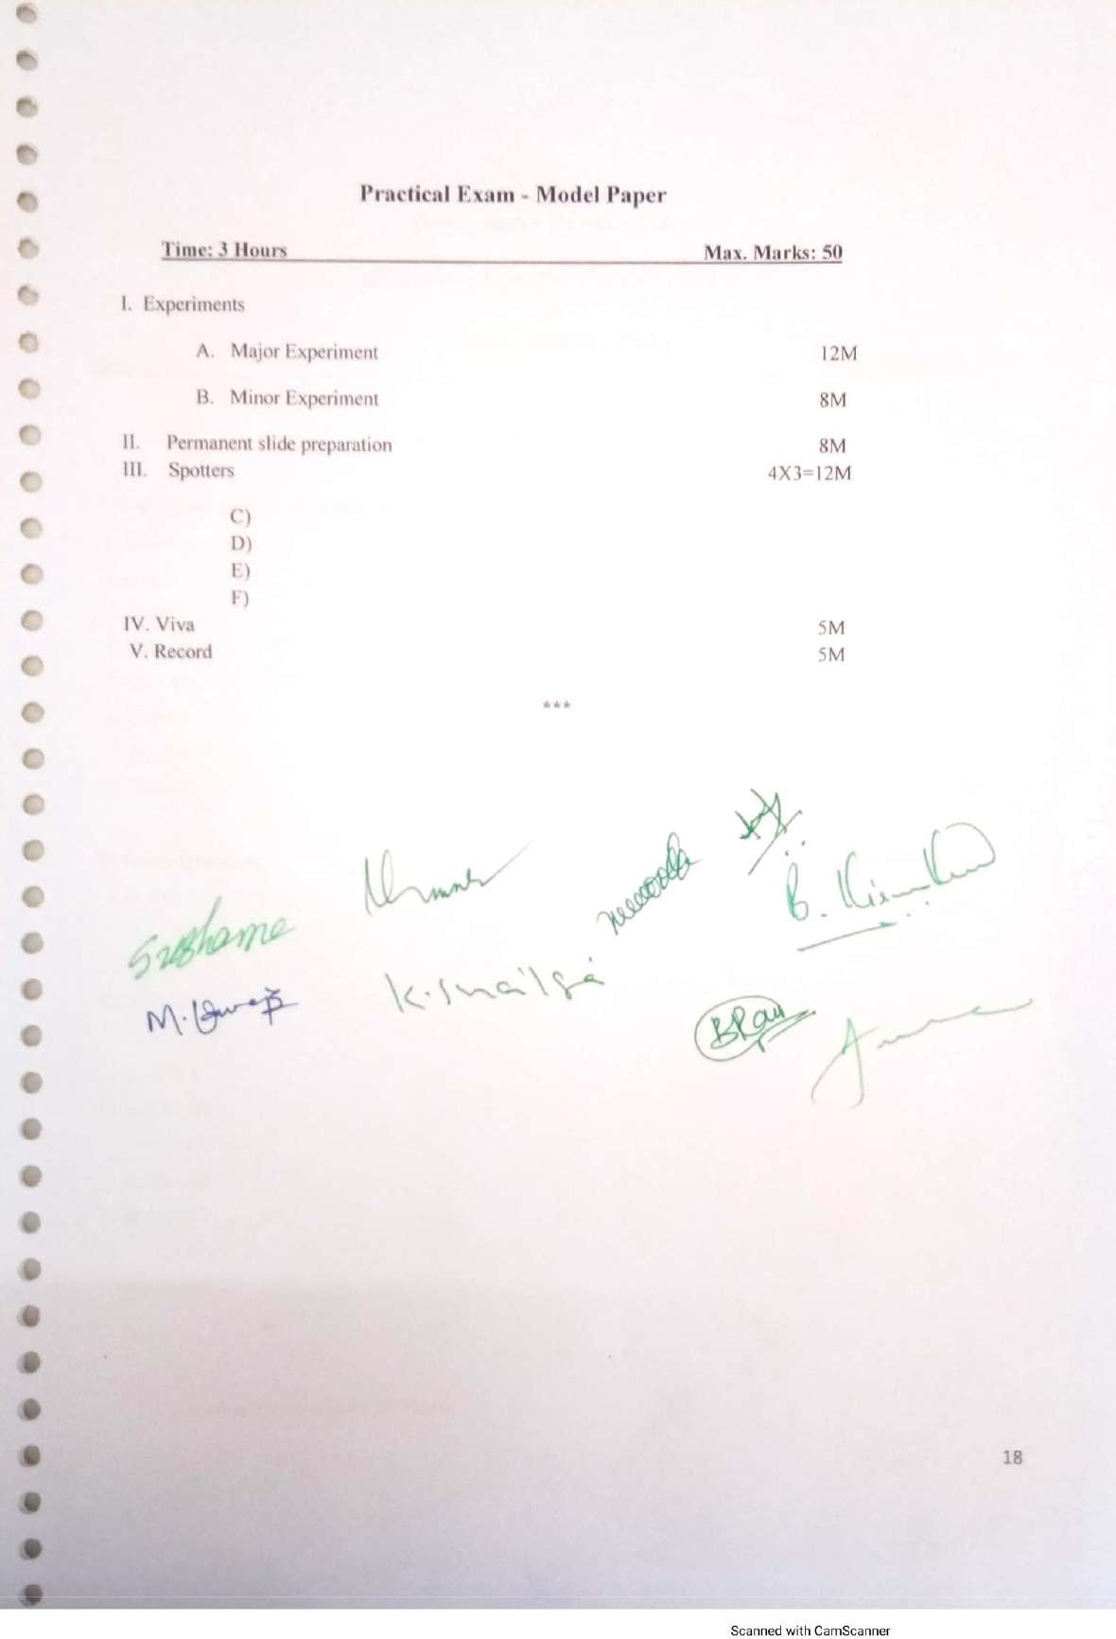

Palamuru University-UG syllabus Botany

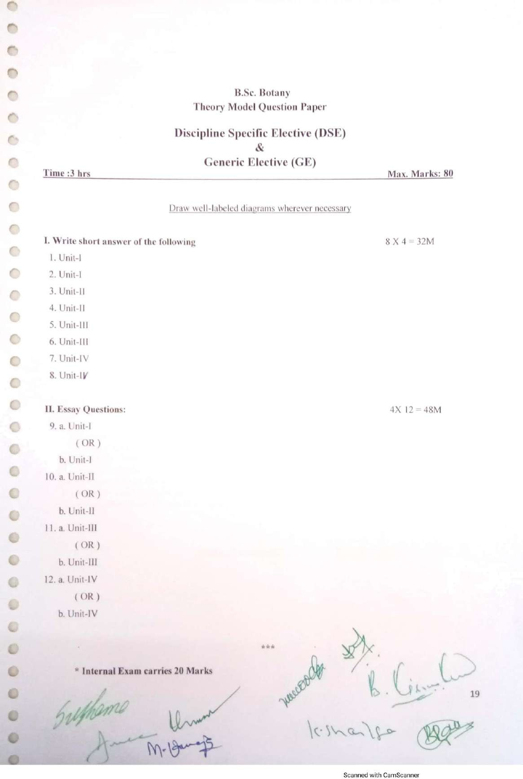

Palamuru University-UG syllabus Botany

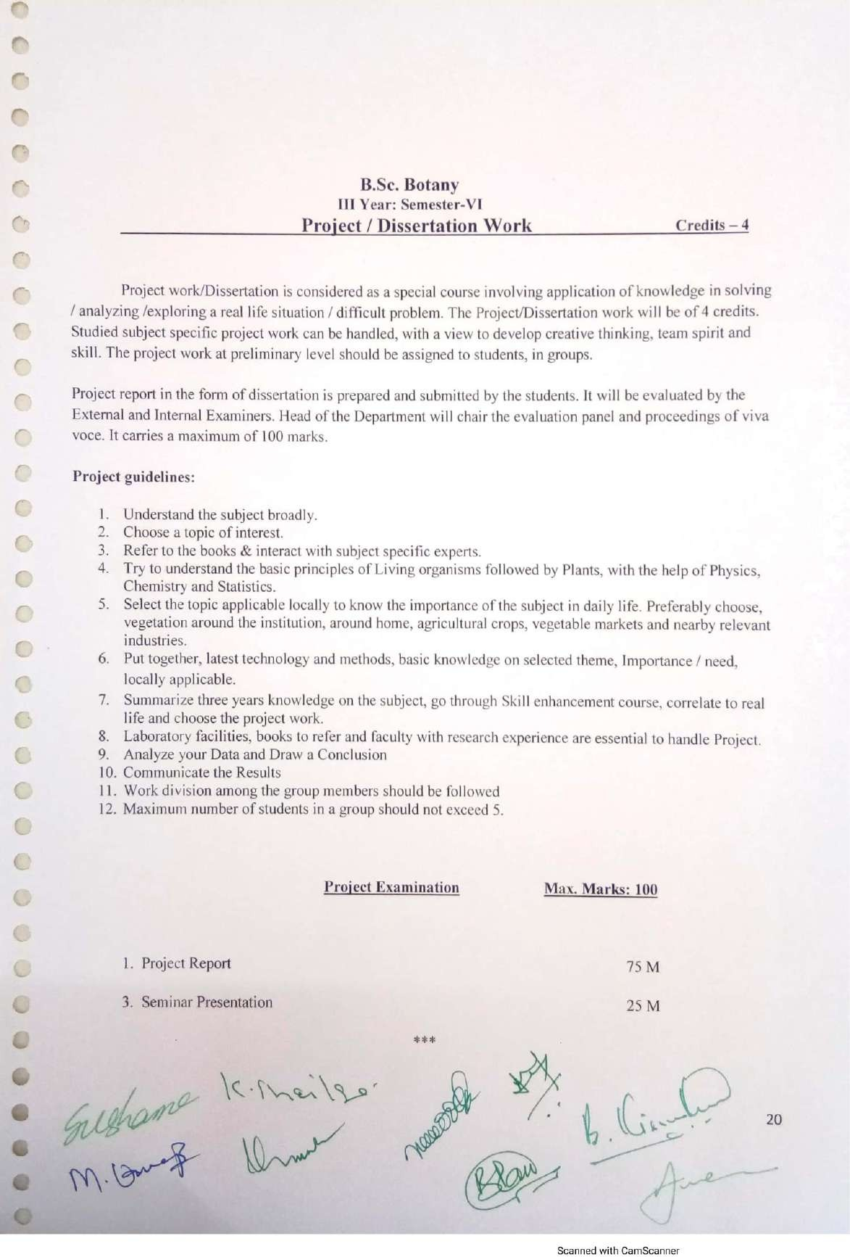

Palamuru University-UG syllabus Botany