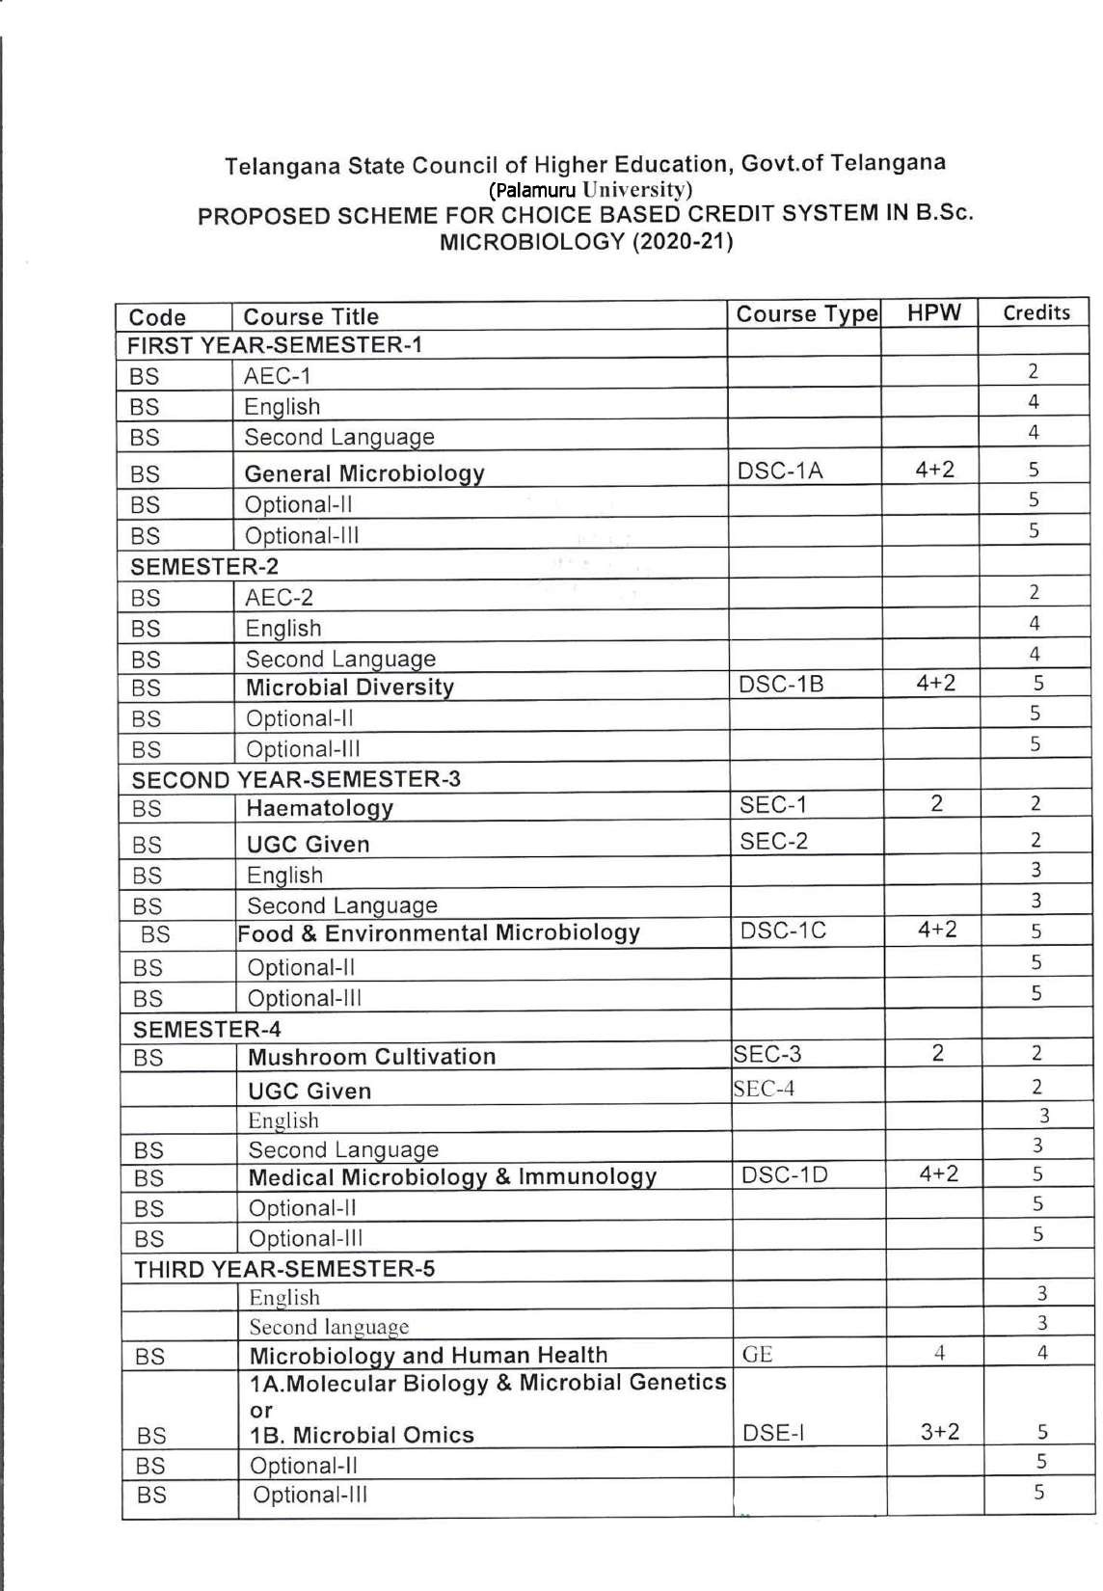

Palamuru University-UG syllabus 2020-21

1

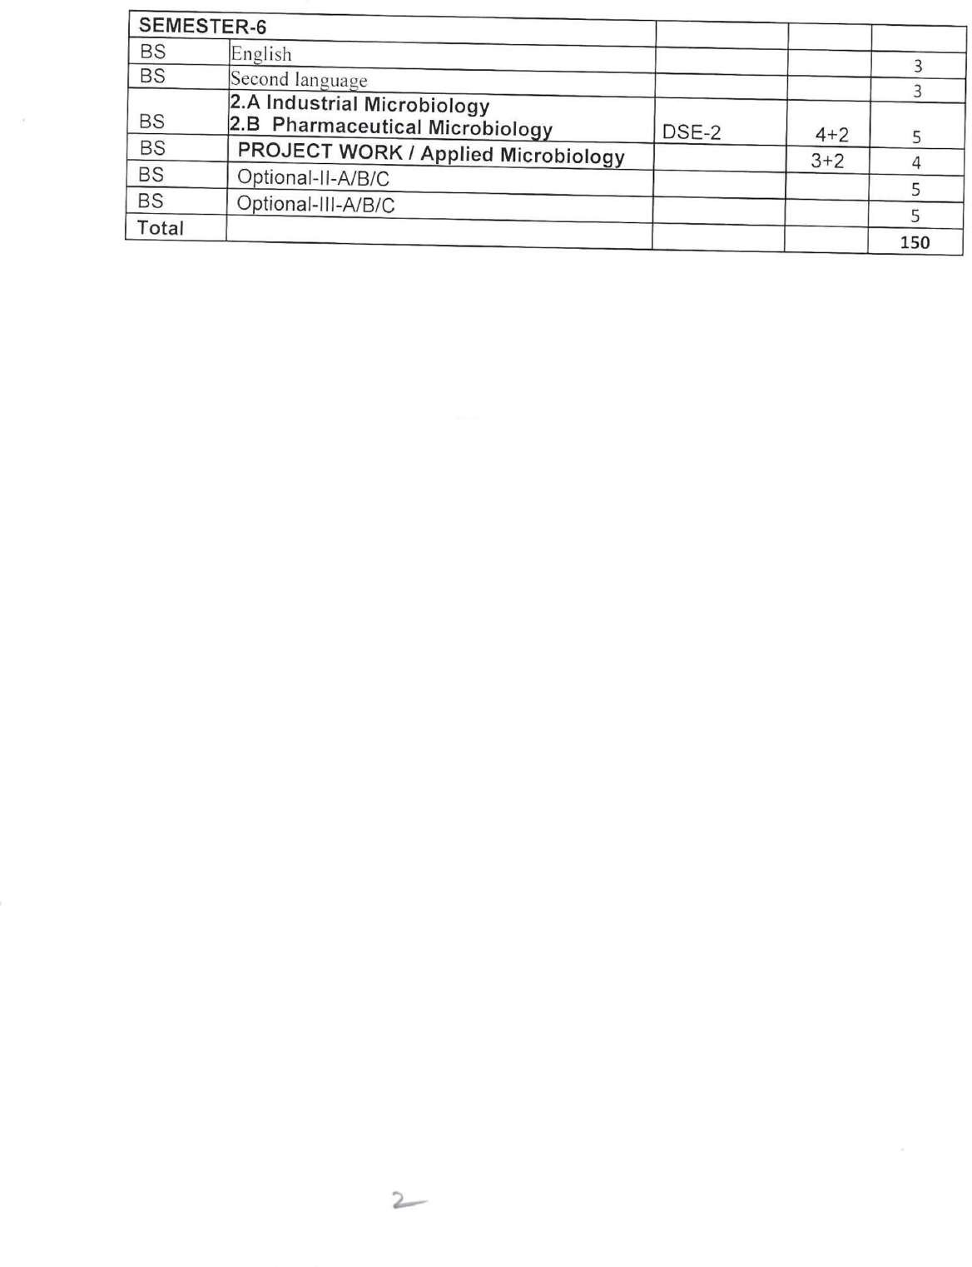

Palamuru University-UG syllabus 2020-21

2

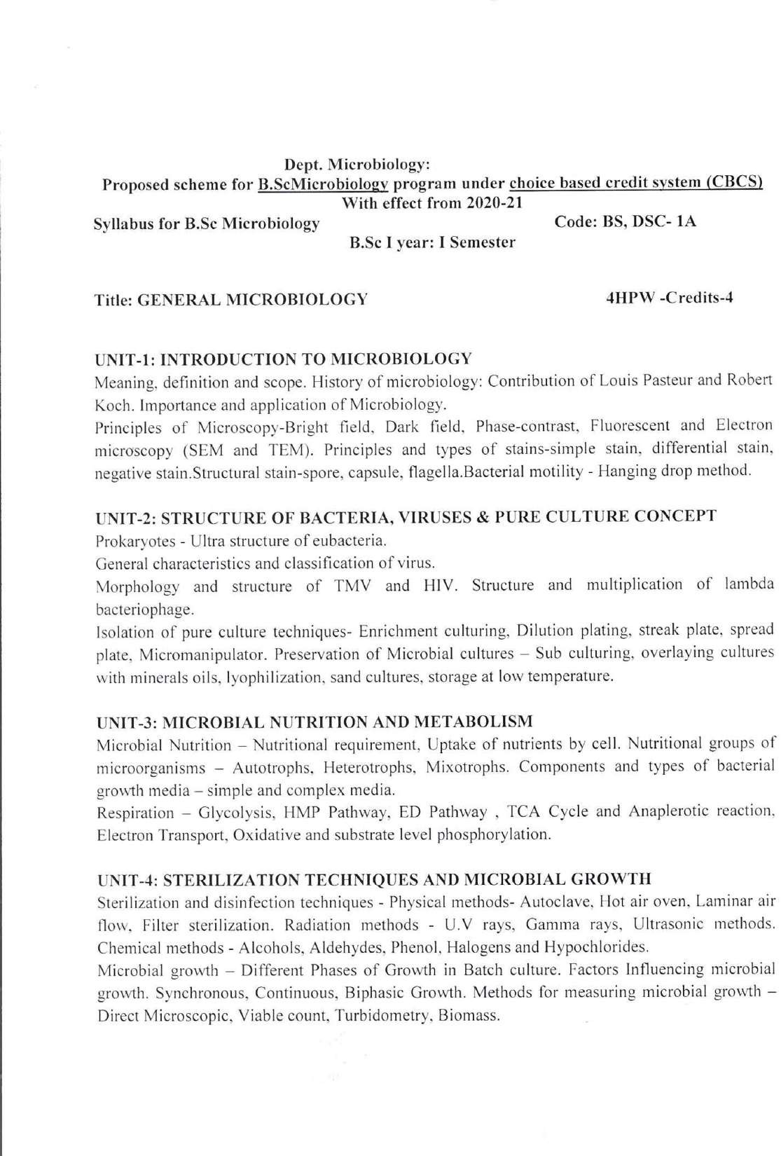

Palamuru University

Palamuru University-UG syllabus 2020-21

3

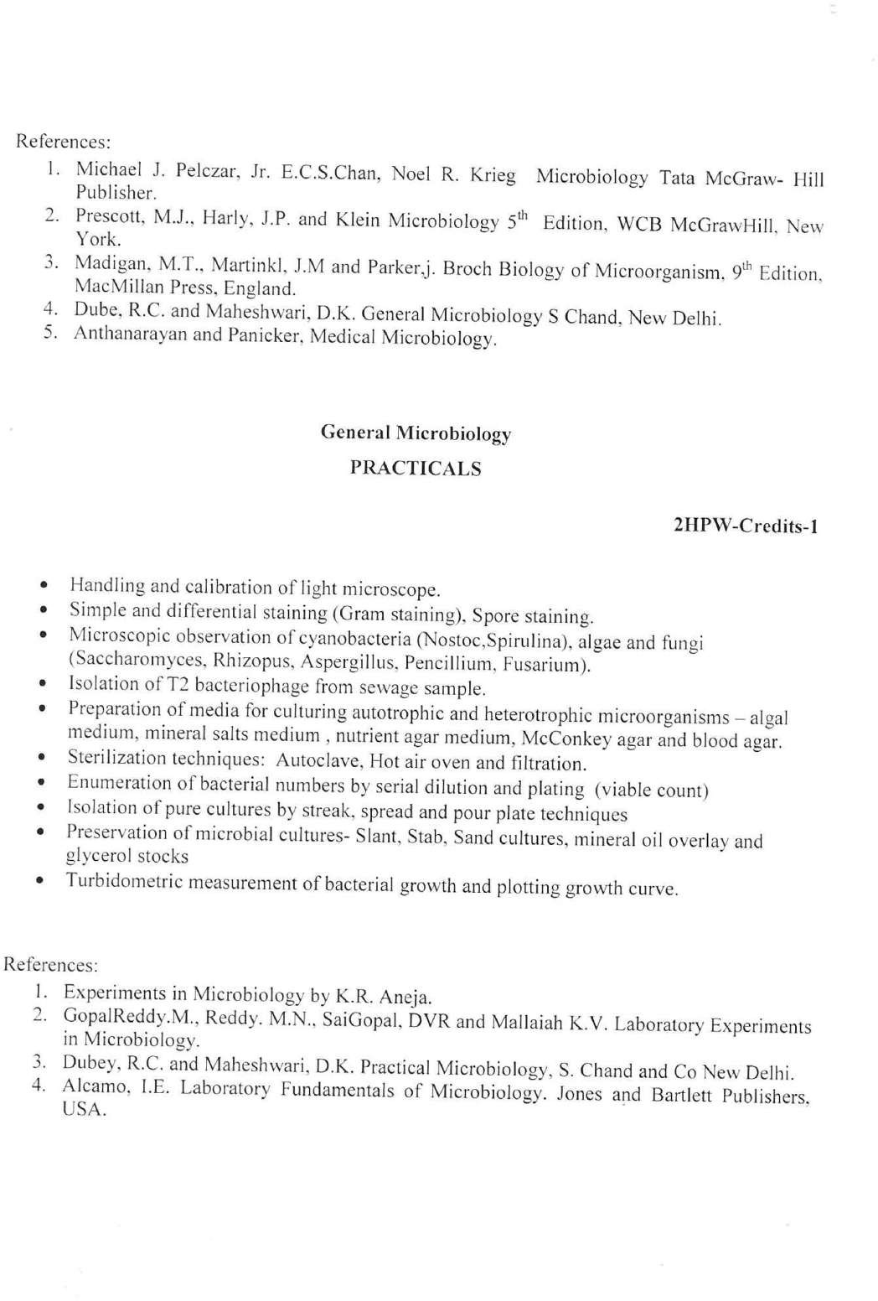

Palamuru University-UG syllabus 2020-21

4

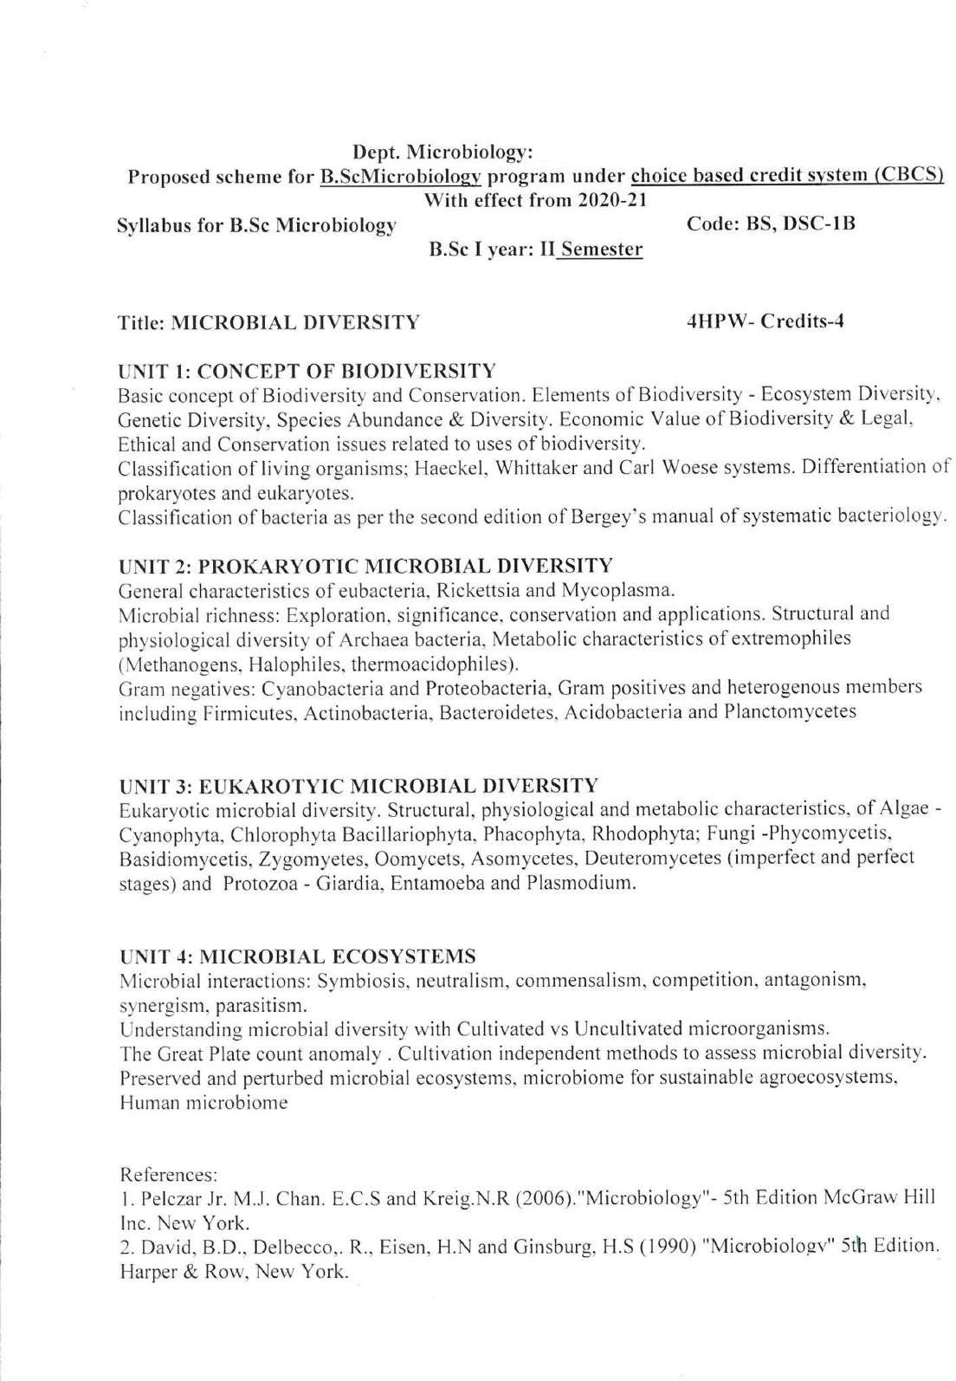

Palamuru University

Palamuru University-UG syllabus 2020-21

5

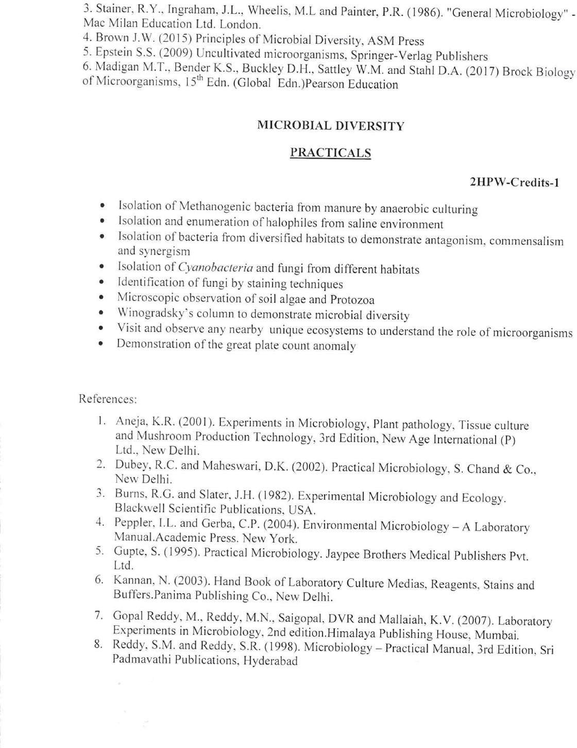

Palamuru University-UG syllabus 2020-21

6

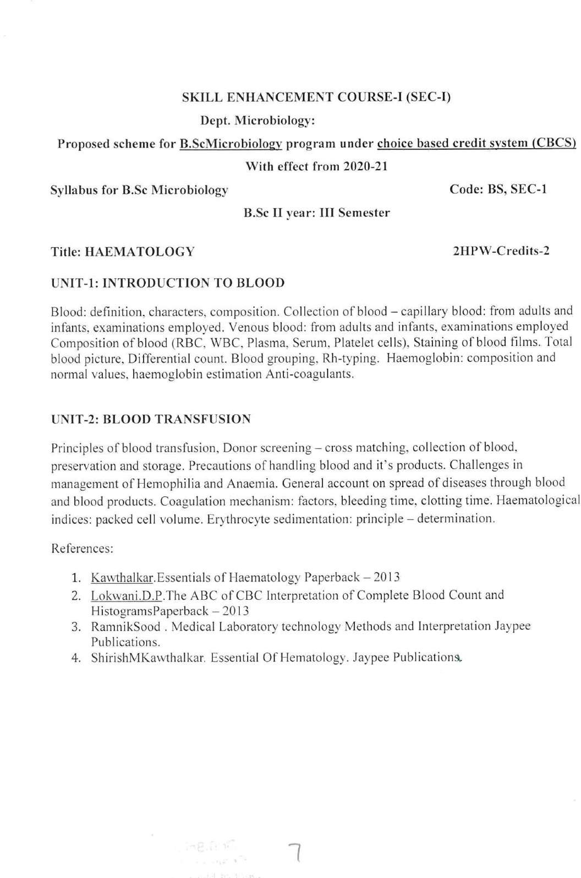

Palamuru University

Palamuru University-UG syllabus 2020-21

7

Palamuru University

Palamuru University-UG syllabus 2020-21

8

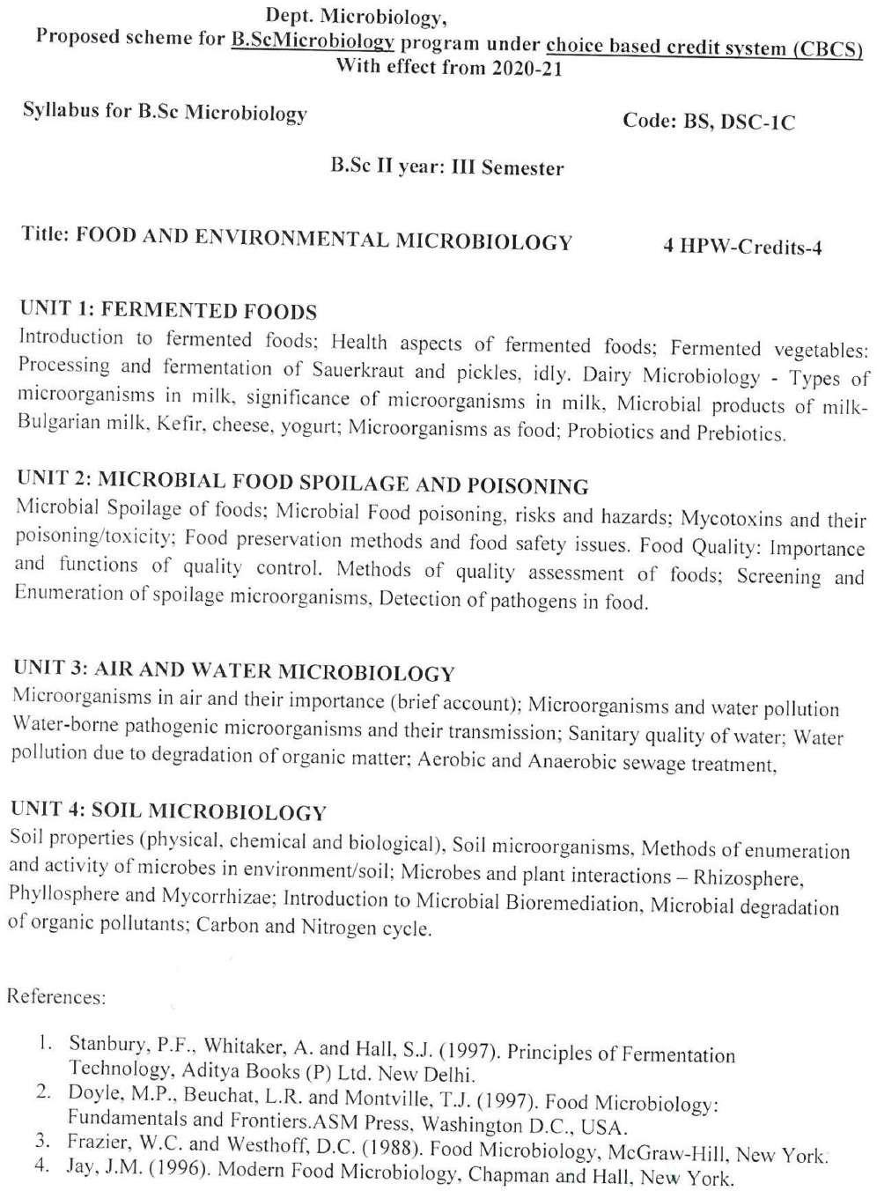

Palamuru University-UG syllabus 2020-21

9

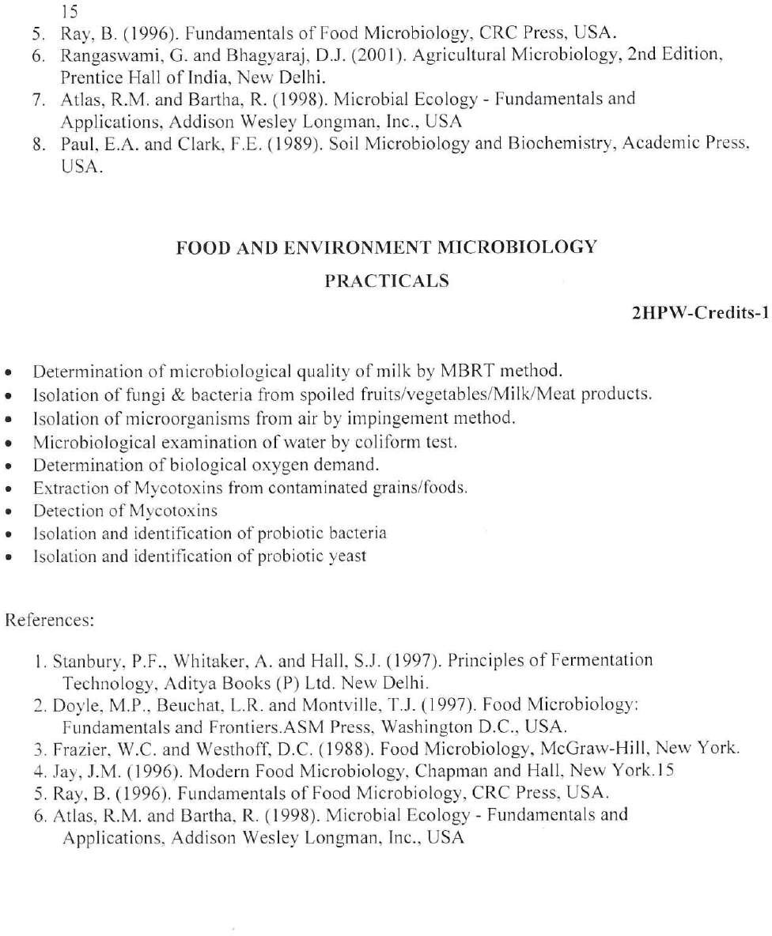

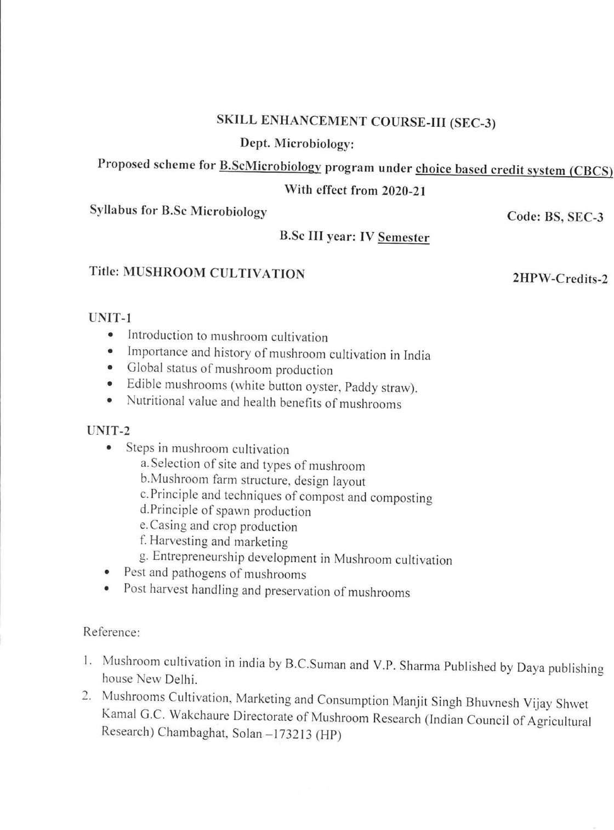

Palamuru University

Palamuru University-UG syllabus 2020-21

10

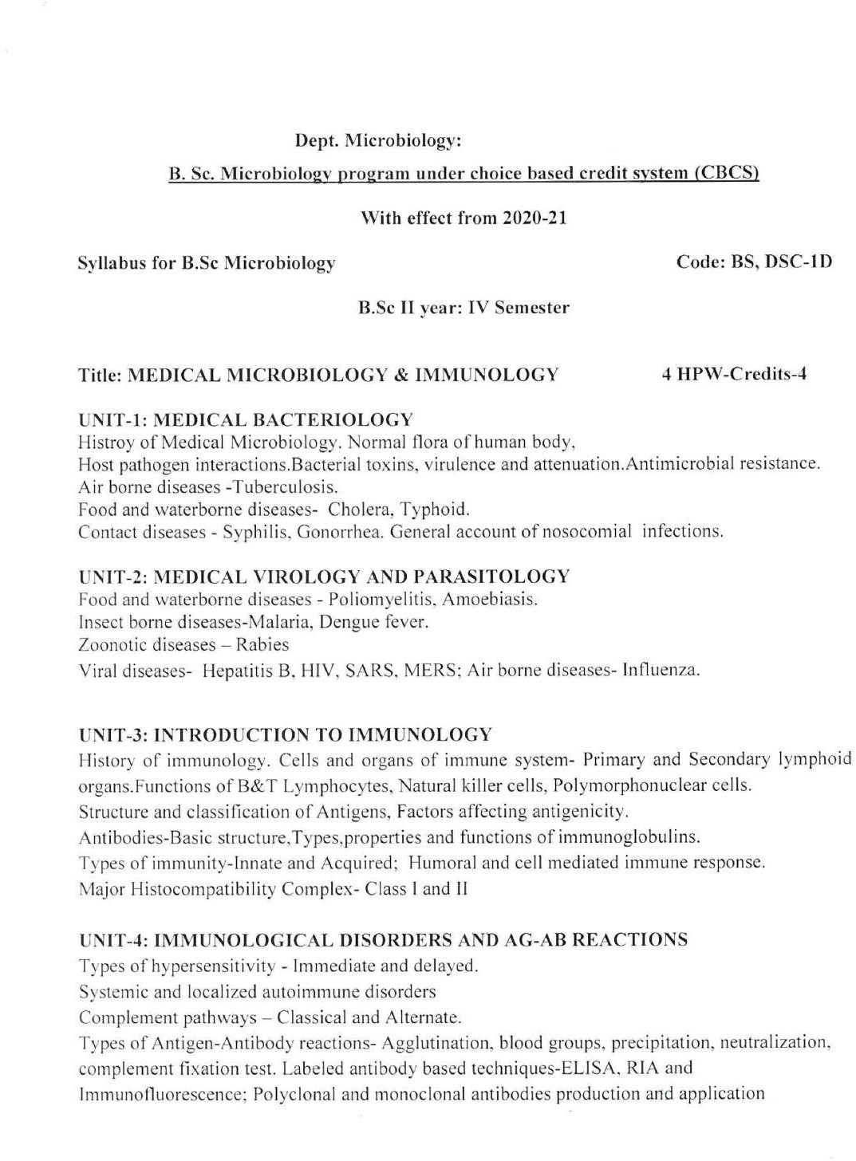

Palamuru University

Palamuru University-UG syllabus 2020-21

11

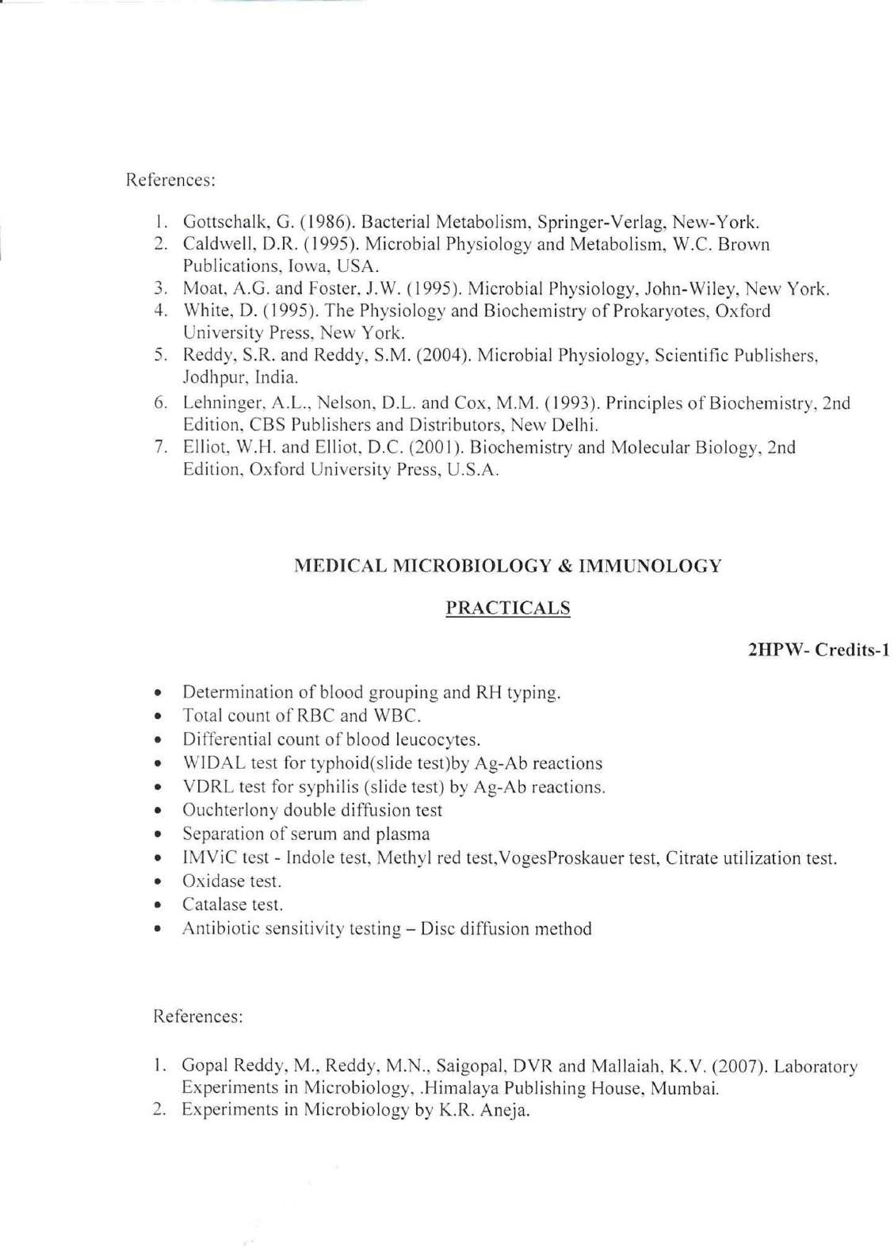

Palamuru University-UG syllabus 2020-21

12

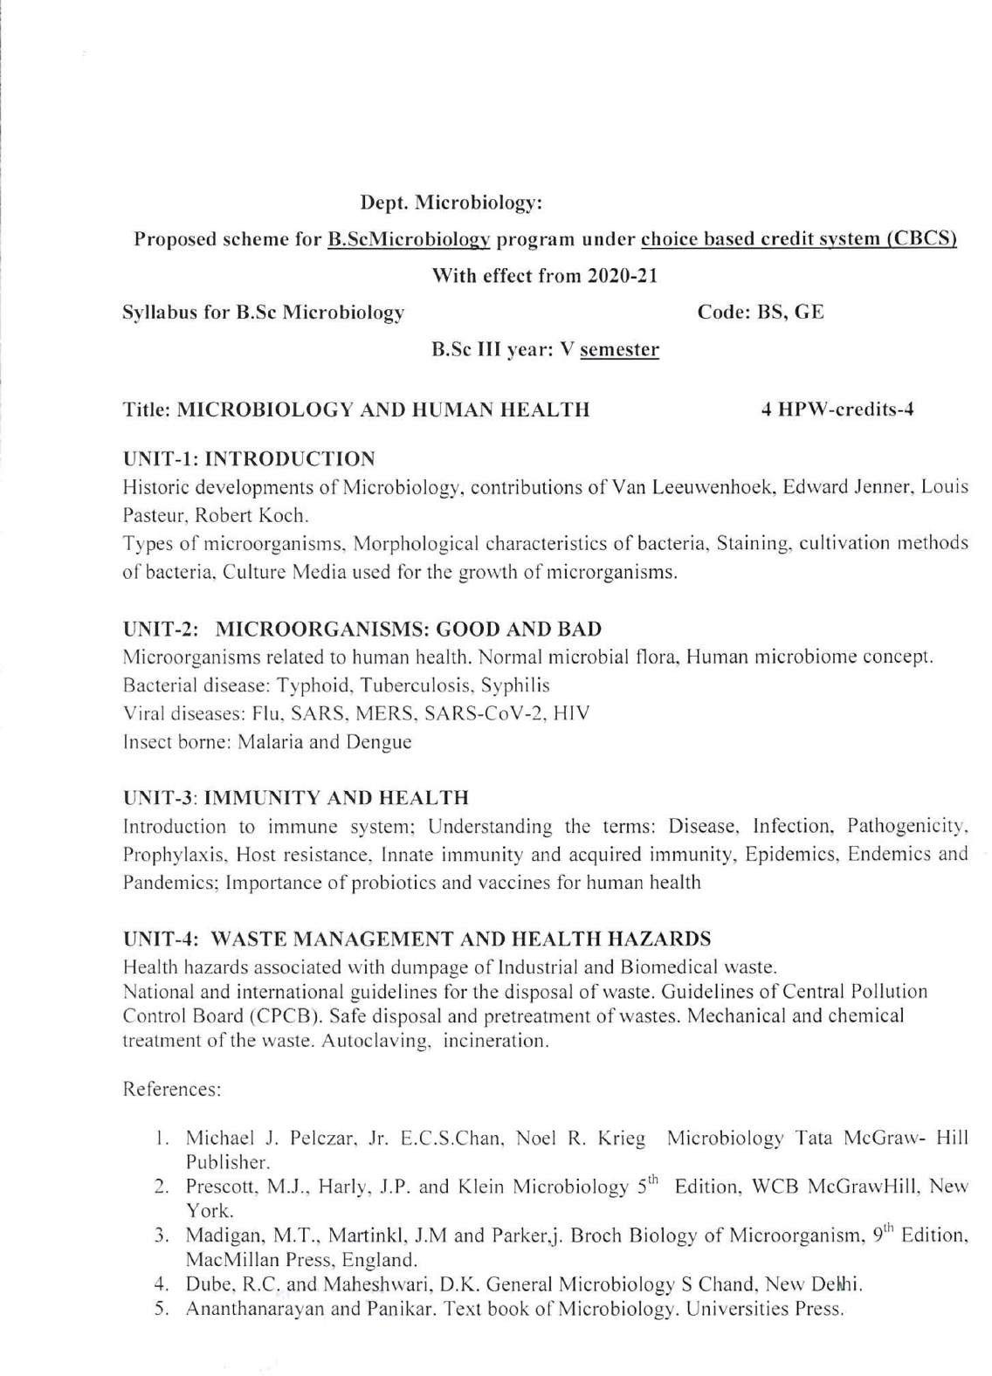

Palamuru University

Palamuru University-UG syllabus 2020-21

13

Palamuru University

Palamuru University-UG syllabus 2020-21

14

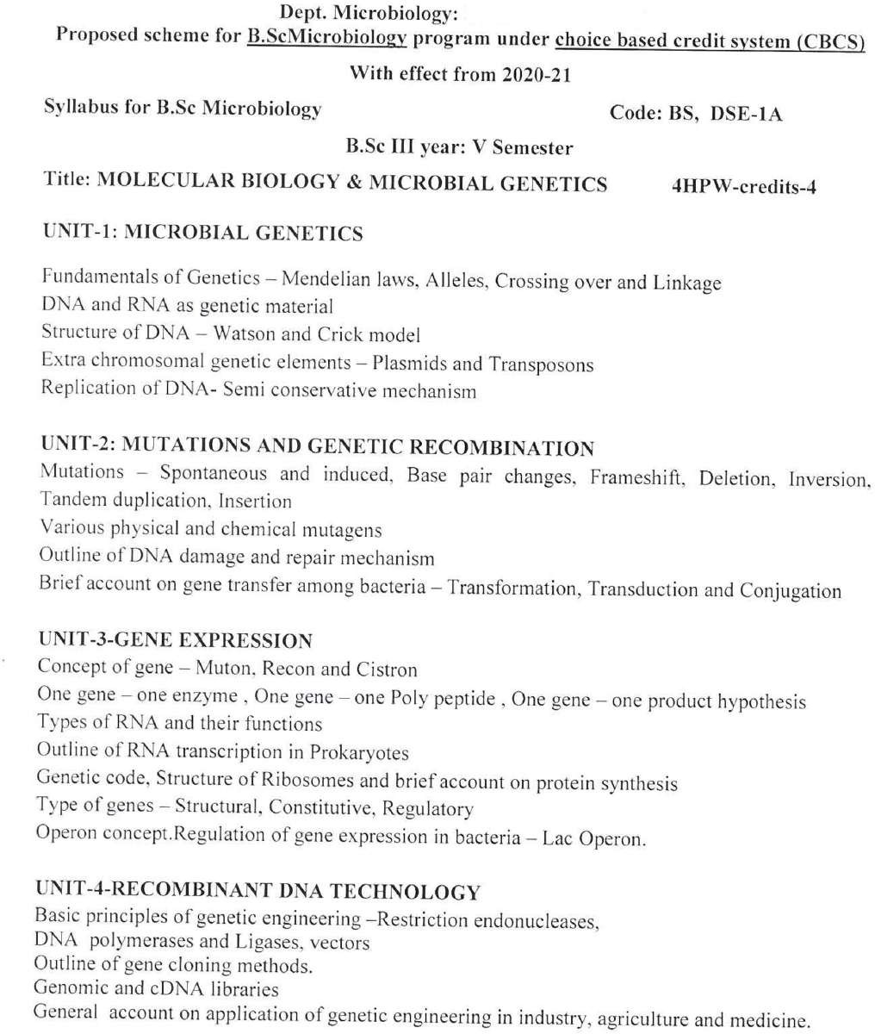

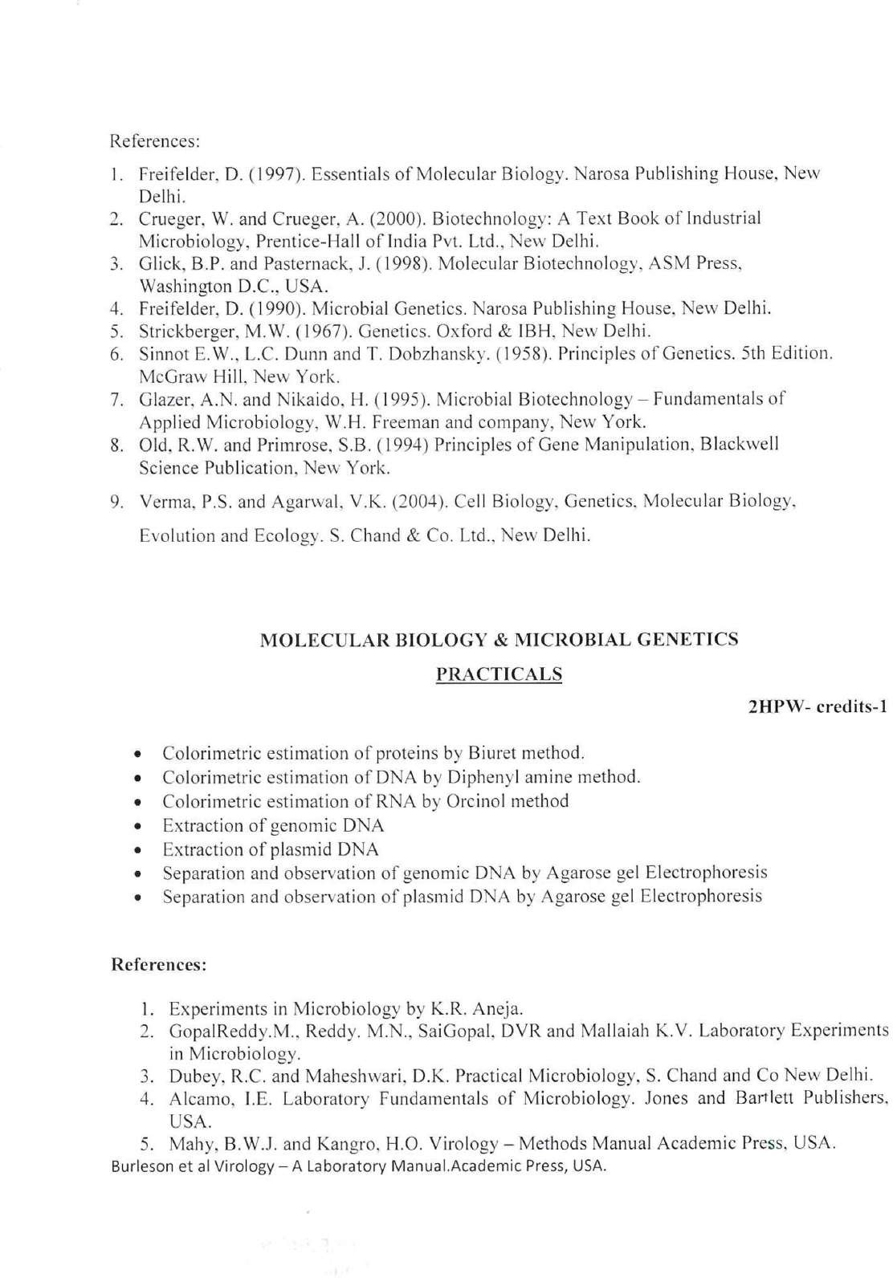

Palamuru University-UG syllabus 2020-21

15

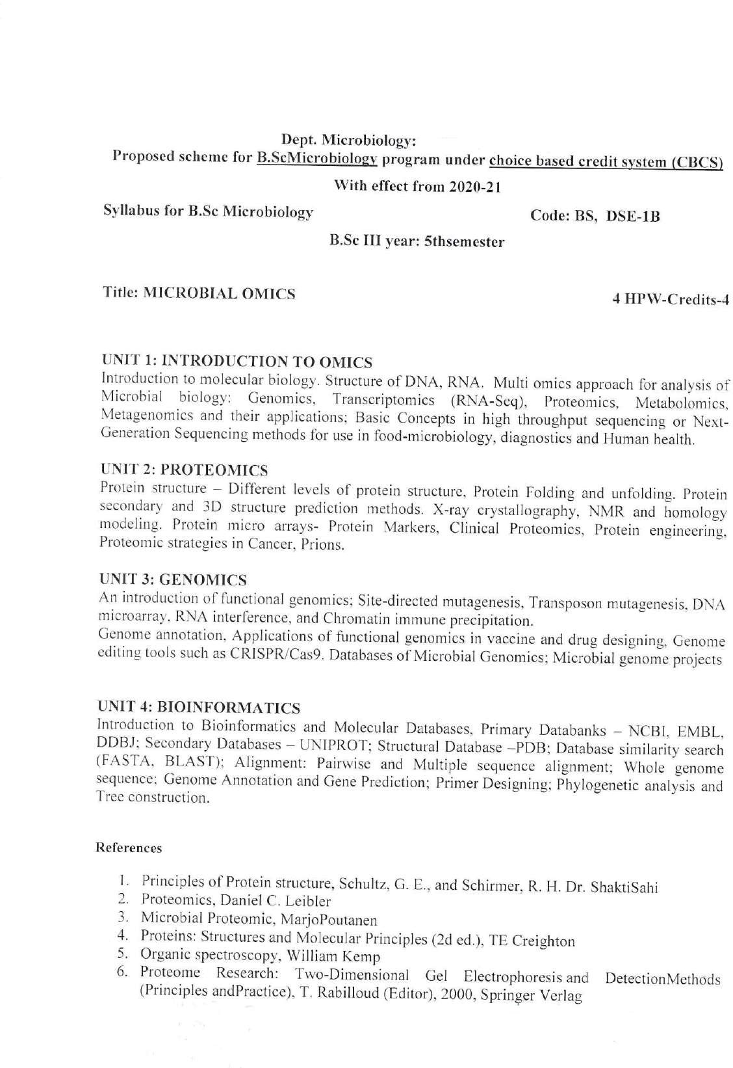

Palamuru University

Palamuru University-UG syllabus 2020-21

16

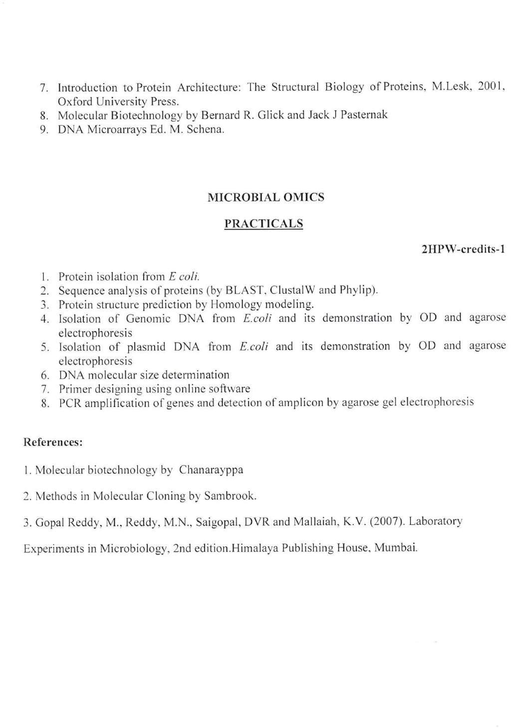

Palamuru University-UG syllabus 2020-21

17

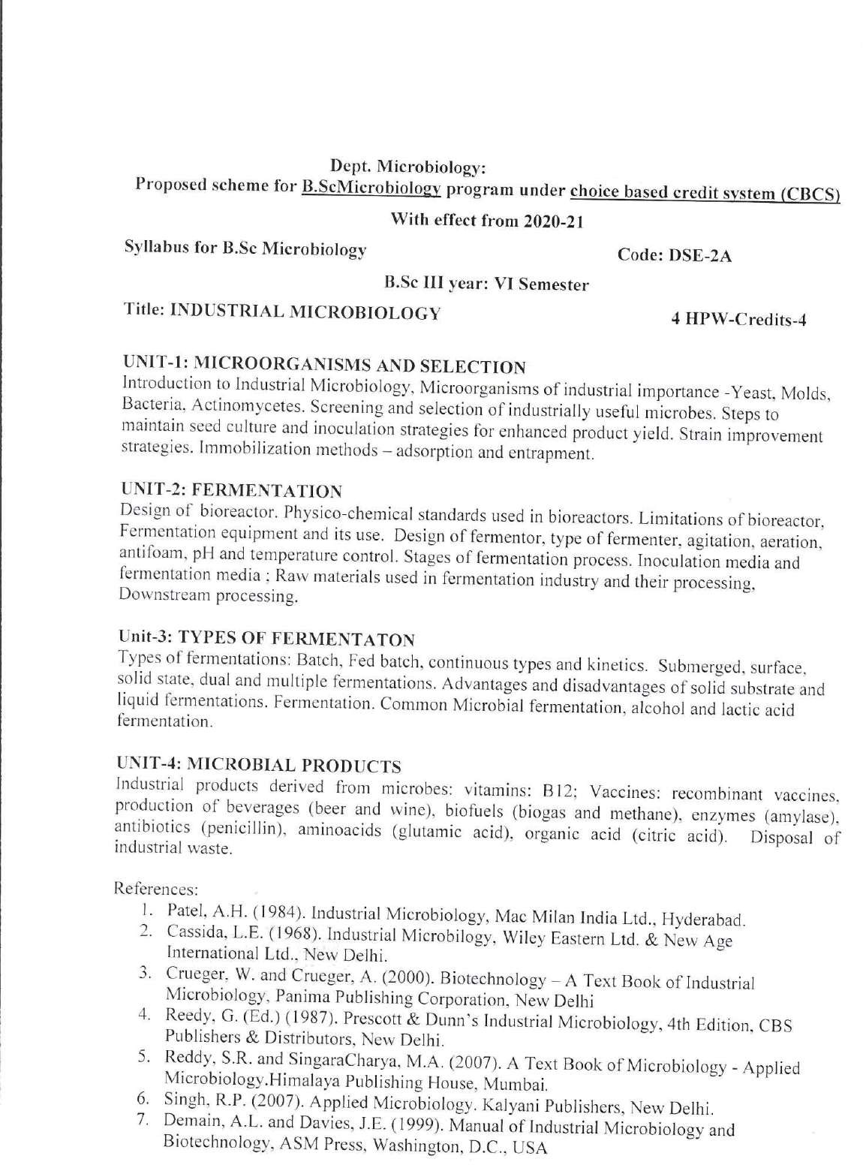

Palamuru University

Palamuru University-UG syllabus 2020-21

18

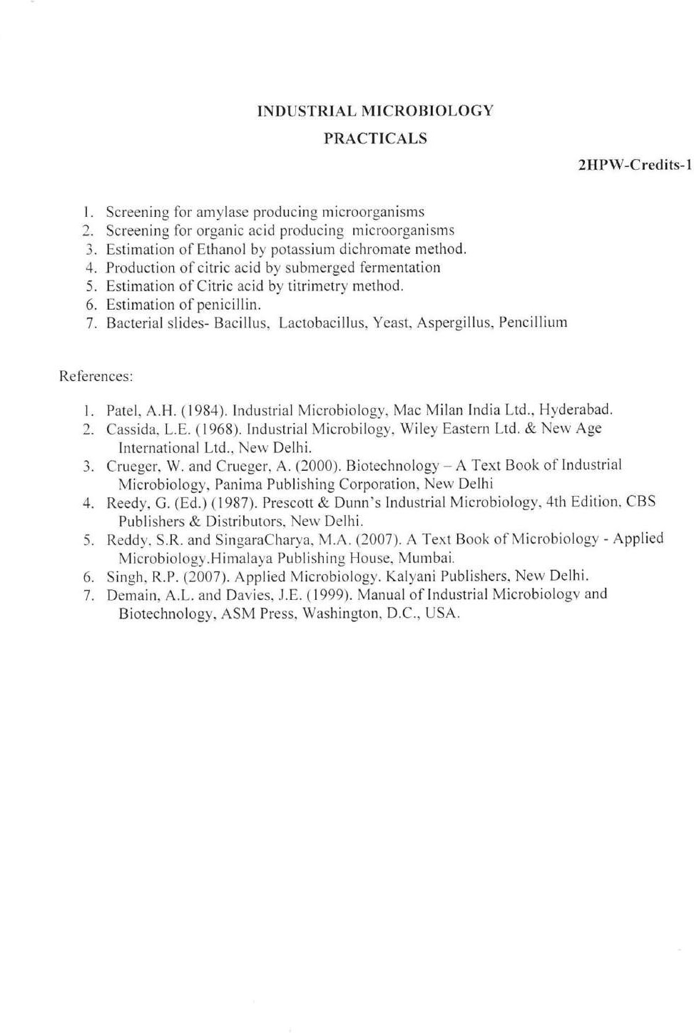

Palamuru University-UG syllabus 2020-21

19

PALAMURU

Palamuru University-UG syllabus 2020-21

20

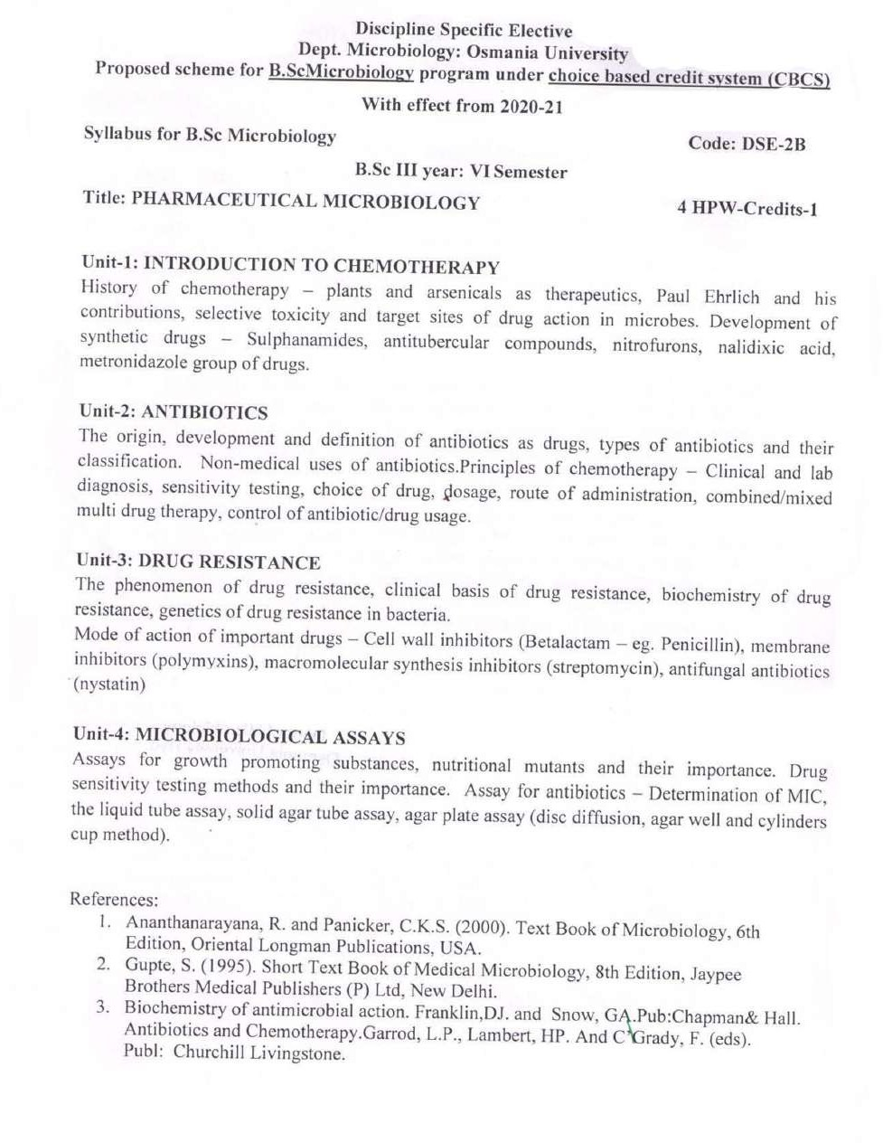

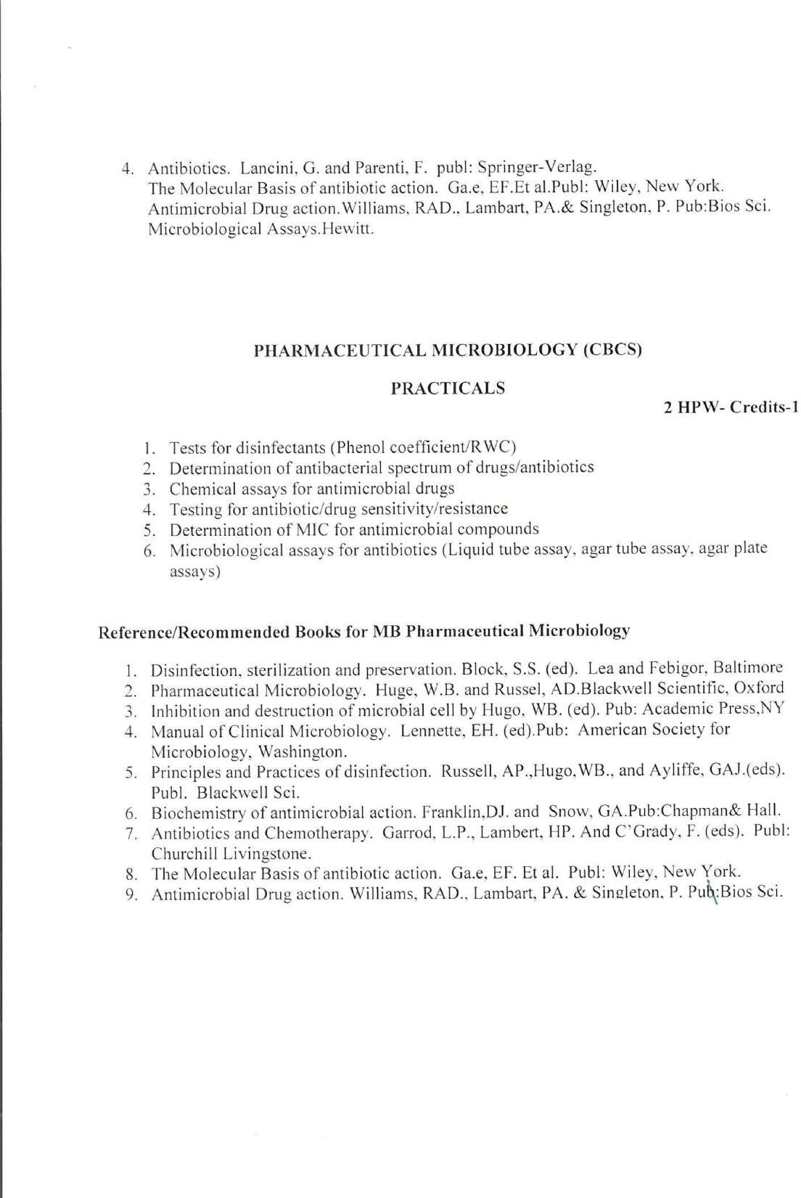

Palamuru University-UG syllabus 2020-21

21

Palamuru University

Palamuru University-UG syllabus 2020-21

22

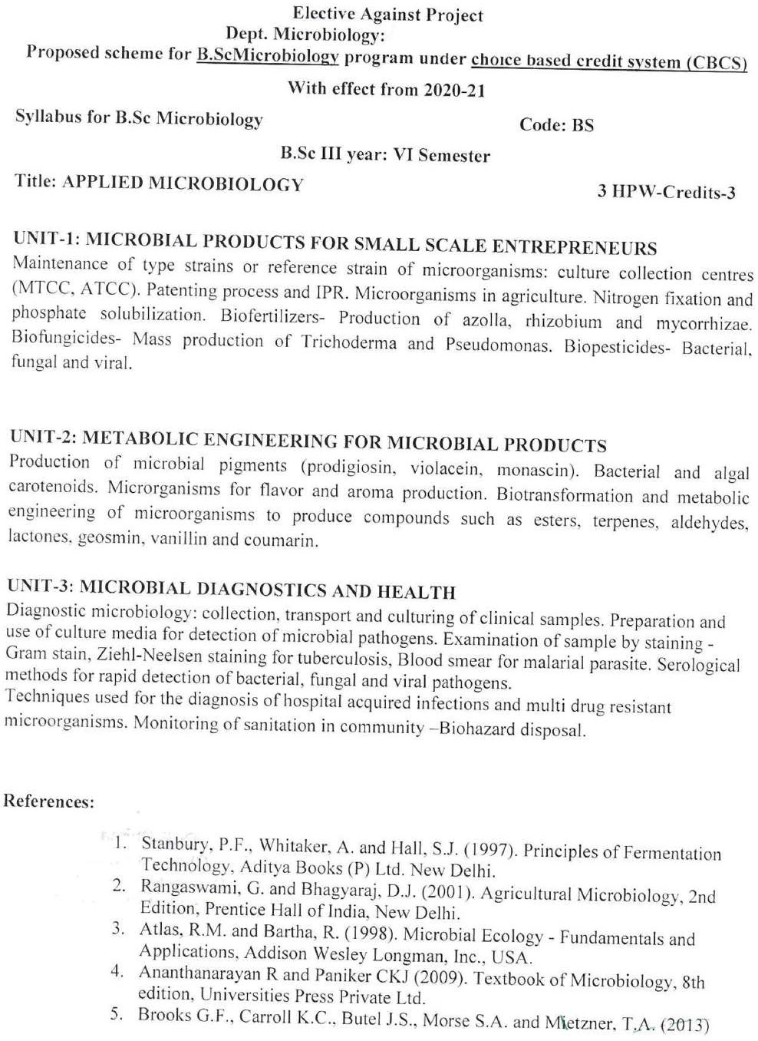

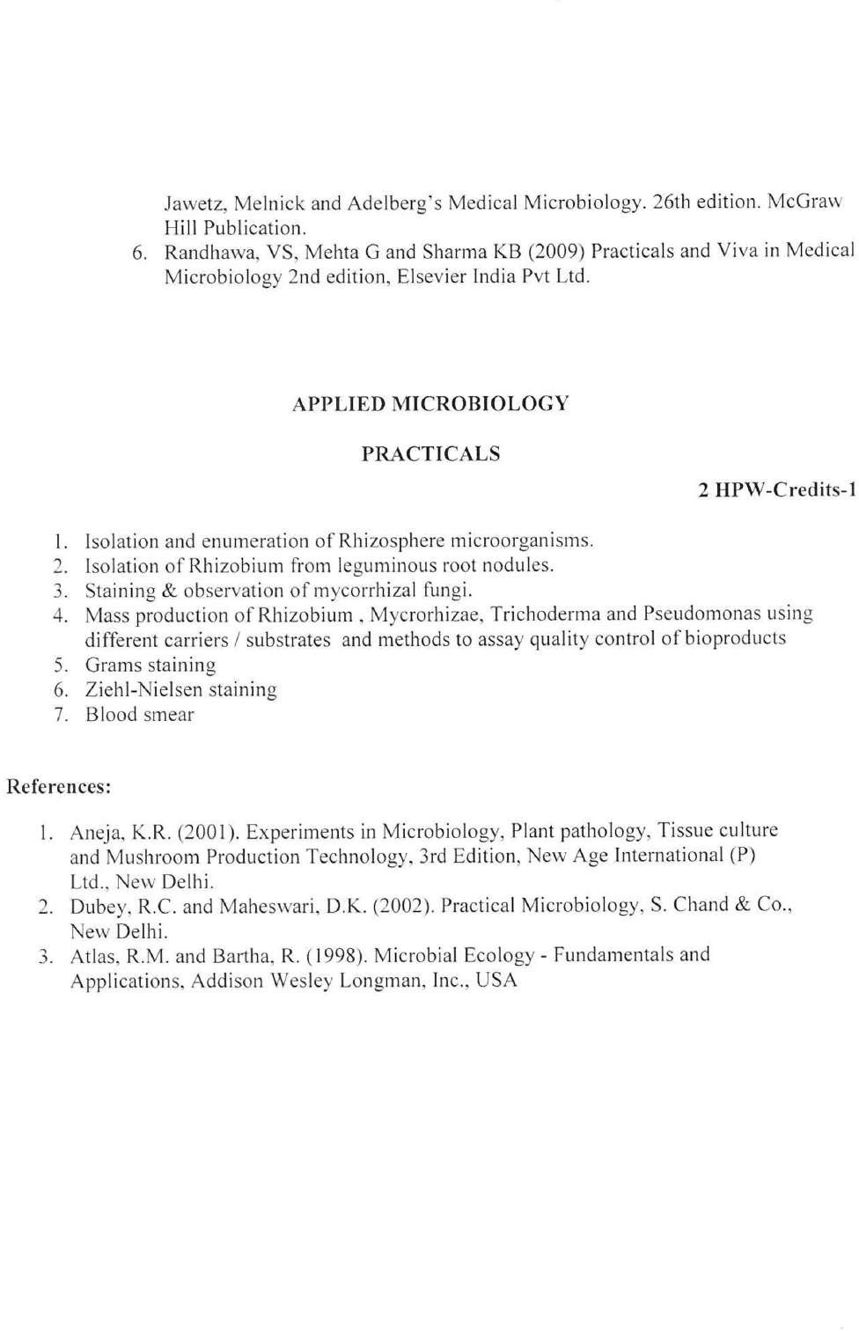

Palamuru University-UG syllabus 2020-21

23

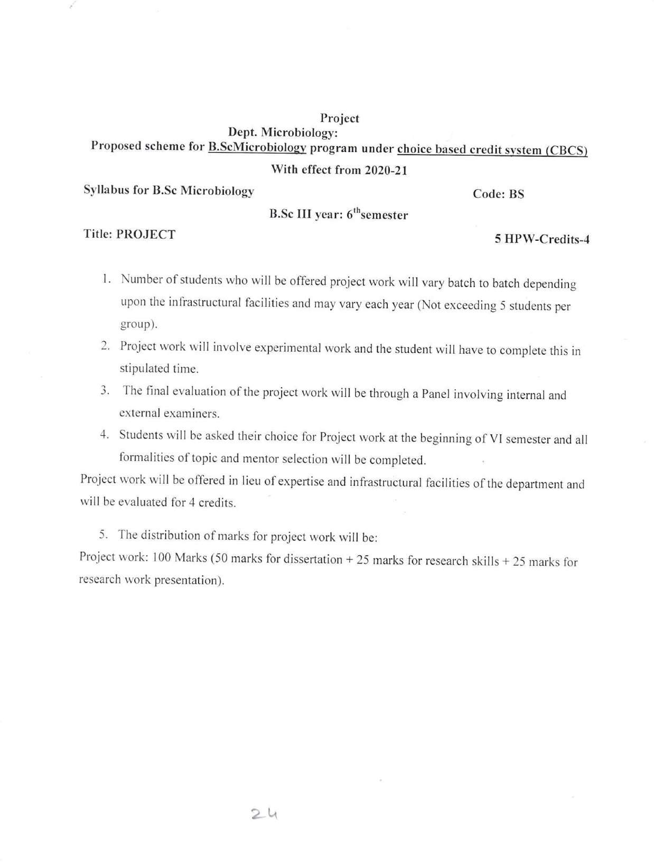

Palamuru University

Palamuru University-UG syllabus 2020-21

24