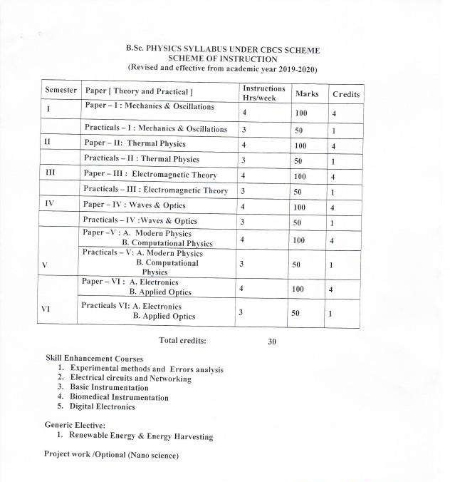

PALAMURU UNIVERSITY-UG SYLLABUS 2019-20

1

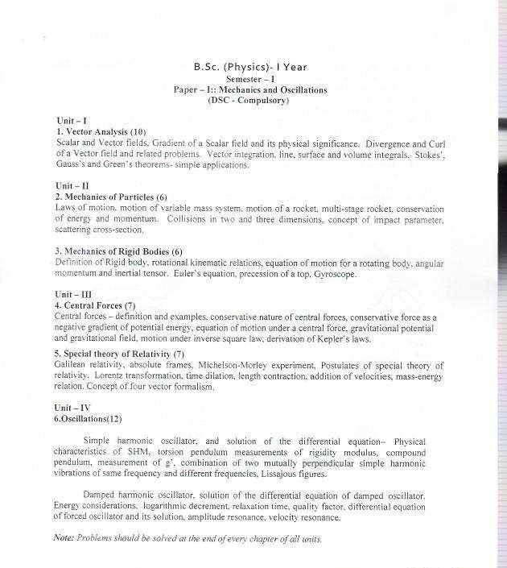

PALAMURU UNIVERSITY-UG SYLLABUS 2019-20

2



PALAMURU UNIVERSITY-UG SYLLABUS 2019-20

3

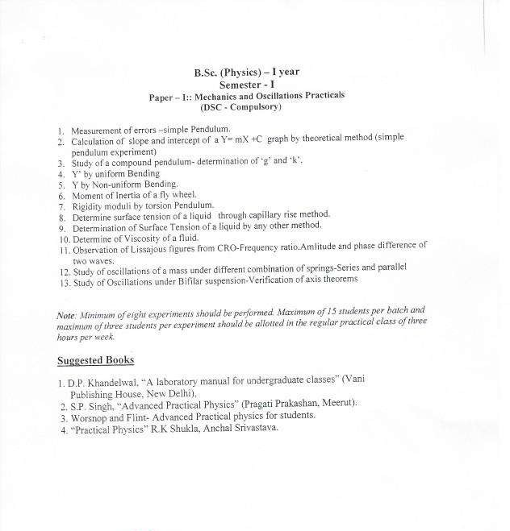

PALAMURU UNIVERSITY-UG SYLLABUS 2019-20

4

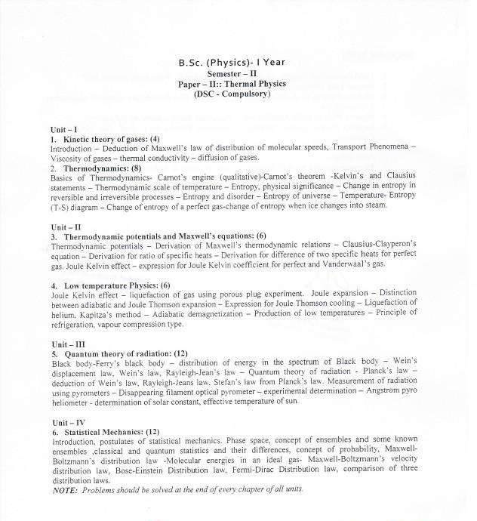

PALAMURU UNIVERSITY-UG SYLLABUS 2019-20

5

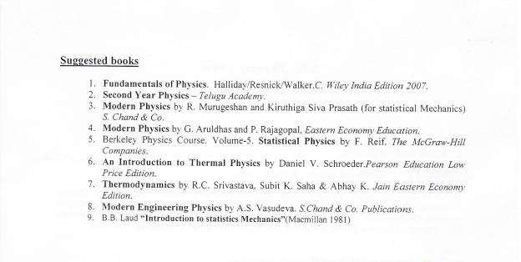

PALAMURU UNIVERSITY-UG SYLLABUS 2019-20

6

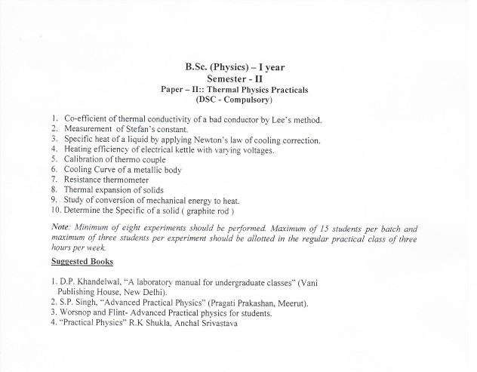

PALAMURU UNIVERSITY-UG SYLLABUS 2019-20

7

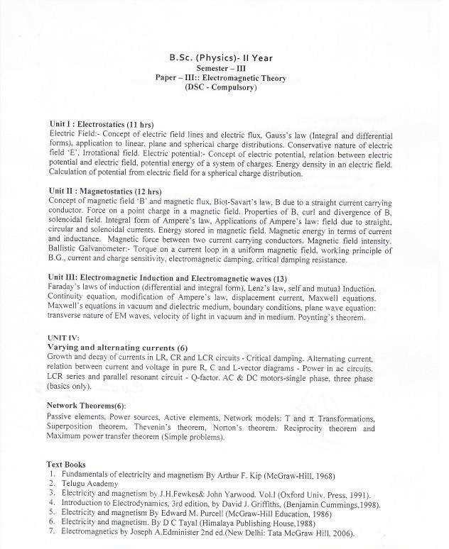

PALAMURU UNIVERSITY-UG SYLLABUS 2019-20

8

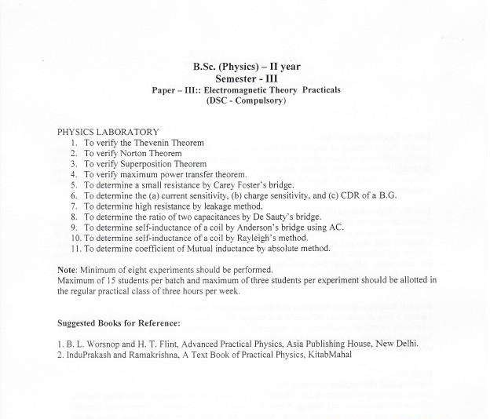

PALAMURU UNIVERSITY-UG SYLLABUS 2019-20

9

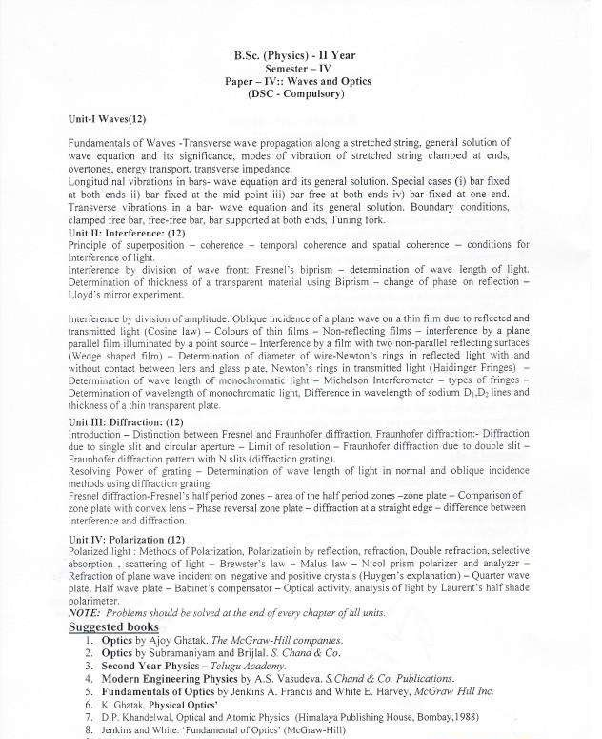

PALAMURU UNIVERSITY-UG SYLLABUS 2019-20

10

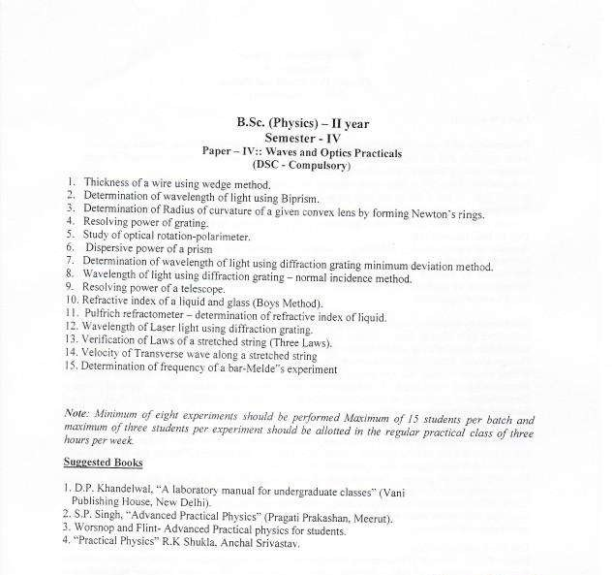

PALAMURU UNIVERSITY-UG SYLLABUS 2019-20

11

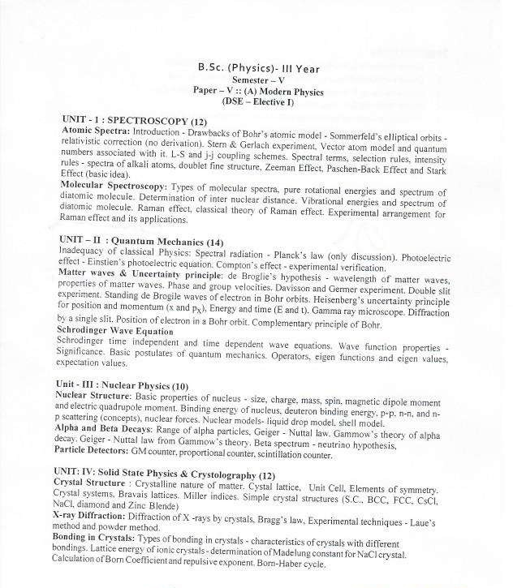

PALAMURU UNIVERSITY-UG SYLLABUS 2019-20

12

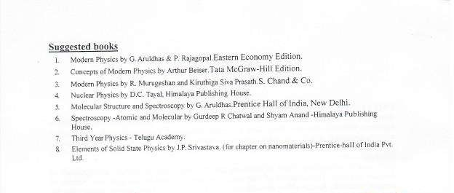

PALAMURU UNIVERSITY-UG SYLLABUS 2019-20

13

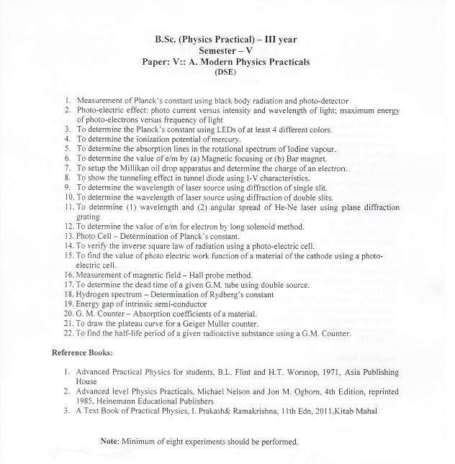

PALAMURU UNIVERSITY-UG SYLLABUS 2019-20

14

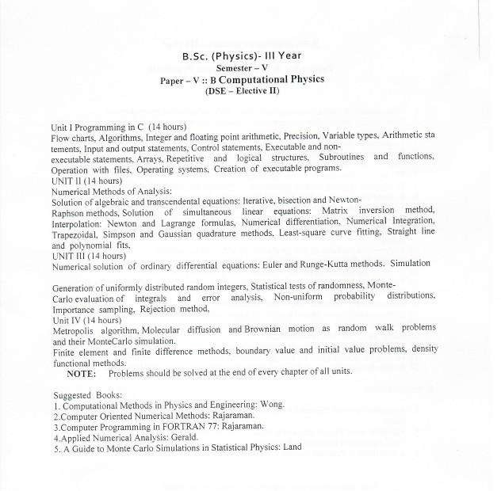

PALAMURU UNIVERSITY-UG SYLLABUS 2019-20

15

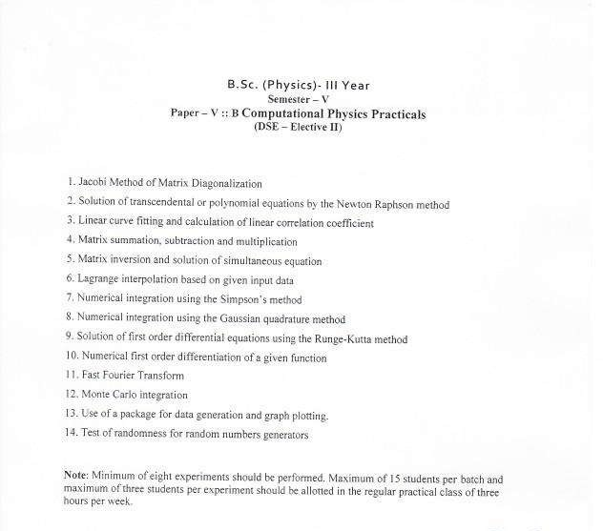

PALAMURU UNIVERSITY-UG SYLLABUS 2019-20

16

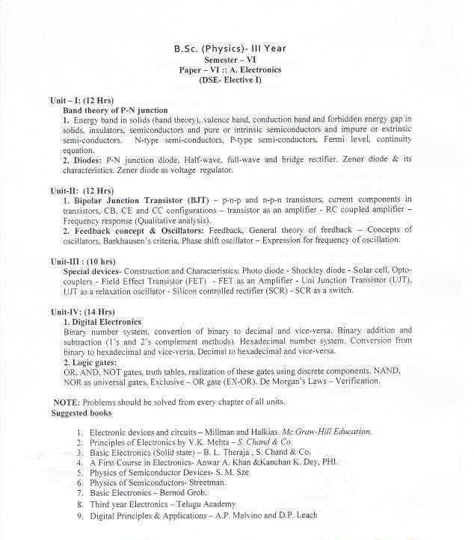

PALAMURU UNIVERSITY-UG SYLLABUS 2019-20

17

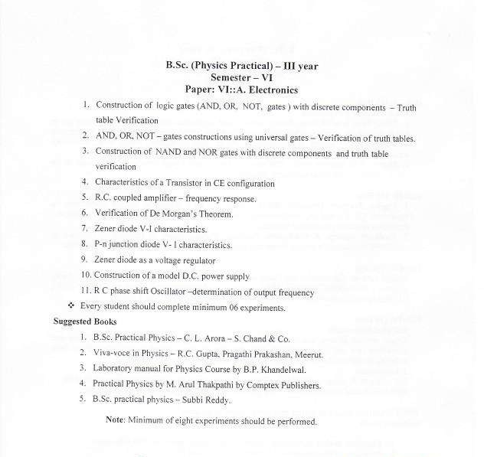

PALAMURU UNIVERSITY-UG SYLLABUS 2019-20

18

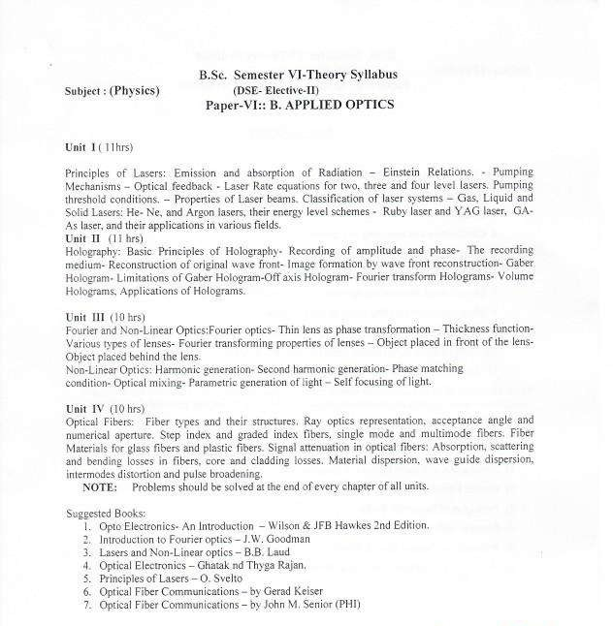

PALAMURU UNIVERSITY-UG SYLLABUS 2019-20

19

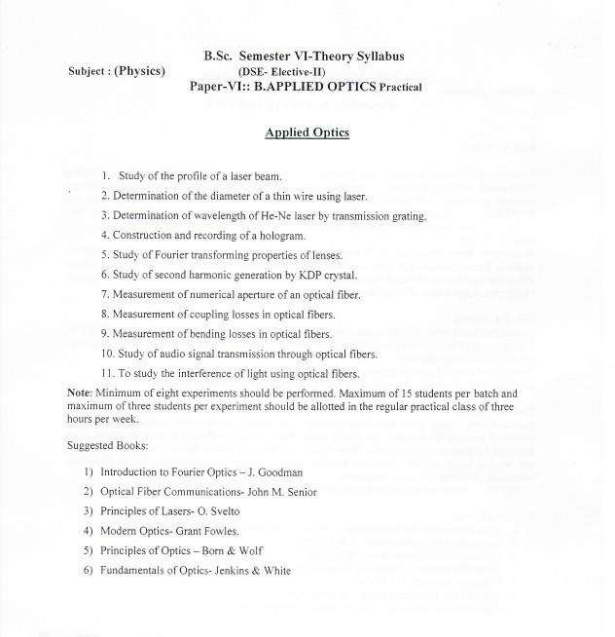

PALAMURU UNIVERSITY-UG SYLLABUS 2019-20

20

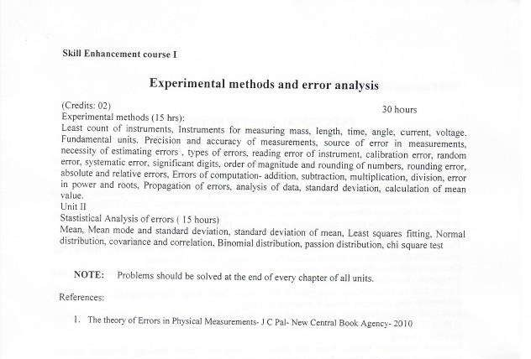

PALAMURU UNIVERSITY-UG SYLLABUS 2019-20

21

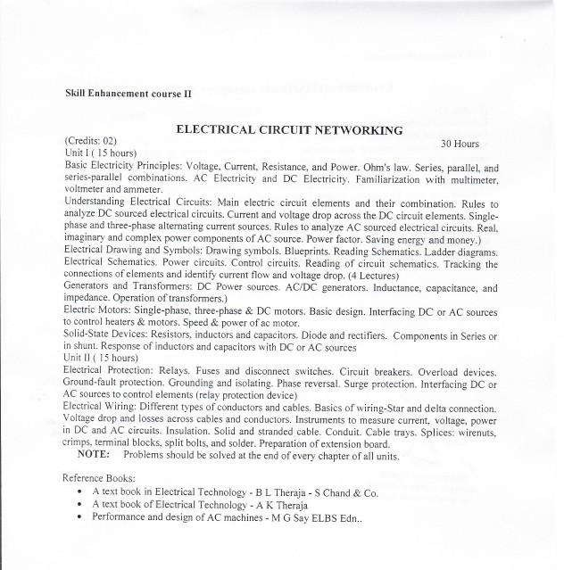

PALAMURU UNIVERSITY-UG SYLLABUS 2019-20

22

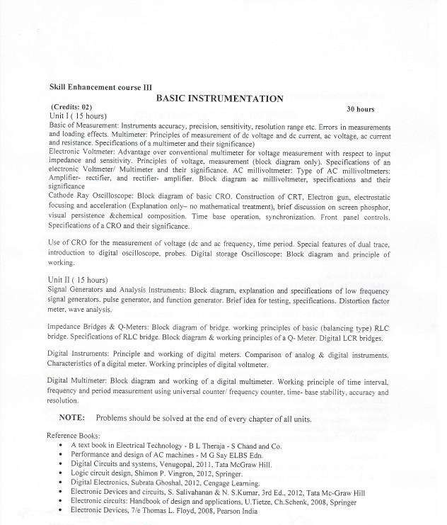

PALAMURU UNIVERSITY-UG SYLLABUS 2019-20

23

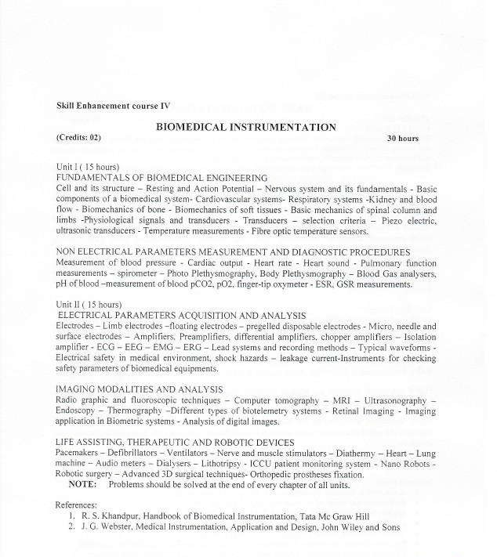

PALAMURU UNIVERSITY-UG SYLLABUS 2019-20

24

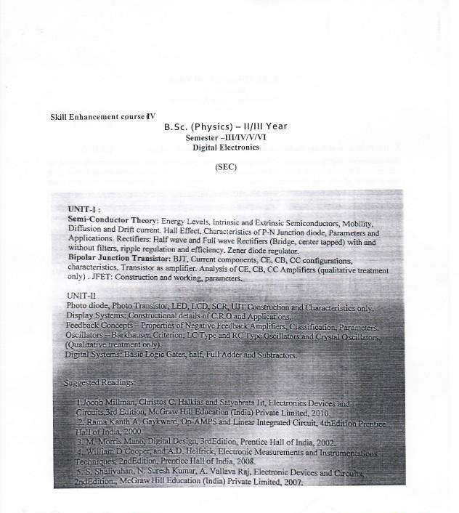

PALAMURU UNIVERSITY-UG SYLLABUS 2019-20

25

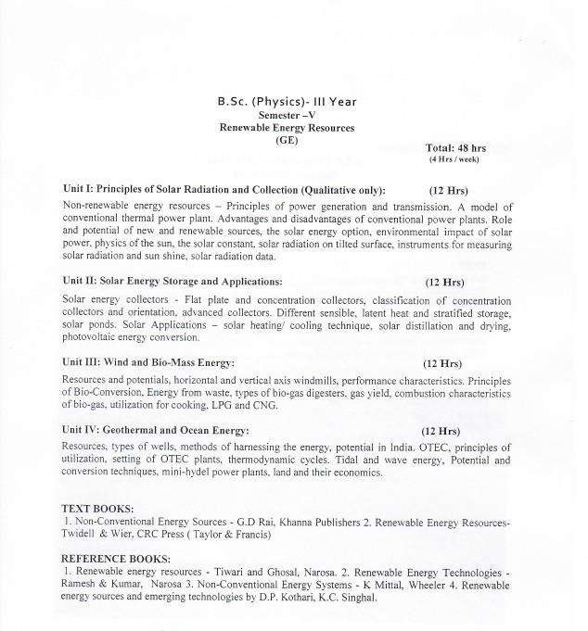

PALAMURU UNIVERSITY-UG SYLLABUS 2019-20

26

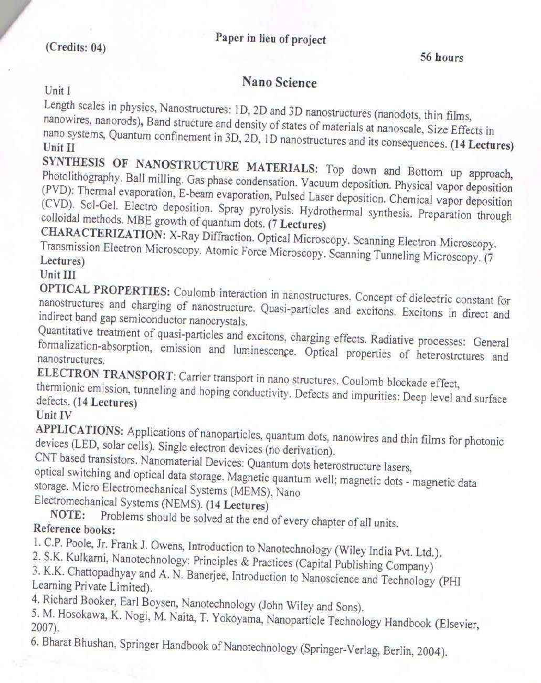

PALAMURU UNIVERSITY-UG SYLLABUS 2019-20

27

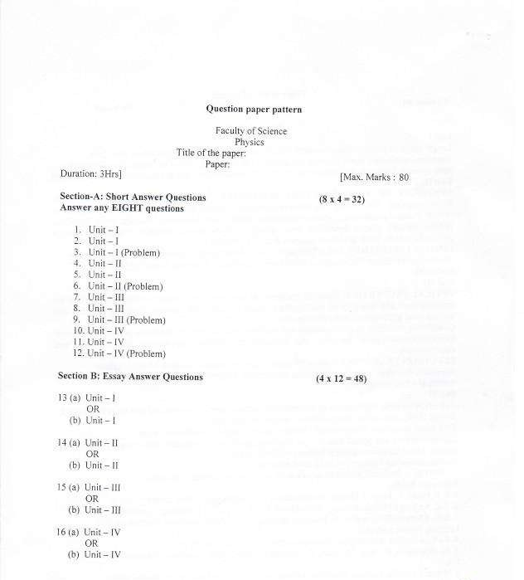

PALAMURU UNIVERSITY-UG SYLLABUS 2019-20

28