**TELANGANA SOCAIL WELFARE**

**RECIDENTIAL DEGREE COLLEGE FOR WOMEN, WANAPARTHY**

**STUDENT AMENITIES:**

The TSWREI Society is supplying centralized student amenities i.e., Uniform (Formal ware Pant Shirt ,Punjabi dresses (top and bottom with chunnies),Towels ,Bed sheets, Carpets Note Books and Text books to the TSWR Institutions function in the State at free of cost every year.

The following are the details of amenities provided to every student studying in TGSWR Institutions.

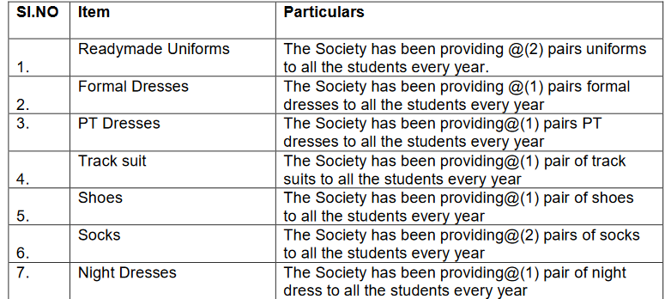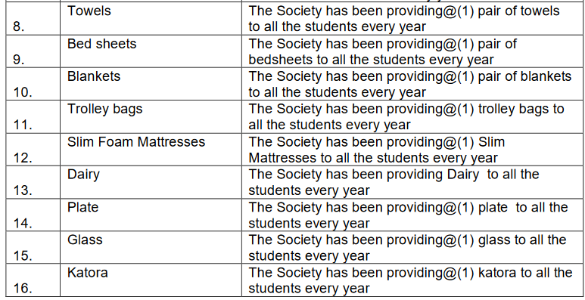

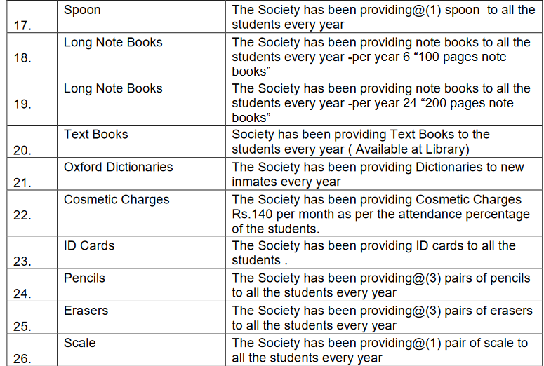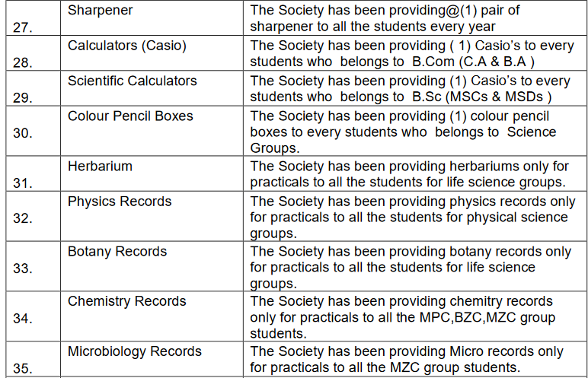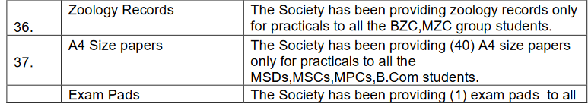

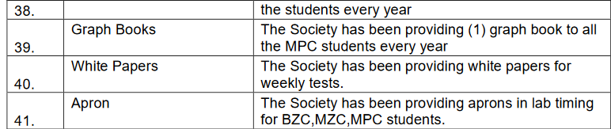

**Report on Students Amenities**

The Telangana Social Welfare Residential Educational Institutions Society (TSWREI Society) has meticulously crafted a robust system to procure and distribute essential amenities for women students in TSWR Institutions. This process begins with comprehensive surveys and assessments to ascertain the specific needs of students, ensuring a tailored approach to provisioning the requirement of students. Through transparent procurement channels, the Society sources top-tier materials for uniforms, towels, bed sheets, carpets, notebooks, and textbooks, prioritizing quality and durability.

Equitable distribution lies at the heart of the initiative, with meticulous attention paid to each TSWR Institution's requirements, including the number of students and their unique needs. This commitment ensures that no student is left without access to these vital resources, irrespective of their location or background. Regular monitoring mechanisms are in place to uphold the quality and utilization of the provided amenities, with feedback loops integrated to continuously refine and improve the process.

This holistic approach to student welfare underscores the Society's commitment to nurturing the overall well-being of women students, recognizing the intrinsic link between physical comfort and academic success.

In conclusion, the TSWREI Society's centralized student amenities initiative stands as a beacon of empowerment for women students in Telangana. By addressing their basic needs and fostering an inclusive learning environment, the Society paves the way for academic excellence and holistic development. Continued dedication to this initiative ensures that women students can thrive, unencumbered by material concerns, as they pursue their educational aspirations