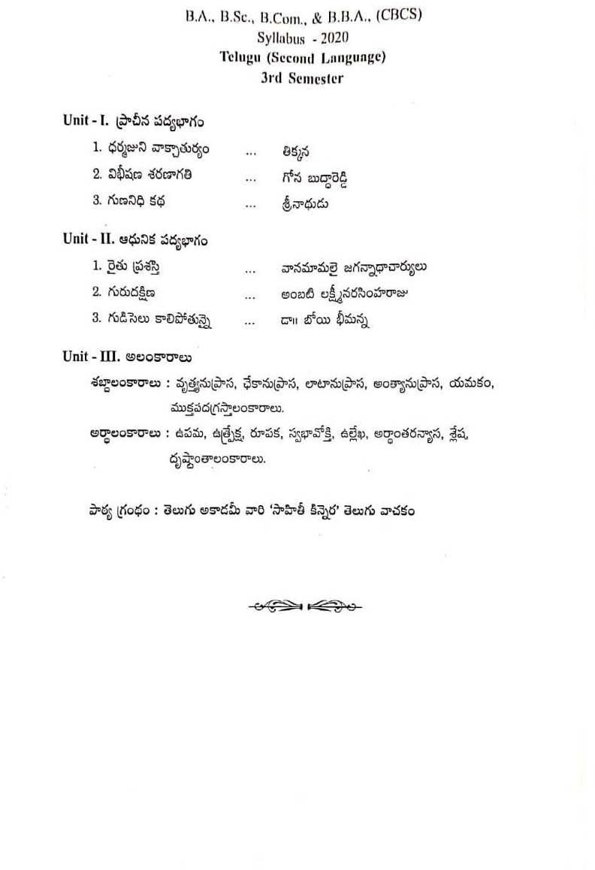

Palamuru University-UG Syllabus Telugu (SL)

Palamuru University-UG Syllabus Telugu (SL)

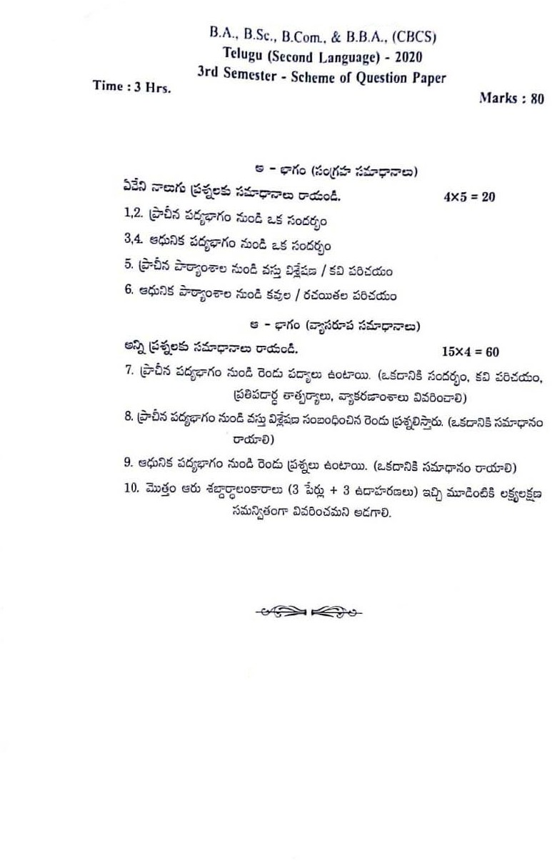

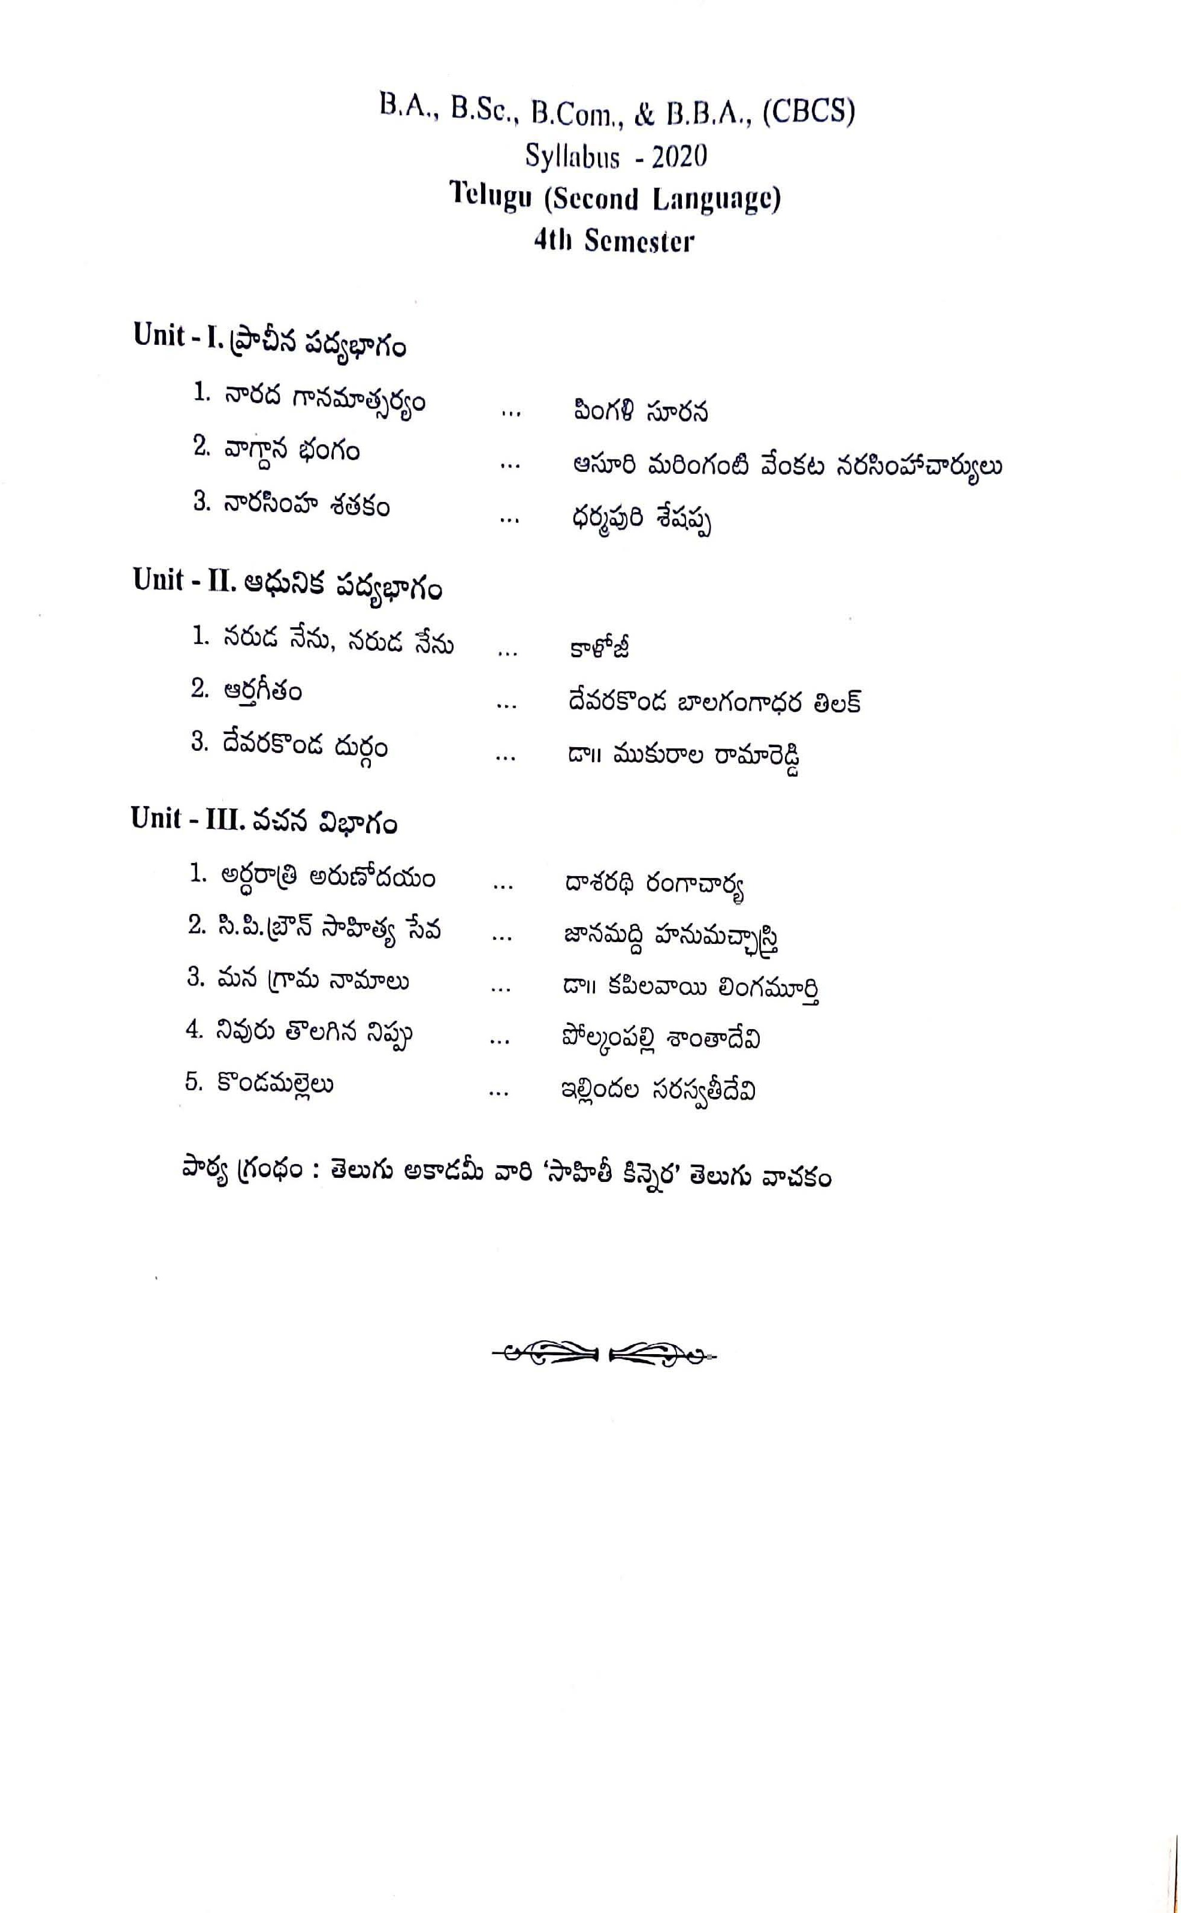

Palamuru University-UG Syllabus Telugu (SL)

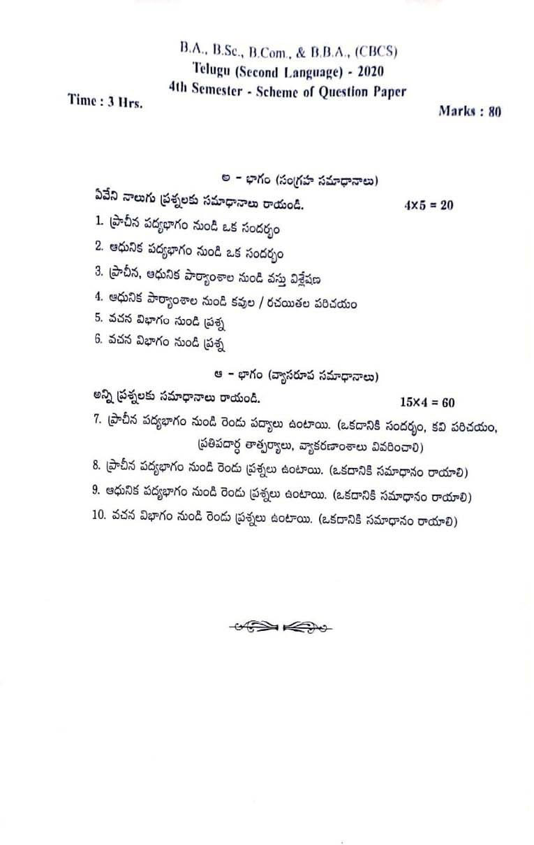

Palamuru University-UG Syllabus Telugu (SL)